|  |  |
| --- | --- |
|  |  |
|  |  |

**Licenciatura em Engenharia Informática**

Escola Superior de Tecnologia e Gestão

*Instituto Politécnico de Viana do Castelo*

Unidade curricular de

Projeto I

Relatório de projeto

2022/2023

*Gestão de uma empresa de transporte pesados de mercadorias*

28257 – Diogo Manuel Machado Assunção,

28248 – David José Sousa Braga

Sumário

1. Introdução 3

1.1 - Apresentação do tema 3

1.2 - Objetivos do projeto 3

2. Apresentação do negócio 4

2.1 - Âmbito e enquadramento do negócio 4

2.2 - Modelação dos Processos de negócio 4

2.2.1 Processo 1 – Processo de estabelecimento de mercadoria 5

2.2.2 Processo 2 – Processo de gestão e configuração da entrega 6

2.2.3 Processo 3 – Processo de confirmação de dados e faturação 7

2.2.4 Processo 4 – Processo de finalização do pedido de entrega e inspeção 8

3. Levantamento de Requisitos 9

3.1.1 - Apresentação dos tipos de utilizador 9

3.1.2 - Ações de cada tipo de utilizador 9

3.2 - Requisitos Funcionais 10

3.3 - Requisitos não funcionais 12

4. Design e Modelação 13

4.1 - Modelo de casos de uso 13

4.2 - Modelação de dados 37

4.3 - Modelo de classes 38

4.4 - Diagrama de transição de estados do Pedido 39

5. Implementação da BD 40

5.1 - Criação das tabelas 40

5.2 - Gestão dos dados na base de dados 41

5.2.1 - Inserção de dados 41

5.2.2 – Views 42

5.2.3 - Triggers 44

5.2.4 - Indexes 45

5.2.5 Stored Procedures 46

6. Conclusão 48

Anexo 1 – Creates 49

Anexo 2 – Inserts 57

# Introdução

## - Apresentação do tema

Neste projeto desenvolvido na UC de Projeto I, temos como objetivo desenvolver diferentes modelos para melhorar a organização e a gestão dos meios disponíveis da empresa ReiPort.

ReiPort é uma empresa dedicada ao transporte de contentores em camiões (transportes pesados) na União Europeia.

Este projeto consiste na gestão dos pedidos de entrega (feitos pelos clientes) e dos meios para os referidos trabalhos (quer de logística, quer de mão de obra).

## - Objetivos do projeto

Numa primeira fase do projeto, apresentamos os modelos BPMN e a descrição dos respetivos processos.

Numa segunda fase, apresentamos os diferentes tipos de utilizadores, bem como as suas ações no sistema, além de um levantamento de requisitos funcionais e não funcionais. Ainda se expôs os diferentes modelos e diagramas de design e modelação (Diagrama DER, Modelo de Domínio, Modelo de Classes e Modelo Relacional) e modelos e diagramas funcionais (Modelo de Casos de Uso, Templates de Caso de Uso, Diagrama de transição de estados, Diagramas de Sequência para 3 Templates de Caso de Uso e um Diagrama de Atividades).

Numa terceira fase, apresentamos o código utilizado no Postgres para criar as tabelas, os inserts, as views, os triggers, os indexes, os store procedures e por fim os updates e os deletes.

Numa quarta fase, já na UC de Projeto 2, a base de dados sofreu alterações e como tal alguns dos diagramas foram alterados, para ficarem a figura da nova base de dados.

# Apresentação do negócio

Nesta secção apresentaremos os modelos de negócio (em BPMN) e os diferentes processos.

## - Âmbito e enquadramento do negócio

Esta empresa apenas realiza viagens de entrega, por exemplo: transporta a mercadoria para portos, fábricas, depósitos, empresas, comboios, aeroportos, etc. O rececionista recebe um pedido de trabalho, anota os dados e envia para o gestor, que verifica e agenda a entrega, além disso gere também os camiões e contentores a serem utilizados (se os camiões e contentores são disponibilizados pelo cliente ou pela empresa ReiPort), e os motoristas (se forem viagens de mais de 9 horas são necessários 2 motoristas). Ao receber a carga e antes de iniciar o transporte da mesma é realizada a inspeção e documentação da carga pelo/s motorista/s do pesado em questão, e no destino é realizada a verificação novamente para saber se a carga foi entregue em condições. Para os vários trabalhos, ReiPort dispõe do número necessário de camiões, contentores e motoristas para a realização dos trabalhos.

## - Modelação dos Processos de negócio

Secção onde apresentaremos os modelos de negócio formulados.

## Processo 1 – Processo de estabelecimento de mercadoria

Este processo consiste em receber um pedido de entrega, registá-lo e, posteriormente, enviá-lo para o gestor, para iniciar a fase seguinte.

Inicia-se com a receção de um novo pedido por parte de um cliente. O rececionista verifica se o cliente está na base de dados e, se não estiver, procede ao seu registo. No registo é pedido o nome, o email, o NIF, o telefone e, por fim, a morada. Depois regista a carga. Num diálogo com o cliente, configura os detalhes da entrega (origem da entrega, disponibilidade de camião, disponibilidade de contentor, dimensões, peso da carga, data-limite de entrega, tipo de carga, tamanho da carga, destino da entrega). De seguida, envia um pedido de gestão para o gestor e coloca o estado da entrega como suspensa.

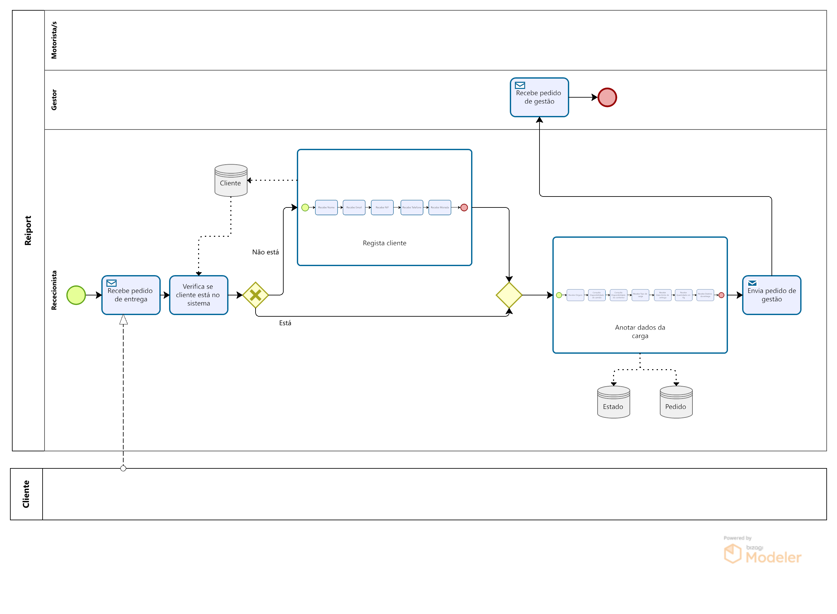

## Processo 2 – Processo de gestão e configuração da entrega

Este processo consiste em receber um pedido de gestão e proceder à organização e gestão dos meios disponíveis na empresa ou pelo cliente e a elaboração do CMR.

Inicia o seu trabalho verificando a disponibilidade de camião, isto é, confirma se o cliente fornece um camião para a entrega ou não. Se este não fornecer, é procurado um camião com as características pretendidas para o trabalho de acordo com o stock da empresa ReiPort. Se não for encontrado, o gestor envia um pedido de anulamento ao rececionista que envia uma mensagem de cancelamento ao cliente e altera o estado da entrega para anulada.

Procede, então, à verificação da disponibilidade de contentor onde executa o mesmo procedimento realizado anteriormente.

Verifica os motoristas com competências para transportar o tipo de carga a entregar (por exemplo: para viagens de transporte de materiais inflamáveis, o motorista necessita do ADR, …) e o tempo de duração da viagem. Em conformidade com a duração da viagem prevista, decide se o motorista necessita de um copiloto (viagens com mais de 9 horas).

Atribui, assim, um ou mais motoristas e um preço à entrega.

Elabora um CMR com toda a informação necessária para o/s motorista/s entregar/em a entrega. No fim envia o CMR ao rececionista.

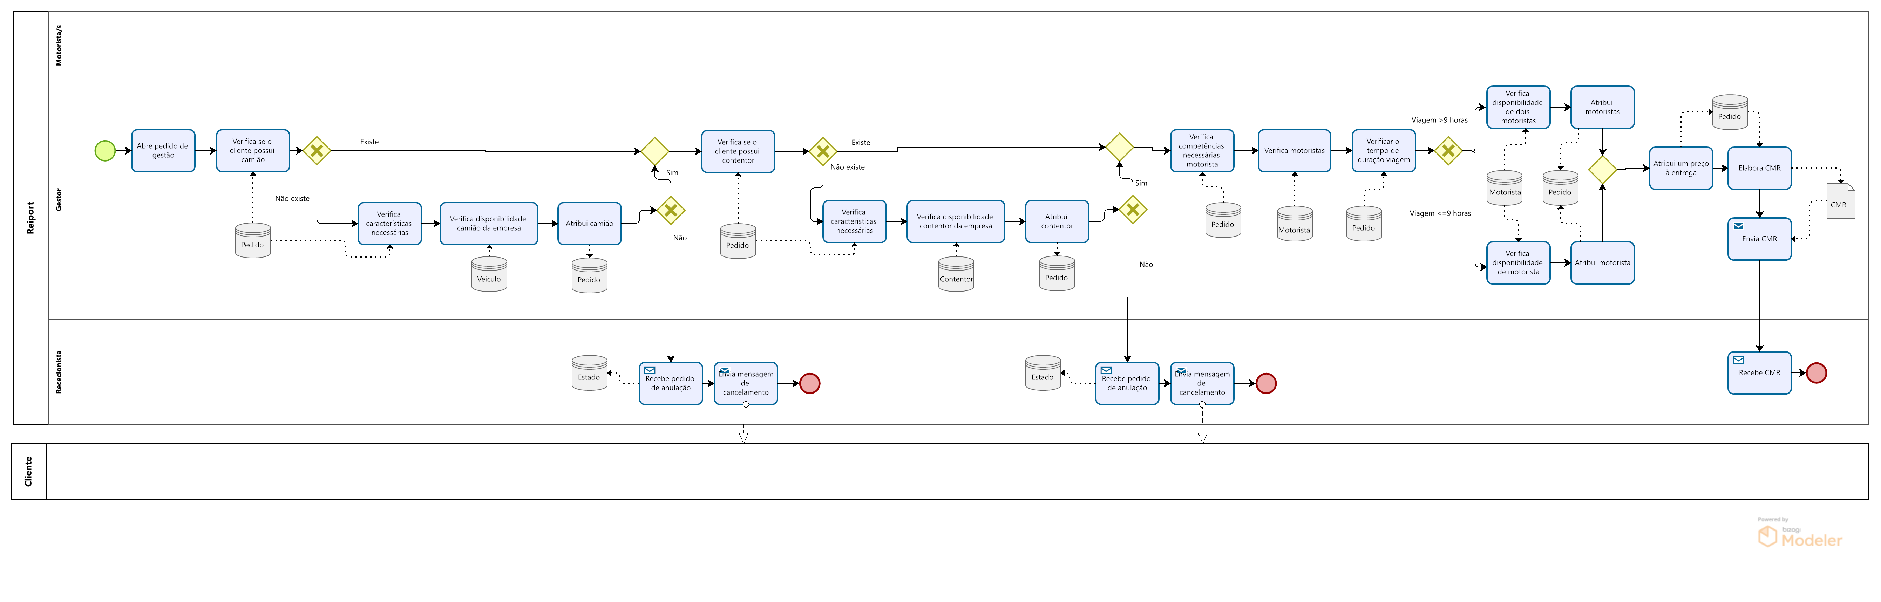

## Processo 3 – Processo de confirmação de dados e faturação

Este processo consiste na confirmação dos dados com o cliente, envio da data prevista da entrega e emissão da fatura.

Assim sendo, depois de enviar os dados recebe a confirmação do cliente e elabora a fatura que envia para o cliente, bem como altera o estado da entrega para agendada. Envia, também, o CMR para o/s motorista/s e a confirmação de transporte para o cliente.

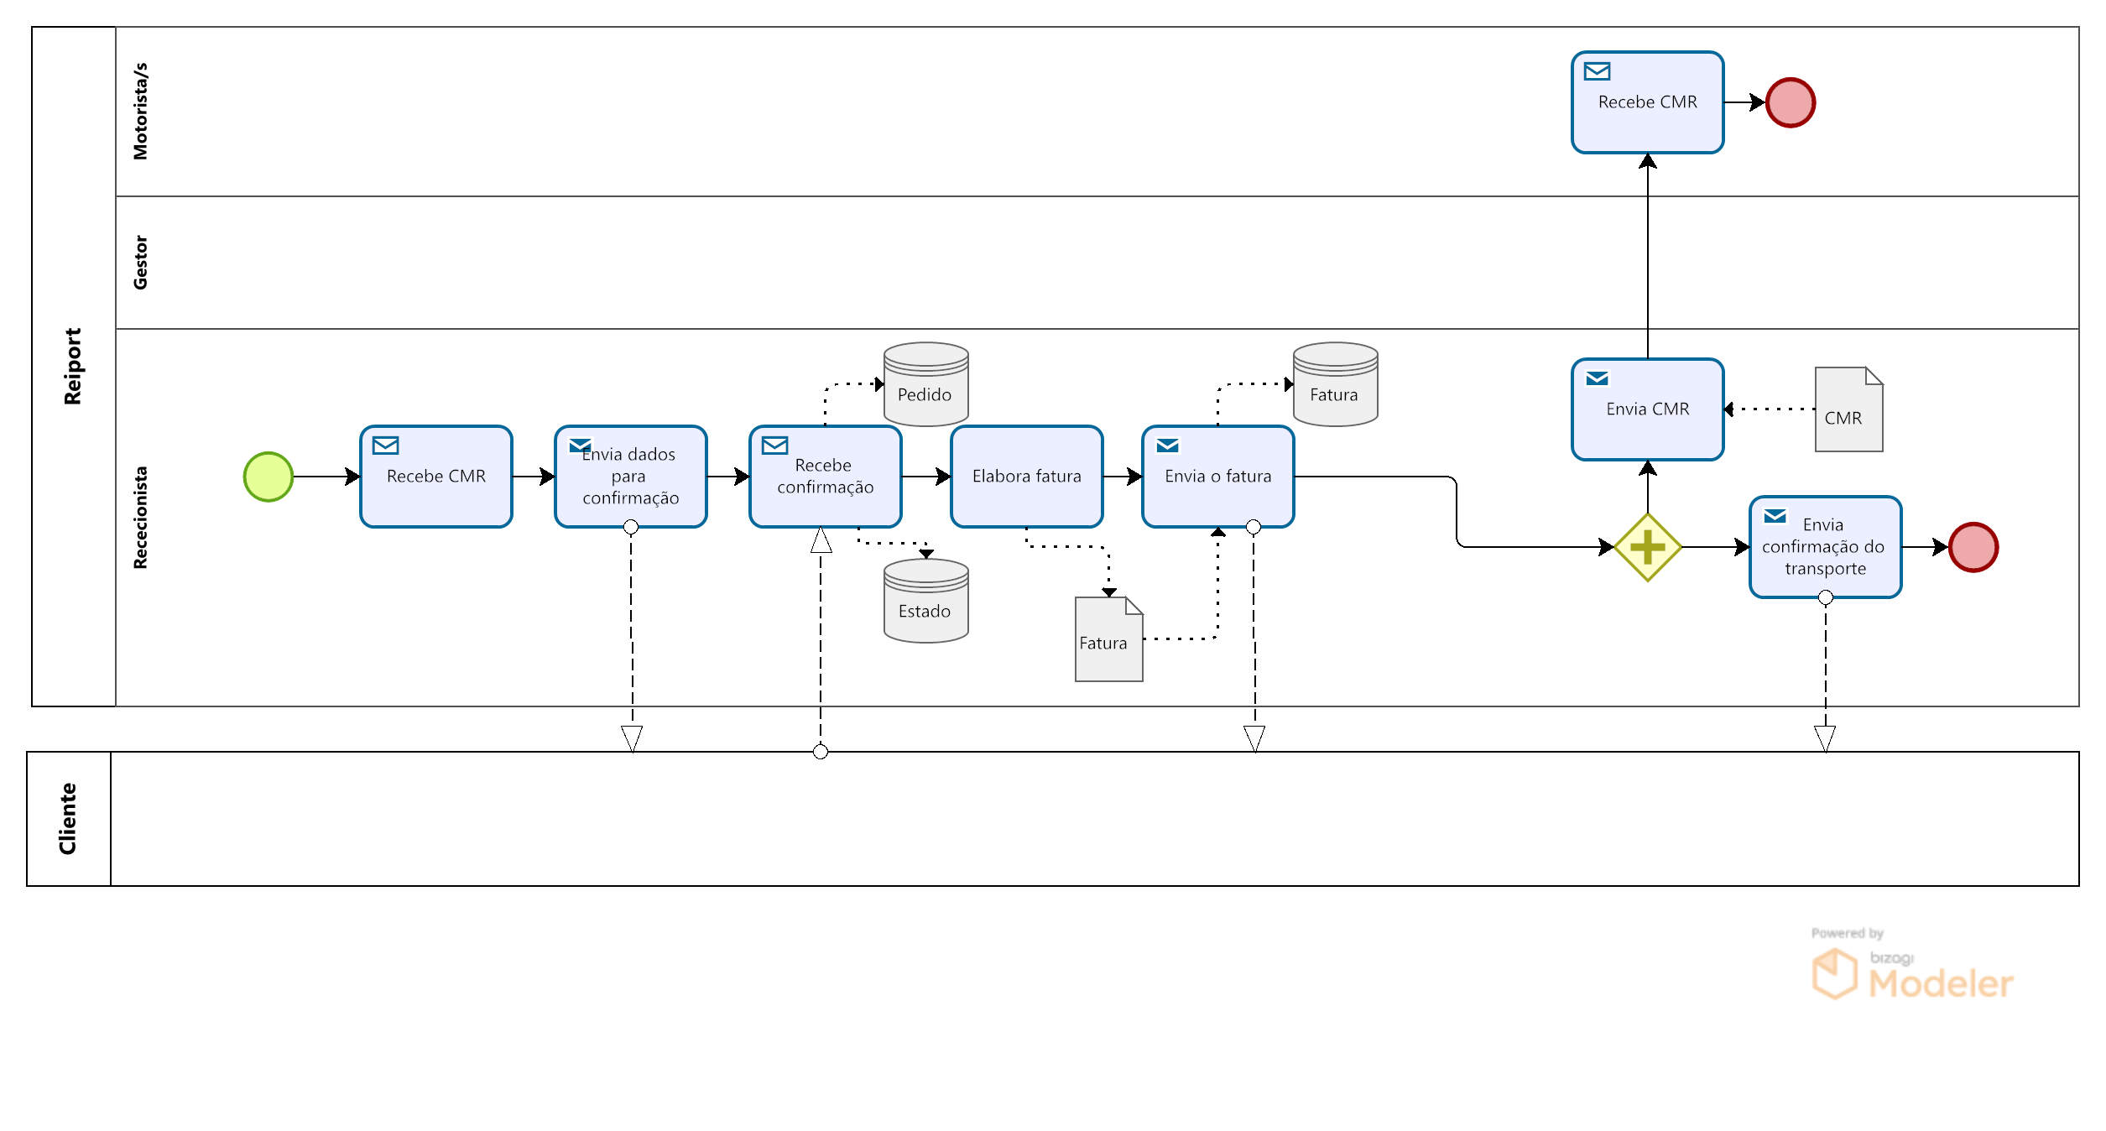

## Processo 4 – Processo de finalização do pedido de entrega e inspeção

Este processo final consiste na viagem do motorista e das duas inspeções realizadas à carga, bem como a receção do pagamento.

O/s motorista/s recebe/m os detalhes enviados pelo rececionista (CMR) e procede/m ao levantamento do camião ou contentor, dependendo da verificação realizada pelo gestor quanto à utilização de camião ou contentor da empresa ou do cliente. Os motoristas dirigem-se para o ponto de origem da viagem de entrega. Na receção da mercadoria, recebem a guia devidamente preenchida pelo cliente. A carga é carregada e inicia-se o processo de inspeção da carga com a presença do cliente. Se o estado da carga e do camião e/ou contentor, bem como todos os documentos (necessários para o tipo de carga a transportar (fatura comercial, declaração de exportação, fotocópia do cartão de contribuinte do exportador e importador e por fim do parking-list (descrição da mercadoria, volumes e pesos))) estiverem em ordem, a entrega é realizada. Se por algum motivo, os documentos ou o estado de um dos três não estiver em ordem o cliente é informado, tal como o rececionista. Este nega o pedido e envia mensagem de cancelamento definitivo ao cliente.

O motorista realiza a entrega e, no destino, volta a verificar o estado da carga, do camião e/ou contentor, bem como todos os documentos. Se por algum motivo algo estiver incorreto, informa a/s irregularidade/s ao cliente e ao gestor, para que a situação seja resolvida.

Preenche o resto da guia com o destinatário e envia a guia para o rececionista.

O rececionista recebe a guia, altera o estado da entrega para concluída e envia para o cliente a guia. Por fim, o cliente paga o serviço e é enviado o recibo correspondente.

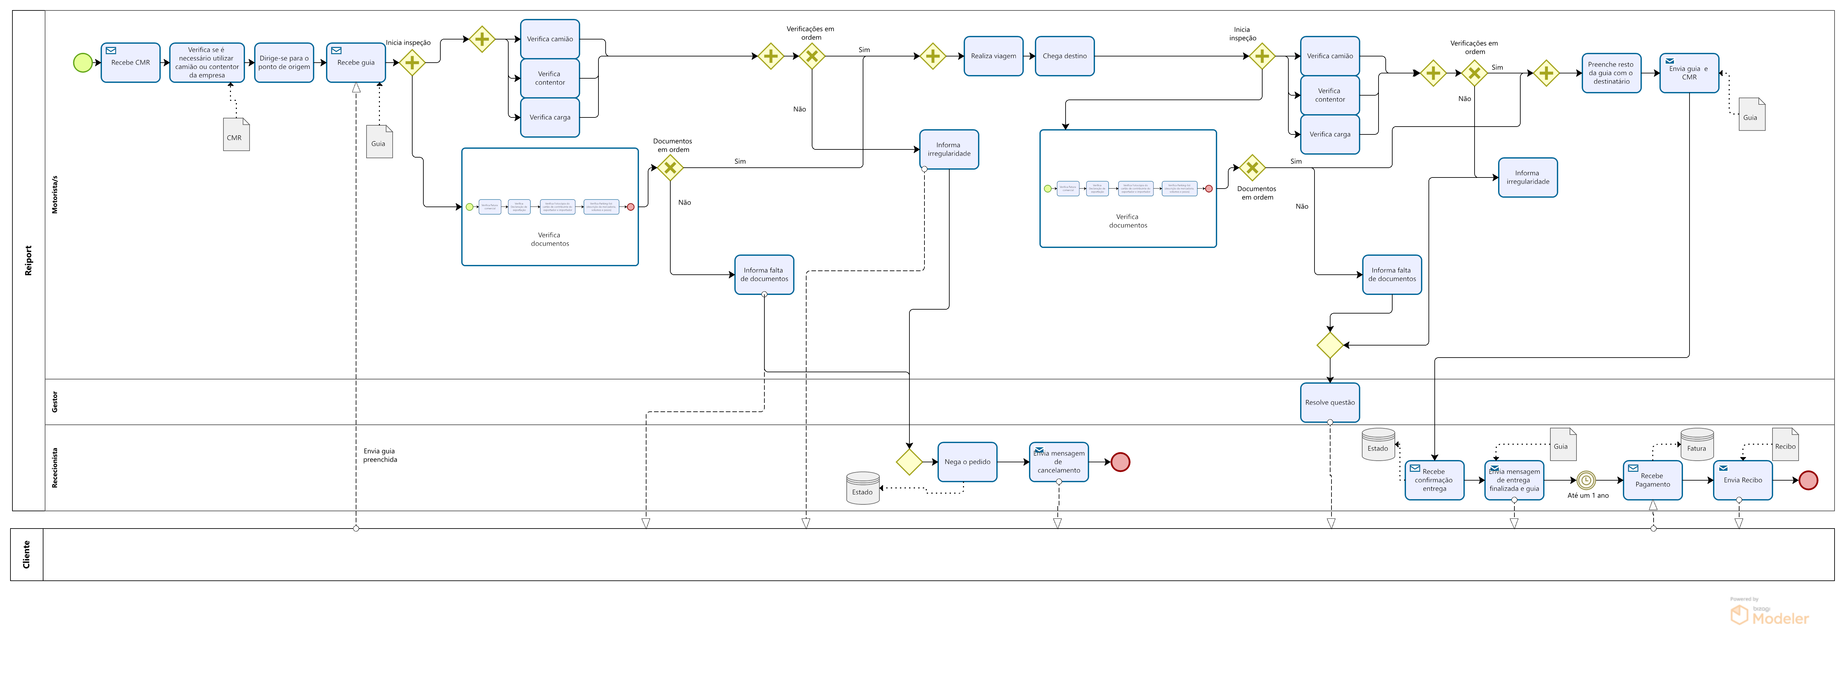

# Levantamento de Requisitos

## - Apresentação dos tipos de utilizador

- Rececionista

- Gestor

-Motorista

-Cliente

-Admin

## - Ações de cada tipo de utilizador

O rececionista consegue registar novos clientes e fazer alterações, registar pedidos de entrega, visualizar os pedidos em procedimento, os pedidos agendados, envia ao cliente mensagens de cancelamento (se houver irregularidades no início da entrega) ou de conclusão do trabalho, atualiza o estado da entrega no sistema e recebe a confirmação destes detalhes, emite a fatura, envia a confirmação do início da entrega e o CMR ao motorista e recebe e envia a guia de transporte ao cliente. Consegue elaborar a fatura e recebe o pagamento do transporte, emite o recibo e envia-o para o cliente.

O gestor pode visualizar os pedidos em procedimento, os pedidos agendados, a logística da frota de camiões e contentores, os motoristas disponíveis, e definir o camião, contentor e motorista/s para o trabalho, além de atribuir um preço à entrega e emitir o CMR, que depois será utilizado pelo/s motorista/s. Além disso, tem de avaliar e corrigir qualquer irregularidade que surja durante a entrega. O gestor pode também registar o camião e/ou contentor para adicionar ao Stock.

O/s motorista/s recebem toda a informação necessária para o seu trabalho (na Guia de Transporte), além de realizar/em as inspeções à carga e aos meios utilizados no transporte. Também são responsáveis por receber e entregar as guias de transporte ao rececionista e, evidentemente, realizar a viagem.

O cliente pode verificar a qualquer altura o estado das suas encomendas, bem como alterar os seus dados, desde que efetue o seu registo no sistema.

O administrador pode gerir qualquer tipo de funcionário (rececionista, gestor e motorista).

## - Requisitos Funcionais

|  |  |
| --- | --- |
| **Vocabulário** | |
| CMR | É um documento de acompanhamento. É o documento preparado pela empresa para entregar ao motorista de um veículo. |
| Guia de transporte | Uma guia de transporte é um documento que declara que uma transportadora leva uma carga de A até B em nome do fornecedor. A guia de transporte declara as mercadorias contidas numa carga e o local onde serão entregues. A guia de transporte declara se devem ser cumpridas obrigações especiais para as mercadorias em questão (que tipo de habilitações são necessárias pelo motorista). O peso é também indicado e pode ser utilizado para verificar se o camião tem excesso de carga. |

|  |  |  |
| --- | --- | --- |
| **Requisitos Funcionais** | | |
| Referência | Descrição | Prioridade |
| RF01 | Como rececionista, quero Registar um cliente para geri-lo no sistema | Alta |
| RF02 | Como rececionista, quero Registar Pedido para os poder gerir | Alta |
| RF03 | Como rececionista, quero poder Alterar os Dados dos Clientes e da sua carga para os atualizar | Média |
| RF04 | Como rececionista, quero Visualizar todos os Pedidos (agendados, execução, suspensos, anulados e completos) para poder geri-los | Média |
| RF05 | Como rececionista, quero poder enviar avisos de cancelamento, início do trabalho ou conclusão para o cliente | Baixa |
| RF06 | Como rececionista, quero poder Alterar os Estados de Entrega para os atualizar | Alta |
| RF07 | Como rececionista, quero enviar a confirmação do transporte para o cliente | Baixa |
| RF08 | Como rececionista, quero poder Enviar Ficheiros para diferentes utilizadores do sistema | Alta |
| RF09 | Como rececionista, quero poder aceder às guias de transporte para as enviar para os clientes | Alta |
| RF10 | Como rececionista, quero Elaborar/Emitir Faturas para posteriormente enviar para os clientes | Média |
| RF11 | Como rececionista, quero Elaborar/Emitir Recibo para posteriormente enviar para os clientes que já pagaram | Média |
| RF12 | Como rececionista, quero Consultar os Ficheiros relativos à entrega para confirmar entregas com clientes | Alta |
| RF13 | Como gestor, quero Visualizar todos os Pedidos (agendados, execução, suspensos, anulados e completos) para poder geri-los | Alta |
| RF14 | Como gestor, quero Visualizar o Stock de Veículos e contentores da empresa ReiPort para poder geri-los | Alta |
| RF15 | Como gestor, quero Consultar os Motoristas disponíveis para poder geri-los | Média |
| RF16 | Como gestor, quero poder atribuir camião, contentor e motorista para a realização do trabalho | Alta |
| RF17 | Como gestor, quero verificar se o cliente possui camião e/ou contentor para saber se é necessário atribuir camião da ReiPort | Média |
| RF18 | Como gestor, quero verificar se a ReiPort possui camião para a entrega para anular o pedido se este não existir | Média |
| RF19 | Como gestor, quero verificar se a empresa possui contentor para a entrega para anular o pedido se este não existir | Média |
| RF20 | Como gestor, quero verificar motoristas com as habilitações necessárias para atribuir um trabalho onde estas são necessárias | Média |
| RF21 | Como gestor, quero verificar se o tempo de duração da viagem é superior a nove horas para atribuir 2 motoristas | Baixa |
| RF22 | Como gestor, quero calcular o preço de entrega de acordo com as condições definidas | Baixa |
| RF23 | Como gestor, quero Elaborar CMRs para o enviar à rececionista e Visualizá-los | Alta |
| RF24 | Como gestor, quero Resolver um aviso de Irregularidade para o poder, posteriormente, resolver | Alta |
| RF25 | Como rececionista, quero poder aceder ao CMR para confirmar os dados com o cliente | Alta |
| RF26 | Como motorista, quero poder aceder a todos os ficheiros relativos ao transporte (Guia de transporte, CMR) para conhecer todos os aspetos da entrega | Alta |
| RF27 | Como motorista, quero Preencher um Formulário de Irregularidades na inspeção do camião, contentor e/ou da carga para colocar no sistema | Alta |
| RF28 | Como motorista quero Enviar Ficheiros (ex: guia de transporte preenchida) para o sistema | Alta |
| RF29 | Como cliente, quero me poder Registar no sistema para previsão de serviço | Alta |
| RF30 | Como cliente, quero Visualizar todos os meus Pedidos (agendados, execução, suspensos, anulados e completos) para ter conhecimento do progresso dos pedidos | Alta |
| RF31 | Como cliente, quero poder Alterar os meus Dados para os atualizar | Alta |
| RF32 | Como gestor, quero Registar Camião e/ou Contentor para os adicionar ao Stock | Alta |
| RF33 | Como Admin, quero Registar, Alterar e Remover qualquer tipo de funcionário para fazer previsão do sistema | Alta |

## - Requisitos não funcionais

|  |  |
| --- | --- |
| **Requisitos Não Funcionais** | |
| Referência | Descrição |
| RNF01 | O sistema deve obrigar o gestor a colocar dois motoristas, quando são estimadas mais de nove horas de viagem |
| RNF02 | O cliente tem até um ano para efetuar o pagamento |
| RNF03 | Quando o motorista dá início ao transporte, pelo sistema, o estado da entrega atualiza, automaticamente, para Execução |
| RNF04 | Um contentor apenas pode carregar um tipo de carga específico |
| RNF05 | Um pedido apenas e só realiza uma entrega |
| RNF06 | Quando o motorista preenche o formulário de irregularidades no transporte, pelo sistema, o estado da entrega atualiza, automaticamente, para Anulado |

# Design e Modelação

## - Modelo de casos de uso

Figura - Caso de Uso

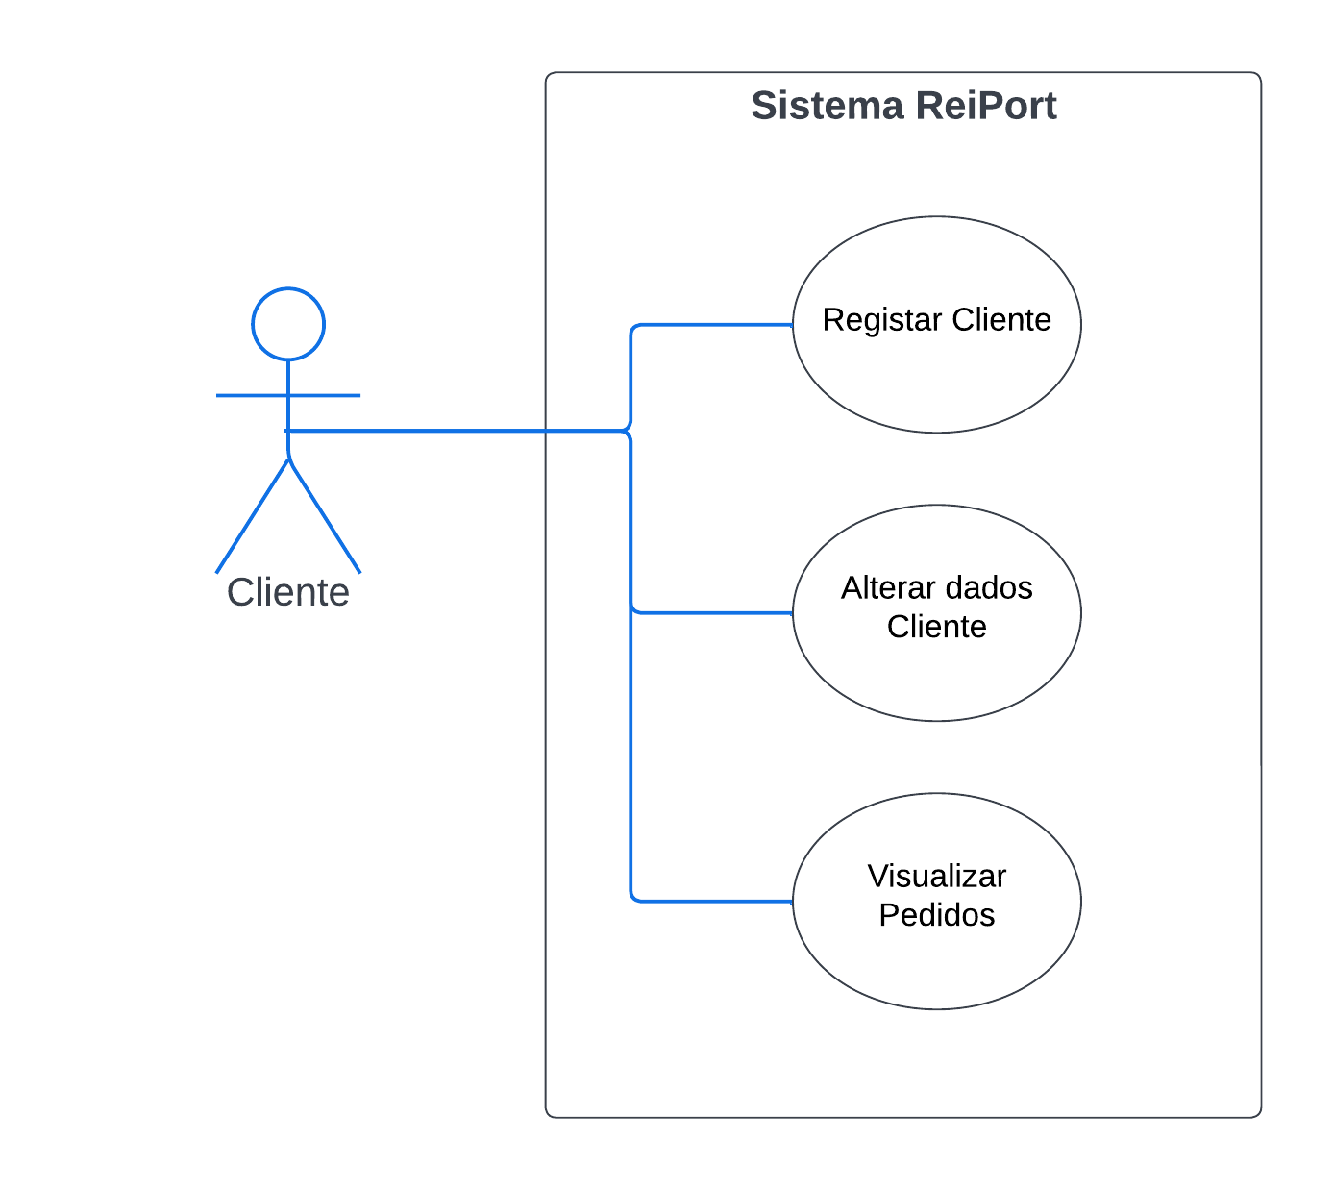

Figura 1 - Caso de Uso - Cliente

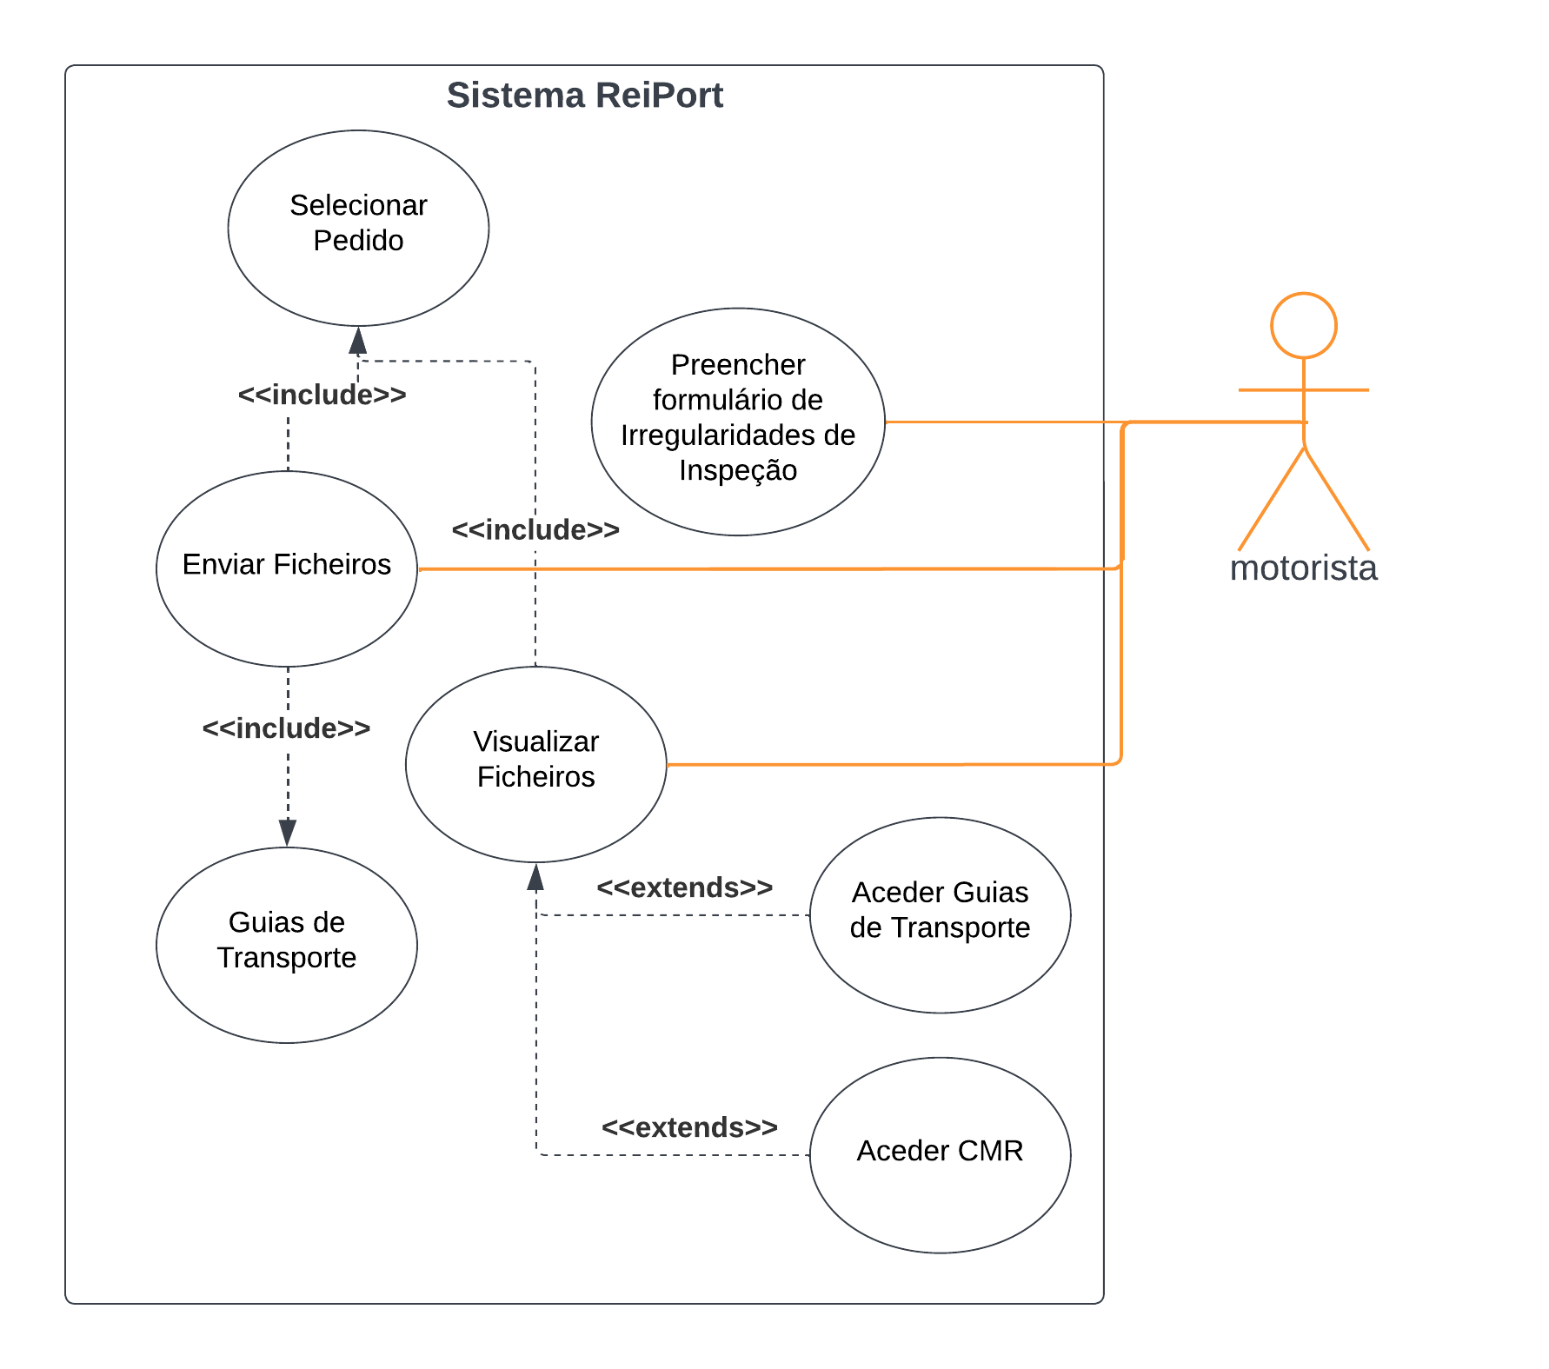

Figura 2 - Casos de Uso - Motorista

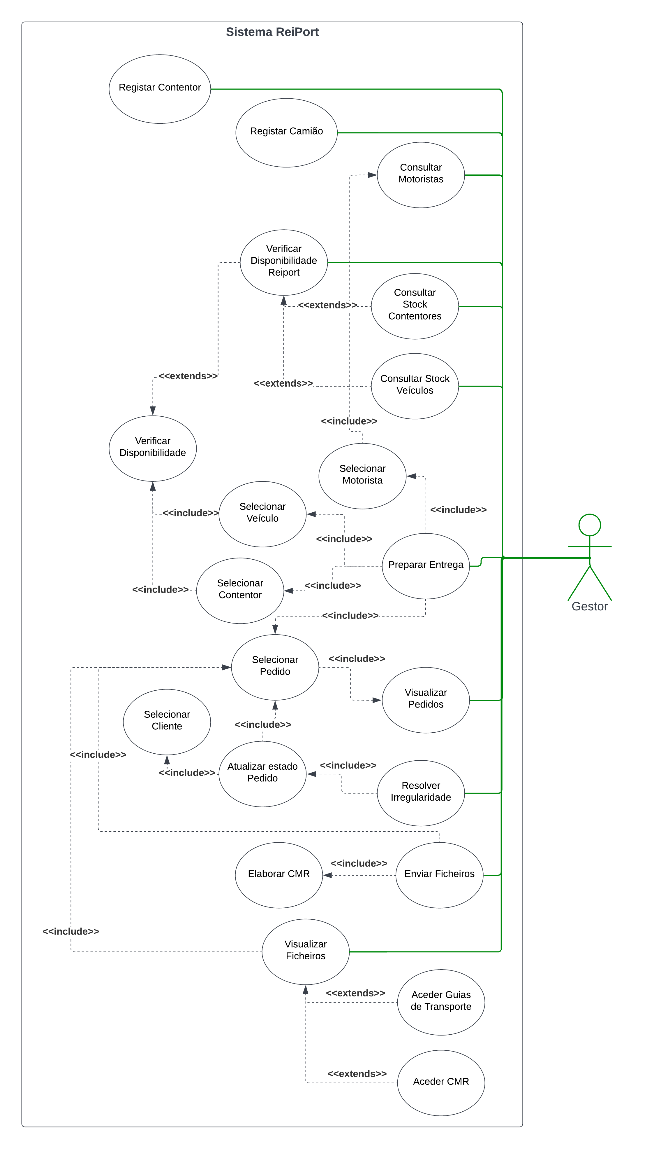

Figura 3 - Caso de Uso - Gestor

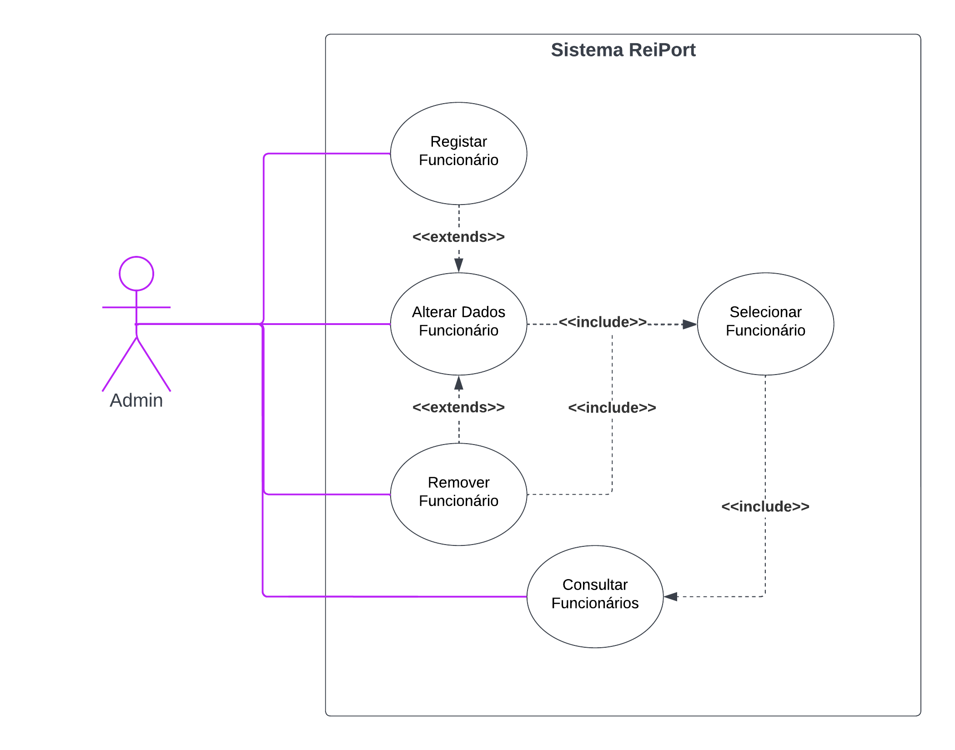

Figura 4 - Caso de Uso - Admin

Figura 5 - Caso de Uso - Rececionista

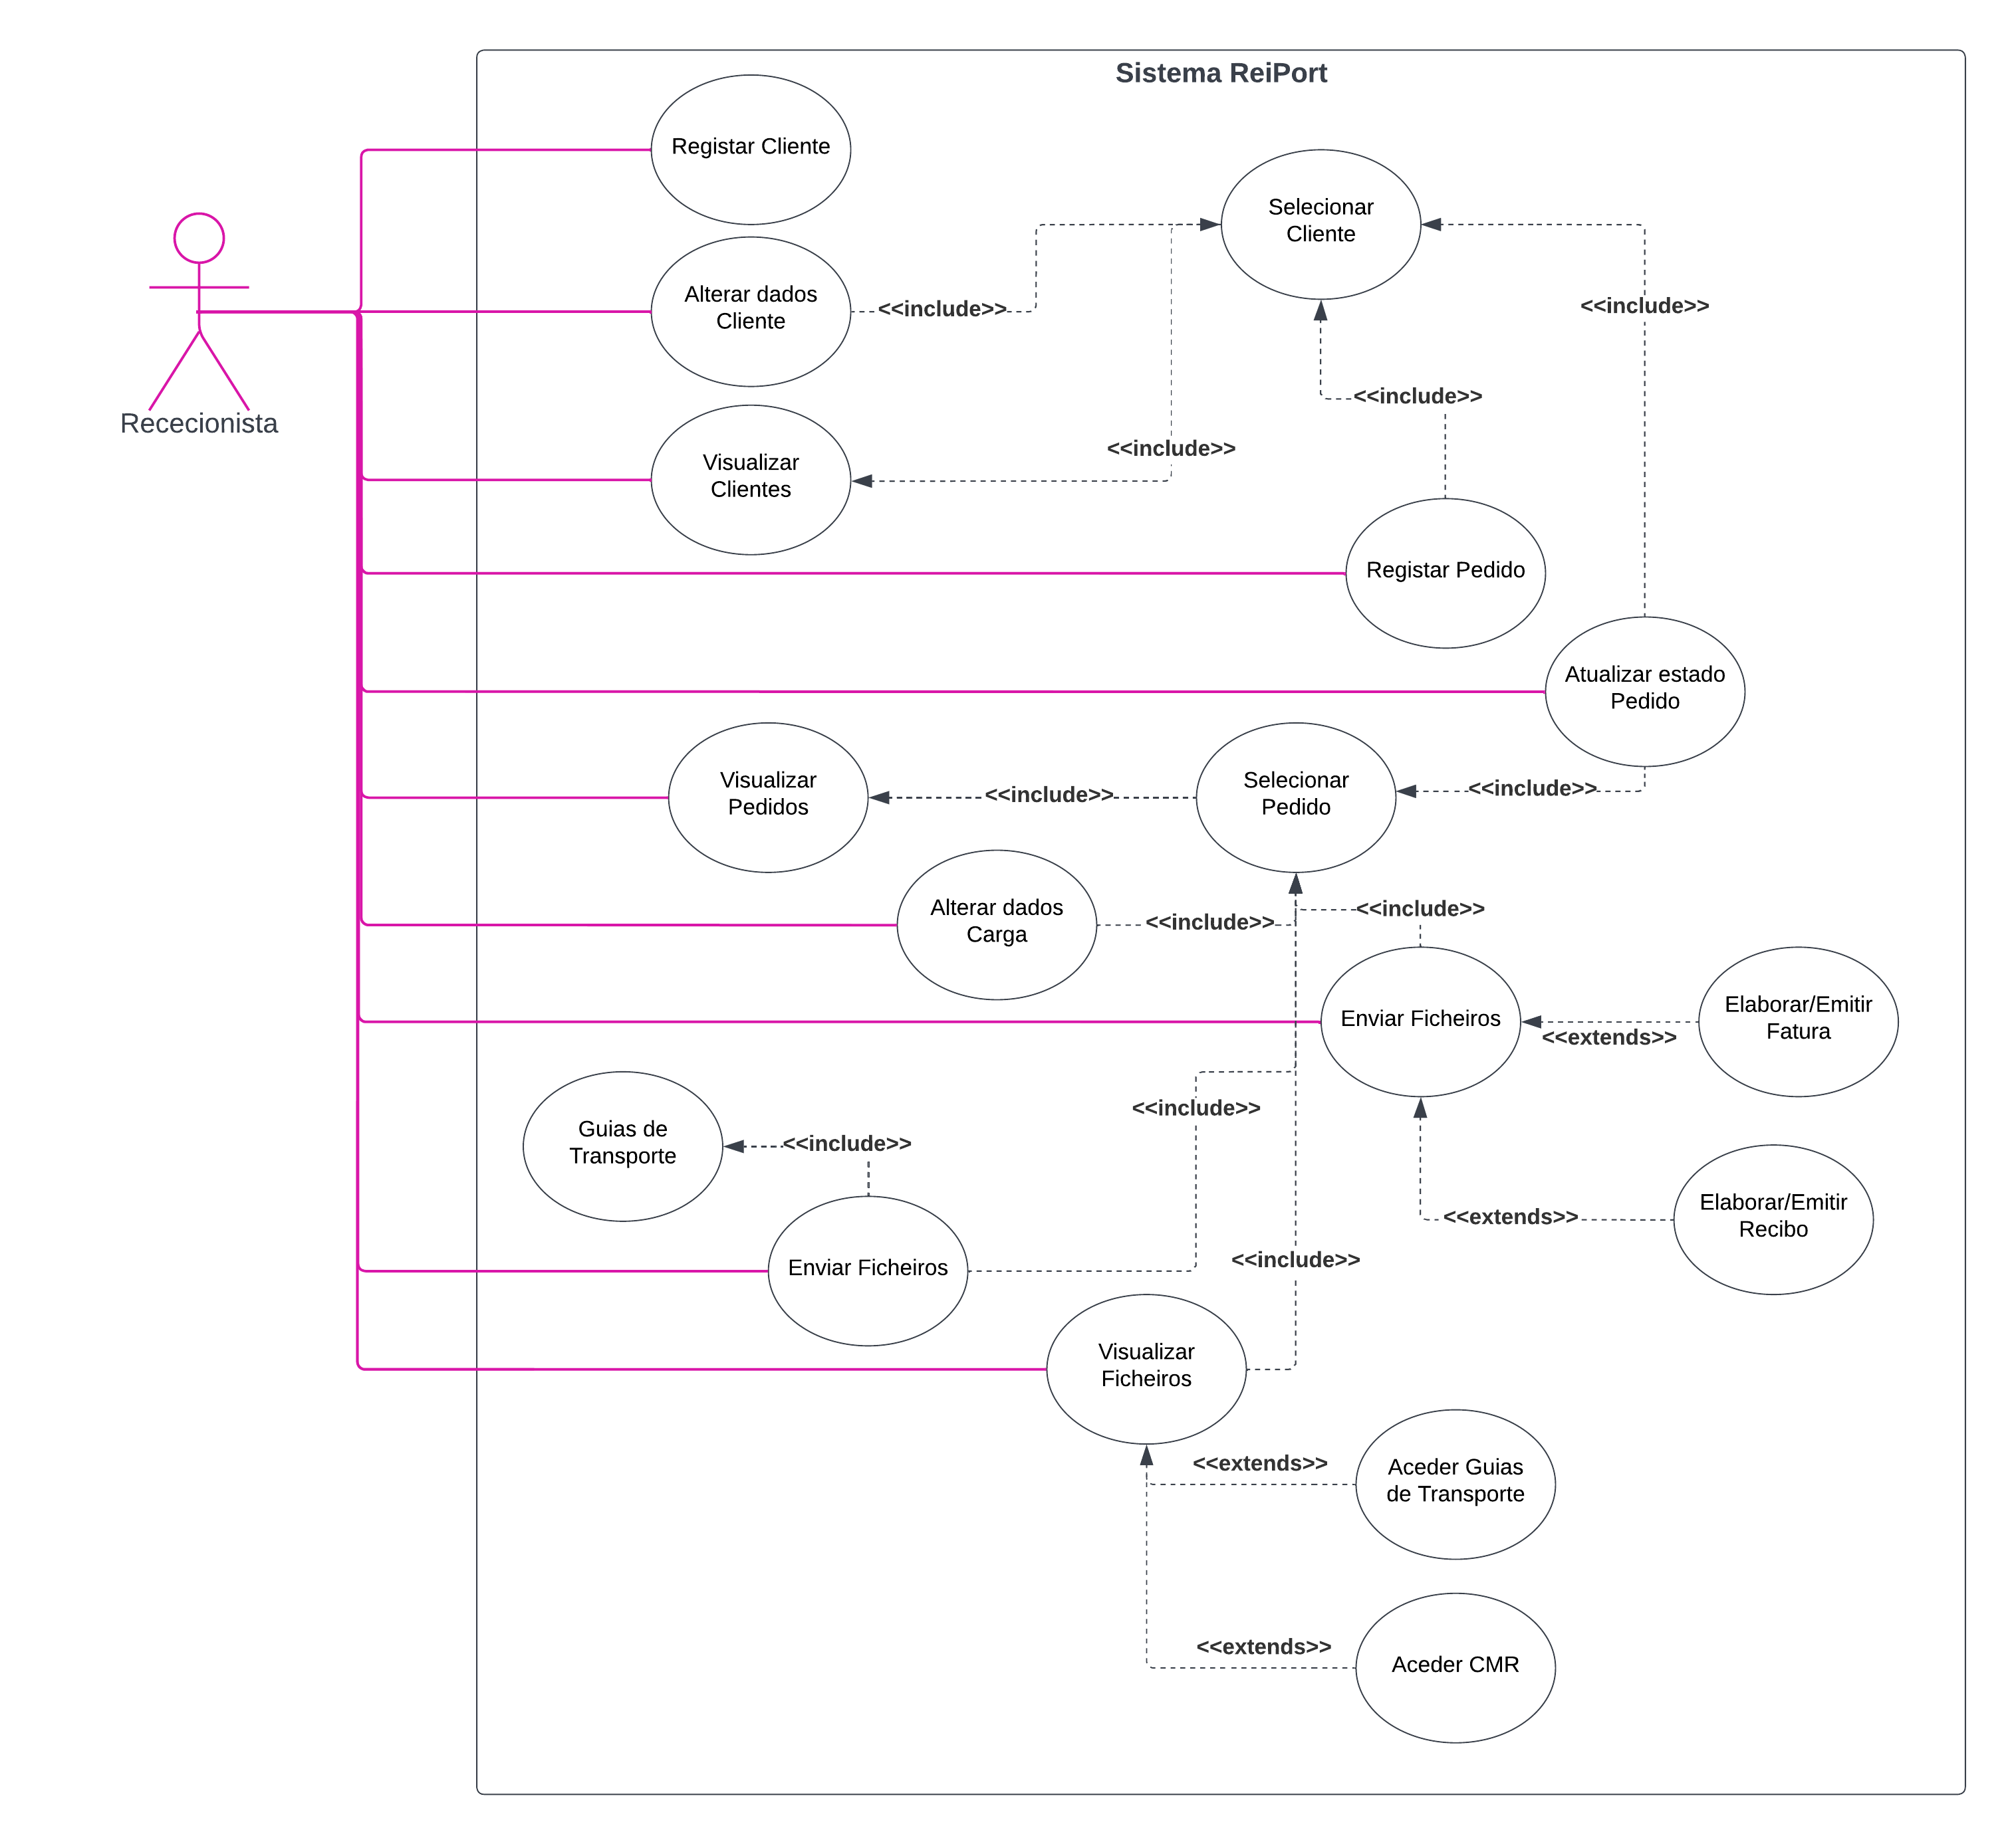

Templates dos Casos de Uso

Templates do Admin

|  |  |
| --- | --- |
| Uso Caso 1: | Registar Funcionário |
| Ator Principal: | Admin |
| Requisitos | RF33 |
| Pré-Requisitos: | Admin tem de estar registado no sistema |
| Pós-Requisitos: | É criado um funcionário no sistema |
| Cenário Principal: | 1. Admin insere nome, data de nascimento, NIF, morada e telefone 2. Sistema apresenta dados e pede confirmação para criar Utilizador 3. Admin confirma 4. Sistema gera email e password 5. Sistema cria Utilizador |
| Cenários Alternativos: | 1. Funcionário é Motorista 2. Admin insere nome, data de nascimento, NIF, morada e telefone, número de cartão de cidadão, ADR e CAM 3. Funcionário é Motorista e não tem CAM 4. Admin define campo CAM como Falso 5. Funcionário é Motorista e não tem ADR 6. Admin define campo ADR como Falso |
| Exceções: | 1. NIF inválido |

|  |  |
| --- | --- |
| Uso Caso 2: | Alterar Dados Funcionário |
| Ator Principal: | Admin |
| Requisitos | RF33 |
| Pré-Requisitos: | Admin tem de estar registado no sistema |
| Pós-Requisitos: | Os dados do funcionário são alterados no sistema |
| Cenário Principal: | 1. Admin pesquisa Funcionários 2. Sistema lista Funcionários por filtros definidos 3. Admin seleciona Funcionário 4. Admin altera os campos pretendidos 5. Sistema apresenta dados e pede confirmação para Alterar Dados de Funcionário 6. Admin confirma |
| Cenários Alternativos: |  |
| Exceções: | 1. Funcionário não existe 2. Dados por preencher 3. Dados inadmissíveis em campos |

|  |  |
| --- | --- |
| Uso Caso 3: | Remover Funcionário |
| Ator Principal: | Admin |
| Requisitos | RF33 |
| Pré-Requisitos: | Admin tem de estar registado no sistema |
| Pós-Requisitos: | Os dados do funcionário são removidos do sistema |
| Cenário Principal: | 1. Admin pesquisa funcionários 2. Sistema lista funcionários de acordo com filtros definidos 3. Admin seleciona Funcionário 4. Admin remove Funcionário 5. Sistema apresenta funcionário e pede confirmação para Remover 6. Admin confirma ação 7. Sistema remove Funcionário |
| Cenários Alternativos: |  |
| Exceções: | 1. Funcionário não existe |

|  |  |
| --- | --- |
| Uso Caso 4: | Consultar Funcionários |
| Ator Principal: | Admin |
| Requisitos | RF33 |
| Pré-Requisitos: | Admin tem de estar autenticado |
| Pós-Requisitos: | Os funcionários são apresentados pelo sistema |
| Cenário Principal: | 1. Admin pesquisa funcionários 2. Sistema apresenta funcionários por filtros definidos |
| Cenários Alternativos: |  |
| Exceções: |  |

Templates do Motorista

|  |  |
| --- | --- |
| Uso Caso 5: | Preencher Formulário de Irregularidades de Inspeção |
| Ator Principal: | Motorista |
| Requisitos | RF27 |
| Pré-Requisitos: | Motorista tem de estar autenticado |
| Pós-Requisitos: | É submetido um formulário de irregularidades preenchido no sistema |
| Cenário Principal: | 1. Motorista cria formulário de irregularidades 2. Motorista preenche formulário 3. Motorista submete 4. Sistema pede confirmação de submissão 5. Motorista confirma 6. Sistema armazena ficheiro |
| Cenários Alternativos: |  |
| Exceções: | 1. Ficheiro não enviado |

Templates do Motorista, Gestor e Rececionista

|  |  |
| --- | --- |
| Uso Caso 6: | Visualizar Ficheiros |
| Ator Principal: | Motorista, Gestor, Rececionista |
| Requisitos | RF09, RF12, RF23, RF25, RF26 |
| Pré-Requisitos: | Utilizador tem de estar autenticado no sistema |
| Pós-Requisitos: |  |
| Cenário Principal: | 1. Utilizador pesquisa Pedidos 2. Sistema lista Pedidos por filtros definidos 3. Utilizador seleciona Pedido 4. Utilizador acede aos ficheiros relativos ao Pedido 5. Sistema apresenta ficheiros disponíveis 6. Utilizador seleciona ficheiro pretendido 7. Sistema apresenta ficheiro |
| Cenários Alternativos: |  |
| Exceções: | 1. Pedido não existe 2. Ficheiro não existe |

Templates do Motorista e Rececionista

|  |  |
| --- | --- |
| Uso Caso 7: | Enviar Ficheiros |
| Ator Principal: | Motorista, Rececionista |
| Requisitos | RF08, RF28 |
| Pré-Requisitos: | Utilizador tem de estar autenticado |
| Pós-Requisitos: | Submete um ficheiro no sistema |
| Cenário Principal: | 1. Utilizador pesquisa Pedidos 2. Sistema lista Pedidos por filtros definidos 3. Utilizador seleciona Pedido 4. Utilizador adiciona ficheiro ao Pedido 5. Sistema adiciona ficheiro 6. Sistema altera estado do pedido |
| Cenários Alternativos: |  |
| Exceções: | 1. Pedido não existe 2. Ficheiro não compatível 3. Ficheiro não enviado |

Templates da Rececionista

|  |  |
| --- | --- |
| Uso Caso 8: | Alterar Dados Cliente |
| Ator Principal: | Rececionista |
| Requisitos | RF03 |
| Pré-Requisitos: | Rececionista tem de estar autenticado |
| Pós-Requisitos: | Os dados são alterados na conta do Cliente selecionada |
| Cenário Principal: | 1. Rececionista pesquisa Clientes 2. Sistema lista Clientes por filtros definidos 3. Rececionista seleciona Cliente 4. Rececionista seleciona o parâmetro que pretende alterar e altera um a um 5. Sistema apresenta dados e pede confirmação para alterar dados do Cliente 6. Rececionista confirma |
| Cenários Alternativos: |  |
| Exceções: | 1. Cliente não existe |

|  |  |
| --- | --- |
| Uso Caso 9: | Visualizar Clientes |
| Ator Principal: | Rececionista |
| Requisitos |  |
| Pré-Requisitos: | Rececionista tem de estar autenticado |
| Pós-Requisitos: |  |
| Cenário Principal: | 1. Rececionista pesquisa Clientes 2. Sistema apresenta Clientes por filtros definidos |
| Cenários Alternativos: |  |
| Exceções: |  |

|  |  |
| --- | --- |
| Uso Caso 10: | Registar Pedido |
| Ator Principal: | Rececionista |
| Requisitos | RF02 |
| Pré-Requisitos: | Rececionista tem de estar autenticado |
| Pós-Requisitos: | Um Pedido é criado para um Cliente |
| Cenário Principal: | 1. Rececionista pesquisa Clientes 2. Sistema lista Clientes por filtros definidos 3. Rececionista seleciona Cliente 4. Rececionista regista novo Pedido 5. Rececionista insere disponibilidade pelo Cliente de contentor e de veículo, peso da carga, data-limite, morada de origem de entrega e morada do destinatário no novo Pedido 6. Sistema apresenta dados e pede confirmação 7. Rececionista confirma |
| Cenários Alternativos: |  |
| Exceções: | 1. Cliente não existe |

|  |  |
| --- | --- |
| Uso Caso 11: | Visualizar Pedidos |
| Ator Principal: | Rececionista |
| Requisitos | RF04 |
| Pré-Requisitos: | Rececionista tem de estar autenticado |
| Pós-Requisitos: |  |
| Cenário Principal: | 1. Rececionista pesquisa Pedidos 2. Sistema apresenta Pedidos por filtros definidos |
| Cenários Alternativos: |  |
| Exceções: |  |

|  |  |
| --- | --- |
| Uso Caso 12: | Alterar Dados Pedido |
| Ator Principal: | Rececionista |
| Requisitos | RF03 |
| Pré-Requisitos: | Rececionista tem de estar autenticado |
| Pós-Requisitos: | Os dados do pedido selecionado do Cliente são alterados |
| Cenário Principal: | 1. Rececionista pesquisa Clientes 2. Sistema lista Clientes por filtros definidos 3. Rececionista seleciona Cliente 4. Rececionista pesquisa pedidos do Cliente 5. Sistema apresenta pedidos do Cliente 6. Rececionista seleciona pedido para efetuar alterações 7. Rececionista seleciona o parâmetro que pretende alterar e altera um a um 8. Sistema apresenta dados e pede confirmação 9. Rececionista confirma |
| Cenários Alternativos: |  |
| Exceções: | 1. Cliente não existe 2. Pedido não existe |

|  |  |
| --- | --- |
| Uso Caso 13: | Atualizar Estado do Pedido |
| Ator Principal: | Rececionista |
| Requisitos | RF06 |
| Pré-Requisitos: | Rececionista tem de estar autenticado |
| Pós-Requisitos: | É alterado o estado de um Pedido associado a um Cliente |
| Cenário Principal: | 1. Rececionista pesquisa Clientes 2. Sistema lista Cliente por filtros definidos 3. Rececionista seleciona Cliente 4. Rececionista pesquisa pedidos do Cliente 5. Sistema apresenta pedidos do Cliente 6. Rececionista seleciona pedido para efetuar alterações 7. Rececionista atualiza estado 8. Sistema apresenta dados e pede confirmação 9. Rececionista confirma |
| Cenários Alternativos: |  |
| Exceções: | 1. Cliente não existe 2. Pedido não existe |

|  |  |
| --- | --- |
| Uso Caso 14: | Enviar Ficheiros |
| Ator Principal: | Rececionista |
| Requisitos | RF08, RF10, RF11 |
| Pré-Requisitos: | Rececionista tem de estar autenticado |
| Pós-Requisitos: | Submete um ficheiro no sistema |
| Cenário Principal: | 1. Rececionista pesquisa Pedidos 2. Sistema lista Pedidos por filtros definidos 3. Rececionista seleciona Pedido 4. Rececionista Elabora Fatura/Recibo 5. Rececionista submete ficheiro 6. Sistema pede confirmação 7. Rececionista confirma 8. Sistema envia ficheiro |
| Cenários Alternativos: |  |
| Exceções: | 1. Pedido não existe 2. Ficheiro não compatível 3. Ficheiro não enviado |

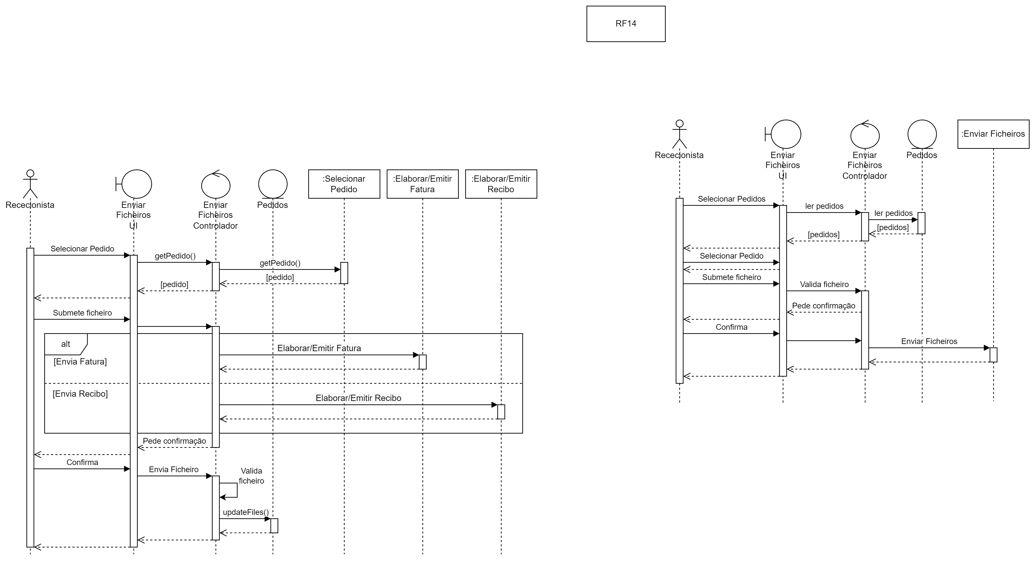

Templates da Rececionista e Cliente

|  |  |
| --- | --- |
| Uso Caso 15: | Registar Cliente |
| Ator Principal: | Rececionista, Cliente |
| Requisitos | RF01, RF29 |
| Pré-Requisitos: | Utilizador tem de estar autenticado |
| Pós-Requisitos: | Uma conta de Cliente é criada no sistema |
| Cenário Principal: | 1. Utilizador insere nome próprio, apelido, data de nascimento, NIF, morada, email, password e telefone 2. Sistema apresenta dados e pede confirmação para criar Cliente 3. Utilizador confirma 4. Sistema regista Cliente |
| Cenários Alternativos: |  |
| Exceções: | 1. NIF inválido |

Templates do Cliente

|  |  |
| --- | --- |
| Uso Caso 16: | Visualizar Pedidos |
| Ator Principal: | Cliente |
| Requisitos | RF30 |
| Pré-Requisitos: | Cliente tem de estar autenticado |
| Pós-Requisitos: |  |
| Cenário Principal: | 1. Cliente pesquisa Pedidos 2. Sistema apresenta Pedidos |
| Cenários Alternativos: |  |
| Exceções: |  |

|  |  |
| --- | --- |
| Uso Caso 17: | Alterar Dados Cliente |
| Ator Principal: | Cliente |
| Requisitos | RF31 |
| Pré-Requisitos: | Cliente tem de estar autenticado |
| Pós-Requisitos: | Os dados são alterados na conta do Cliente |
| Cenário Principal: | 1. Cliente seleciona e editar perfil 2. Cliente seleciona o parâmetro que pretende alterar e altera um a um 3. Sistema apresenta dados e pede confirmação para alterar dados do Cliente 4. Cliente confirma 5. Sistema atualiza os dados do Cliente |
| Cenários Alternativos: |  |
| Exceções: | 1. NIF inválido |

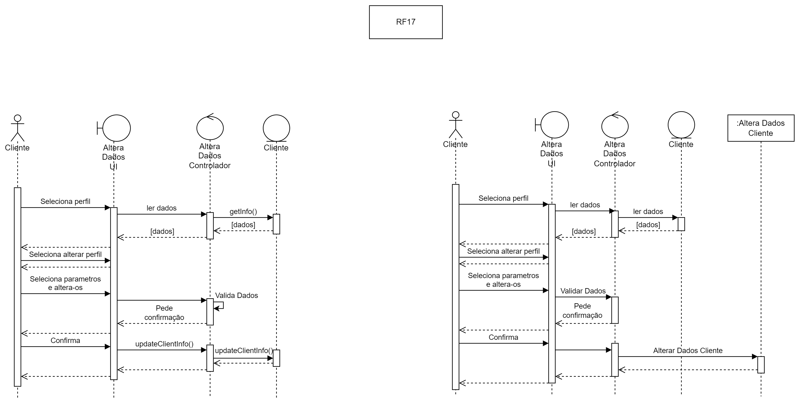

Templates do Gestor

|  |  |
| --- | --- |
| Uso Caso 18: | Registar Contentor |
| Ator Principal: | Gestor |
| Requisitos | RF32 |
| Pré-Requisitos: | Gestor tem de estar autenticado |
| Pós-Requisitos: | Um contentor é registado no sistema |
| Cenário Principal: | 1. Gestor insere largura, comprimento, profundidade, cor, peso máximo suportado, marca, modelo e matrícula 2. Sistema apresenta dados e pede confirmação para criar Contentor 3. Gestor confirma 4. Sistema regista contentor |
| Cenários Alternativos: |  |
| Exceções: | 1. Matrícula inválida |

|  |  |
| --- | --- |
| Uso Caso 19: | Registar Camião |
| Ator Principal: | Gestor |
| Requisitos | RF32 |
| Pré-Requisitos: | Gestor tem de estar autenticado |
| Pós-Requisitos: | Um camião é registado no sistema |
| Cenário Principal: | 1. Gestor insere potência, cilindrada, tanque, cor, peso máximo suportado, marca, modelo e matrícula 2. Sistema apresenta dados e pede confirmação para criar Camião 3. Gestor confirma 4. Sistema regista camião |
| Cenários Alternativos: |  |
| Exceções: | 1. Matrícula inválida |

|  |  |
| --- | --- |
| Uso Caso 20: | Consultar Stock Contentores |
| Ator Principal: | Gestor |
| Requisitos | RF14, RF19 |
| Pré-Requisitos: | Gestor tem de estar autenticado |
| Pós-Requisitos: |  |
| Cenário Principal: | 1. Gestor pesquisa Contentores 2. Sistema apresenta Contentores |
| Cenários Alternativos: |  |
| Exceções: |  |

|  |  |
| --- | --- |
| Uso Caso 21: | Consultar Stock Camiões |
| Ator Principal: | Gestor |
| Requisitos | RF14, RF18 |
| Pré-Requisitos: | Gestor tem de estar autenticado |
| Pós-Requisitos: |  |
| Cenário Principal: | 1. Gestor pesquisa Camiões 2. Sistema apresenta Camiões |
| Cenários Alternativos: |  |
| Exceções: |  |

|  |  |
| --- | --- |
| Uso Caso 22: | Consultar Motoristas |
| Ator Principal: | Gestor |
| Requisitos | RF15, RF20, RF21 |
| Pré-Requisitos: | Gestor tem de estar autenticado |
| Pós-Requisitos: |  |
| Cenário Principal: | 1. Gestor pesquisa Motoristas 2. Sistema apresenta Motoristas |
| Cenários Alternativos: |  |
| Exceções: |  |

|  |  |
| --- | --- |
| Uso Caso 23: | Verificar Disponibilidade Reiport |
| Ator Principal: | Gestor |
| Requisitos | RF17, RF18, RF19 |
| Pré-Requisitos: | Gestor tem de estar autenticado |
| Pós-Requisitos: |  |
| Cenário Principal: | 1. Gestor pesquisa Stock Reiport 2. Gestor seleciona Camião 3. Sistema apresenta Stock de Camiões Reiport 4. Gestor verifica se camião se encontra disponível para a entrega do pedido |
| Cenários Alternativos: | 1. Selecionar Contentor 2. Sistema apresenta Stock de Contentores Reiport 3. Gestor verifica se contentor se encontra disponível para a entrega do pedido |
| Exceções: | 1. Contentor ou Camião com estas especificações não existe 2. Contentor ou Camião com estas especificações está a ser utilizado |

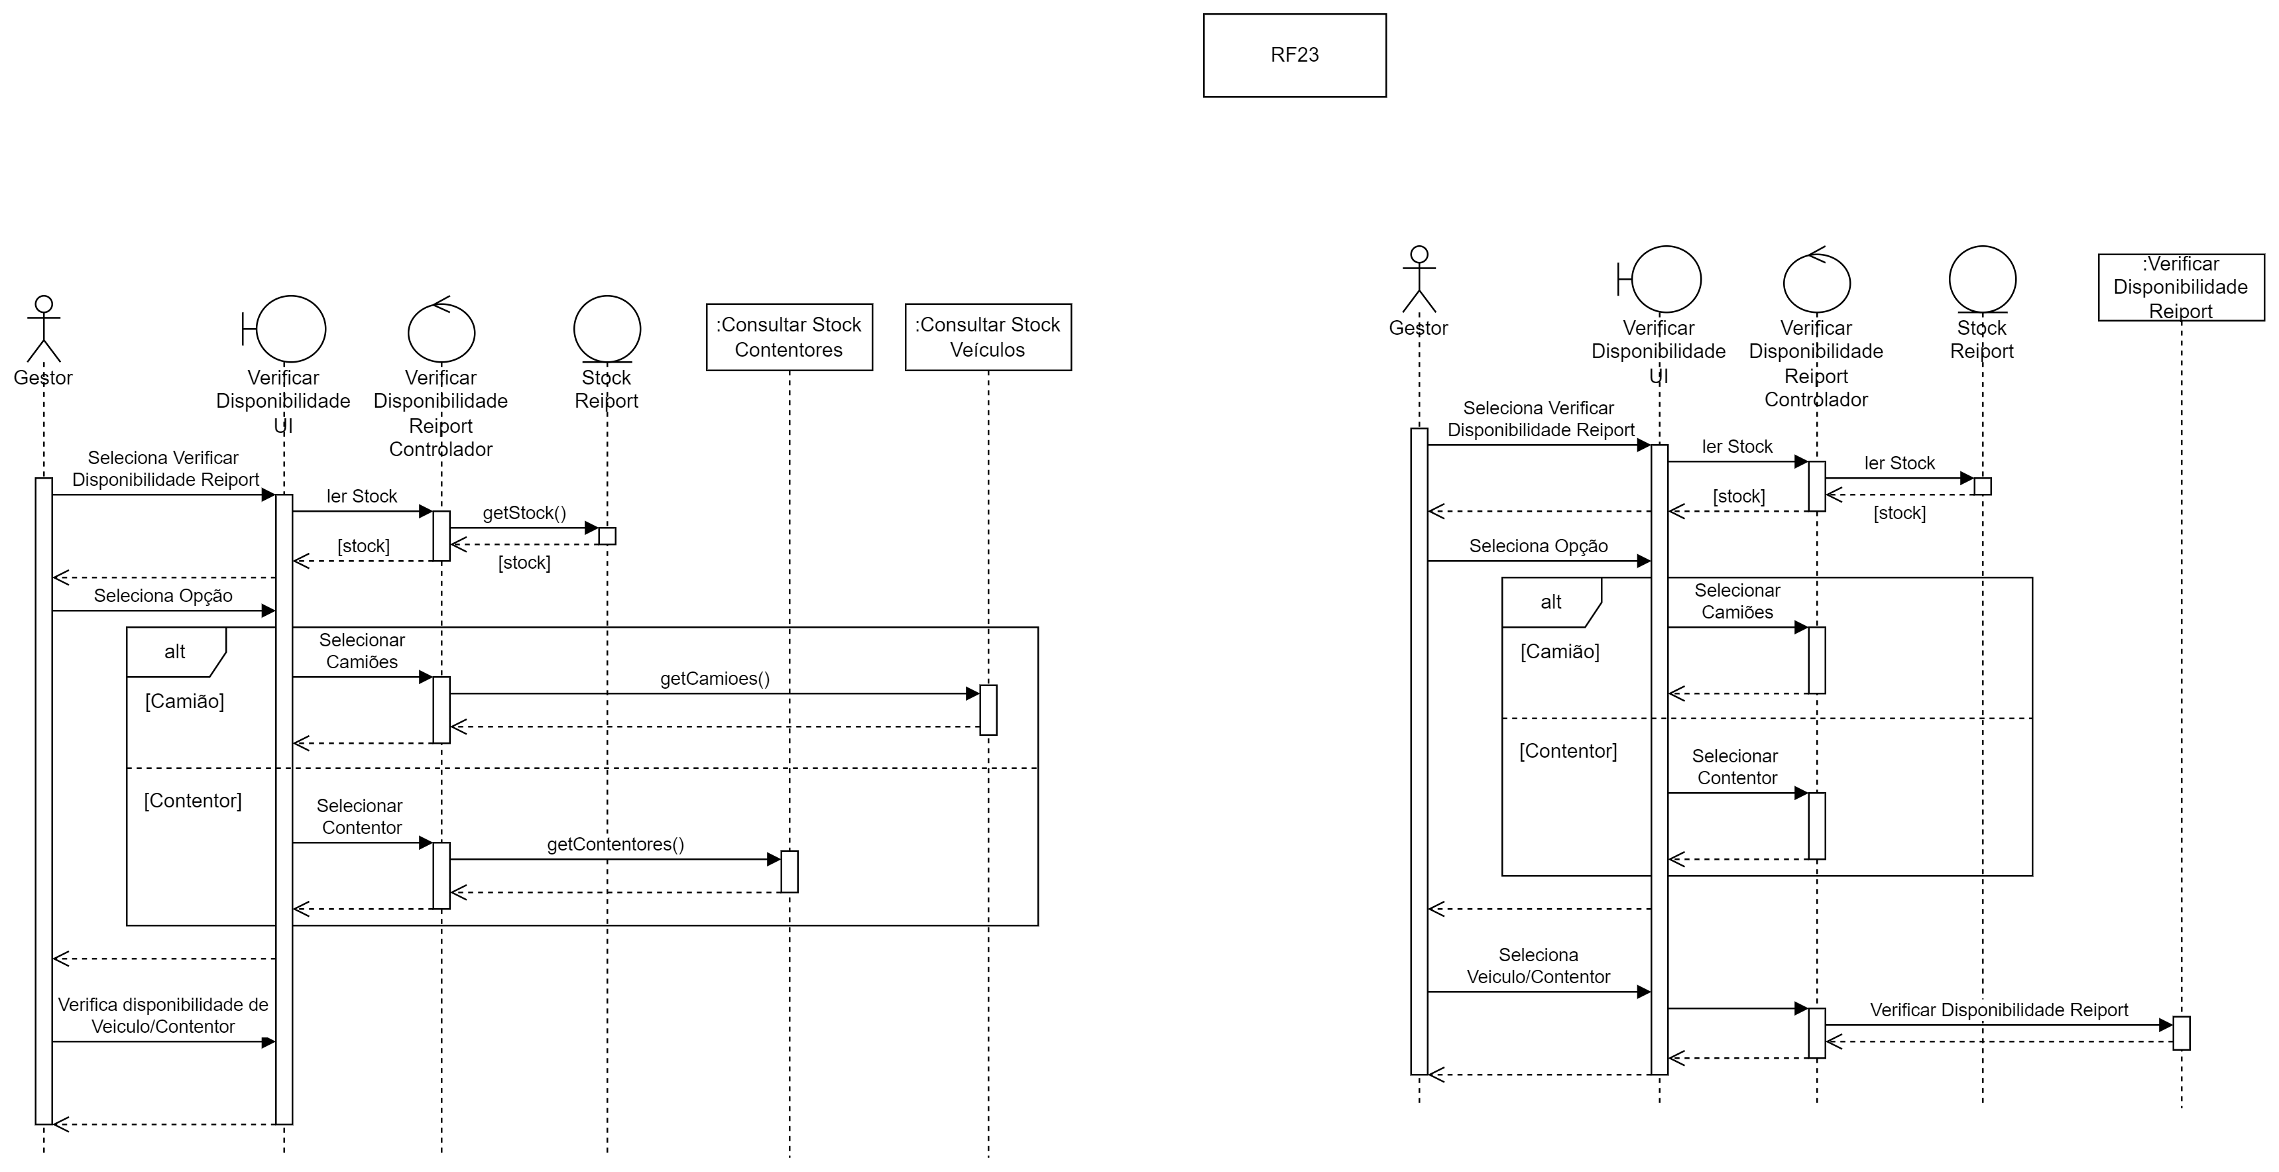

|  |  |
| --- | --- |
| Uso Caso 24: | Visualizar Pedidos |
| Ator Principal: | Gestor |
| Requisitos | RF13 |
| Pré-Requisitos: | Gestor tem de estar autenticado |
| Pós-Requisitos: |  |
| Cenário Principal: | 1. Gestor pesquisa Pedidos 2. Sistema apresenta Pedidos |
| Cenários Alternativos: |  |
| Exceções: |  |

|  |  |
| --- | --- |
| Uso Caso 25: | Resolver Irregularidades |
| Ator Principal: | Gestor |
| Requisitos | RF24 |
| Pré-Requisitos: | Gestor tem de estar autenticado |
| Pós-Requisitos: |  |
| Cenário Principal: | 1. Gestor pesquisa Pedidos 2. Sistema lista Pedidos por filtros definidos 3. Gestor seleciona Pedido 4. Gestor resolve problema 5. Gestor altera estado do pedido |
| Cenários Alternativos: |  |
| Exceções: | 1. Pedido não existe |

|  |  |
| --- | --- |
| Uso Caso 26: | Preparar Pedido |
| Ator Principal: | Gestor |
| Requisitos | RF13, RF15, RF16, RF17, RF18, RF19, RF20, RF21, RF22, RF25 |
| Pré-Requisitos: | Gestor tem de estar autenticado |
| Pós-Requisitos: | Pedido é preparado |
| Cenário Principal: | 1. Gestor pesquisa Pedidos 2. Sistema lista Pedidos 3. Gestor seleciona Pedido 4. Gestor verifica disponibilidade de camião pelo Cliente 5. Gestor inicia “Registar Camião” 6. Gestor verifica disponibilidade de contentor ou contentores pelo Cliente 7. Gestor inicia “Registar Contentor” 8. Gestor pesquisa motoristas com habilitações necessárias 9. Gestor verifica tempo estimado da viagem 10. Gestor marca uma data de início de entrega 11. Gestor pesquisa e seleciona 1 motorista com disponibilidade 12. Atribui preço à entrega 13. Sistema apresenta dados para confirmação 14. Gestor confirma 15. Gestor inicia “Enviar Ficheiro” |
| Cenários Alternativos: | 1. Camião do Cliente não existe 2. Gestor verifica especificações de camião necessário 3. Gestor inicia “Verificar Disponibilidade Reiport” 4. Gestor seleciona camião da Empresa 5. Contentor do Cliente não existe 6. Gestor verifica especificações de contentor necessário 7. Gestor inicia “Verificar Disponibilidade Reiport” 8. Gestor seleciona contentor da Empresa 9. Cliente disponibiliza um de dois contentores necessário 10. Gestor verifica especificações de contentor necessário 11. Gestor inicia “Verificar Disponibilidade Reiport” 12. Gestor seleciona contentor do Stock da Reiport 13. Cliente necessita de dois contentores 14. Gestor verifica especificações de contentores necessários 15. Gestor inicia “Verificar Disponibilidade Reiport” 16. Gestor seleciona contentores do Stock Reiport 17. Tempo Viagem maior que 9 horas 18. Gestor seleciona 2 motoristas |
| Exceções: | 1. Não existe Pedido 2. Não existe Camião, quer Cliente quer de Stock Reiport 3. Não existe Contentor, quer Cliente quer de Stock Reiport 4. Não existe Motorista |

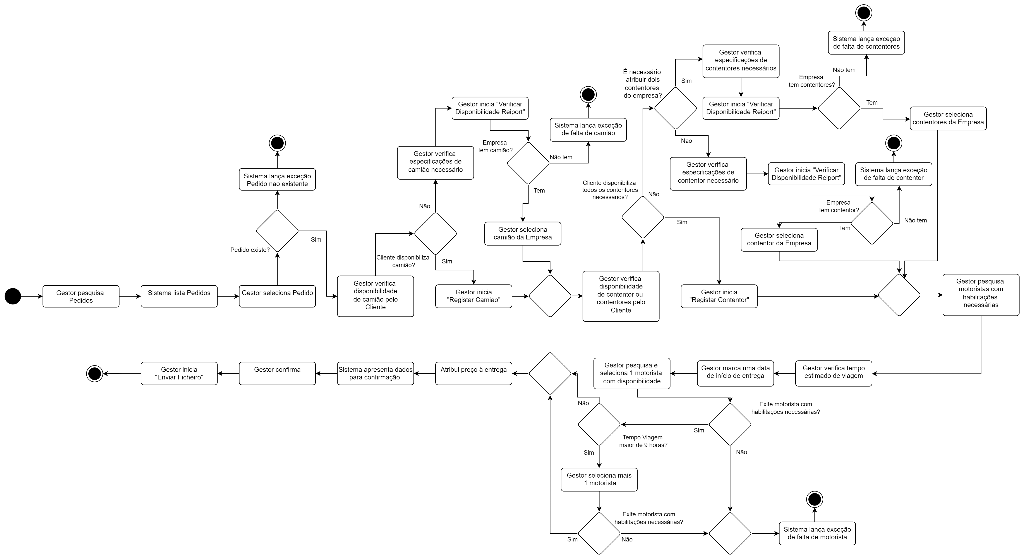

Figura 6 - Diagrama de Atividades do RF26

|  |  |
| --- | --- |
| Uso Caso 27: | Enviar Ficheiros |
| Ator Principal: | Gestor |
| Requisitos | RF23 |
| Pré-Requisitos: | Gestor tem de estar autenticado |
| Pós-Requisitos: |  |
| Cenário Principal: | 1. Gestor pesquisa Pedidos 2. Sistema lista Pedidos 3. Gestor seleciona Pedido 4. Gestor Elabora CMR 5. Gestor submete ficheiro 6. Sistema pede confirmação 7. Gestor confirma |
| Cenários Alternativos: |  |
| Exceções: | 1. Ficheiro não compatível 2. Ficheiro não enviado |

## - Modelação de dados

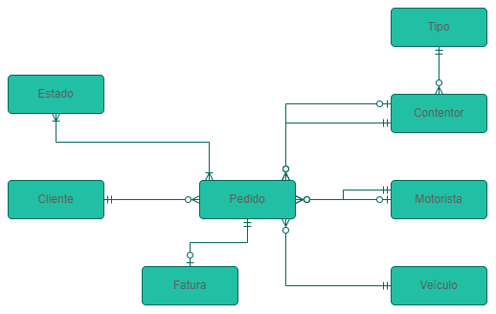

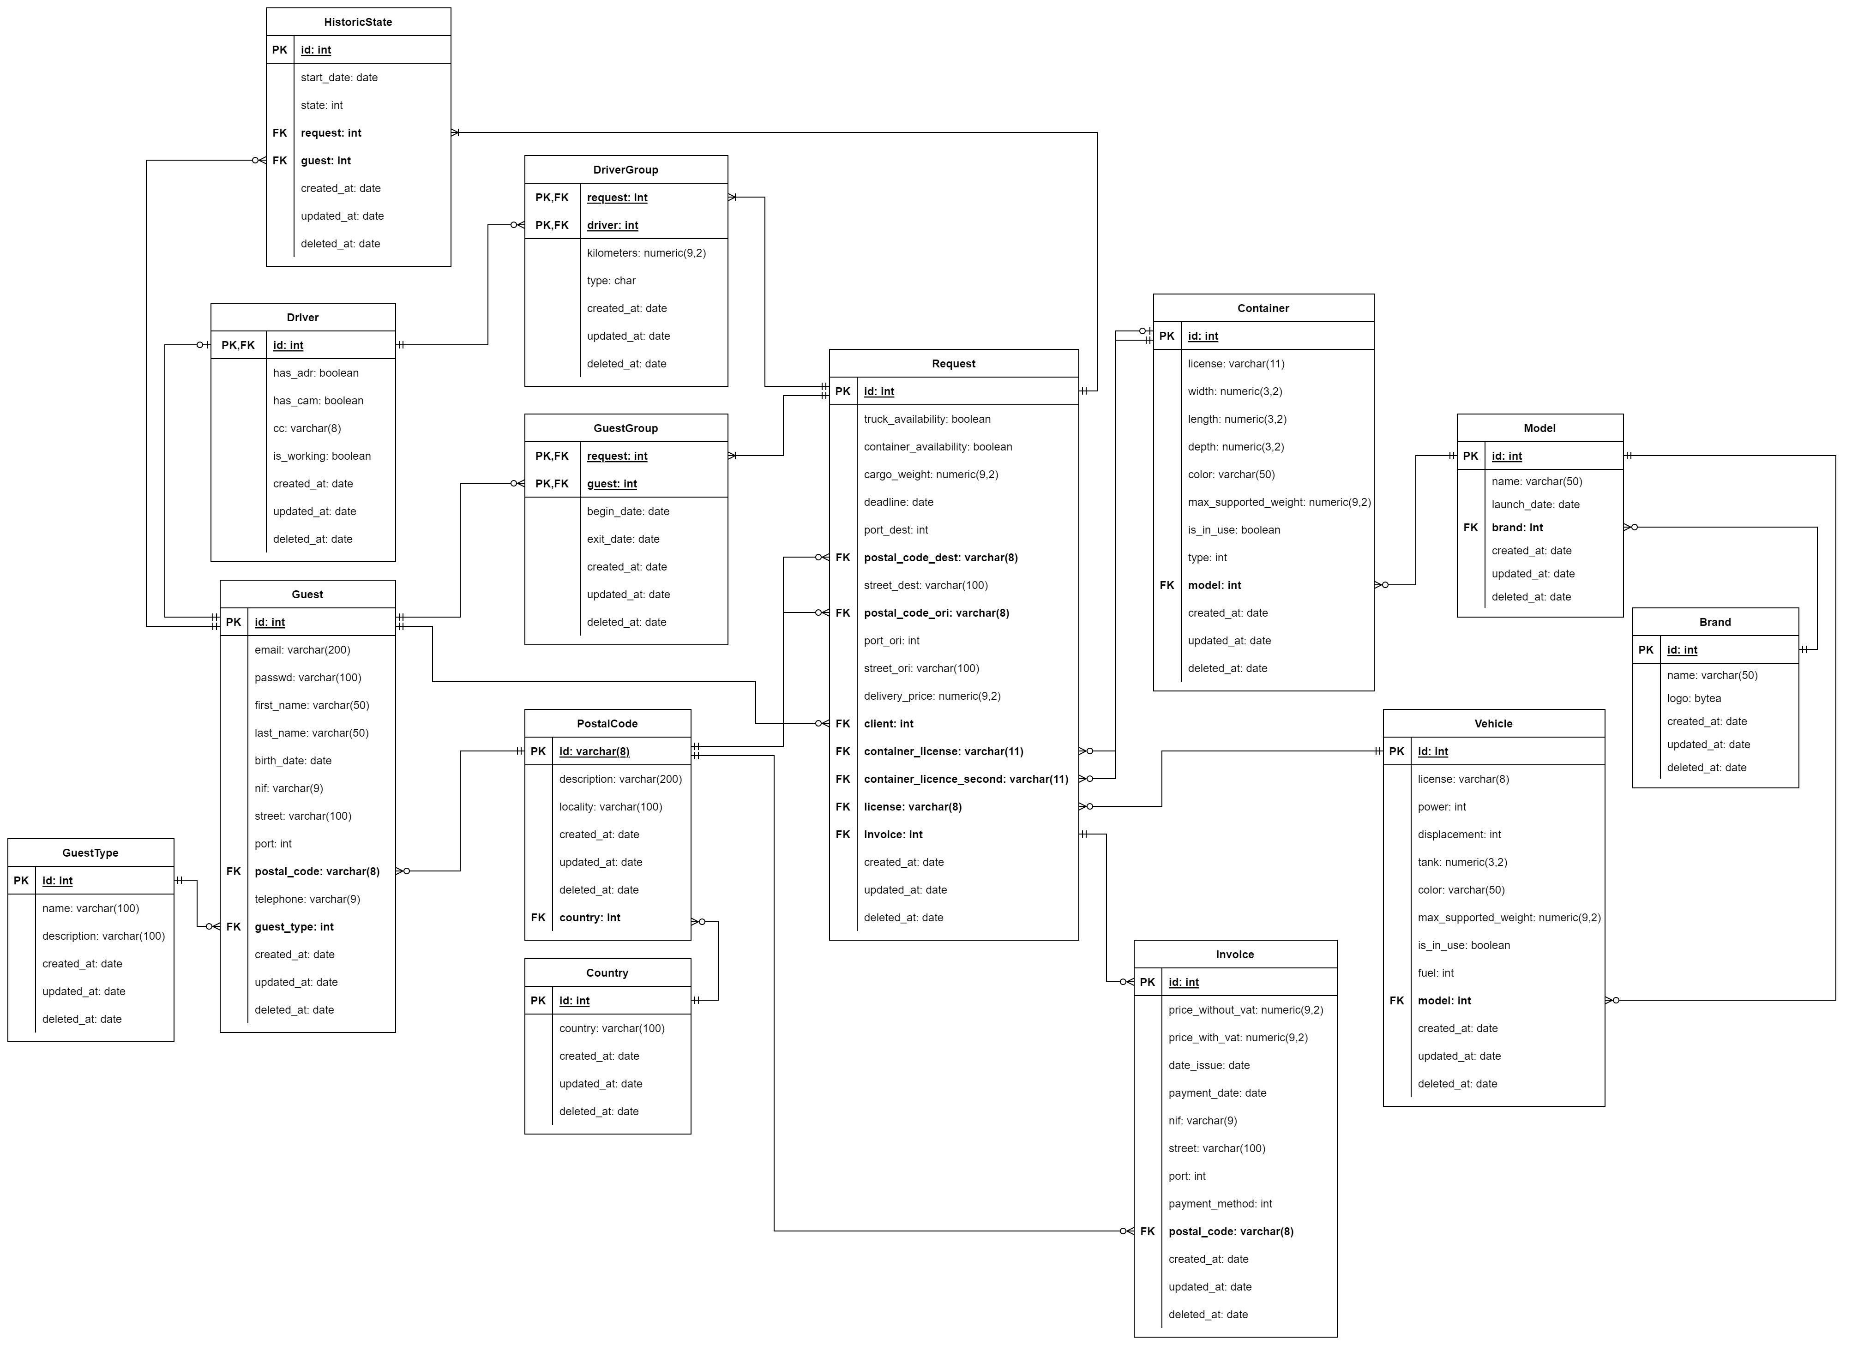

Figura 7 - DIAGRAMA DE ENTIDADES E RELACIONAMENTOS (DER) (1ª ABORDAGEM)

Figura 8 - MODELO RELACIONAL

## - Modelo de classes

Figura 9 - MODELO DE CLASSES

## - Diagrama de transição de estados do Pedido

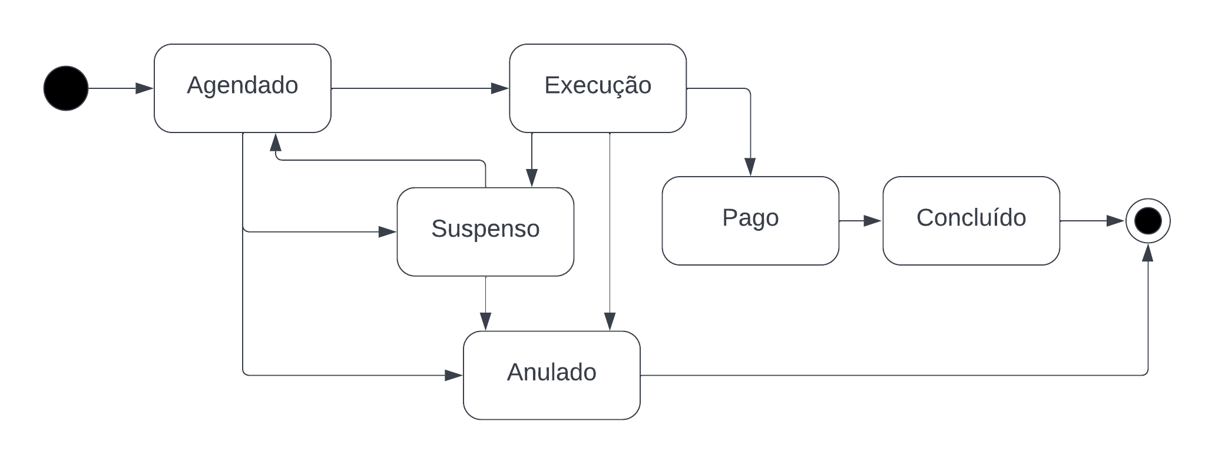

Figura 11 - DIAGRAMA DE TRANSIÇÃO DE ESTADOS

# Implementação da BD

## - Criação das tabelas

CREATE TABLE Country(

id SERIAL NOT NULL,

country VARCHAR(100) NOT NULL UNIQUE,

created_at DATE DEFAULT now(),

updated_at DATE DEFAULT NULL,

deleted_at DATE DEFAULT NULL,

PRIMARY KEY (id)

);

CREATE TABLE PostalCode(

id VARCHAR(8) NOT NULL,

description VARCHAR(200) DEFAULT NULL,

locality VARCHAR(100) NOT NULL,

country INT NOT NULL,

created_at DATE DEFAULT now(),

updated_at DATE DEFAULT NULL,

deleted_at DATE DEFAULT NULL,

PRIMARY KEY (id),

CONSTRAINT country_fk1

FOREIGN KEY (country)

REFERENCES Country (id)

);

CREATE TABLE GuestType(

id SERIAL NOT NULL,

name VARCHAR(100) NOT NULL UNIQUE,

description VARCHAR(100) DEFAULT NULL,

created_at DATE DEFAULT now(),

updated_at DATE DEFAULT NULL,

deleted_at DATE DEFAULT NULL,

PRIMARY KEY (id)

);

Pode ser visualizada a criação das restantes tabelas no anexo 1

## - Gestão dos dados na base de dados

### - Inserção de dados

insert into Country (country) values ('Russia');

insert into Country (country) values ('Philippines');

insert into Country (country) values ('Japan');

insert into Country (country) values ('Morocco');

insert into Country (country) values ('China');

insert into Country (country) values ('Indonesia');

insert into Country (country) values ('Argentina');

insert into Country (country) values ('Madagascar');

insert into Country (country) values ('France');

insert into Country (country) values ('Greece');

insert into Country (country) values ('Peru');

insert into Country (country) values ('United States');

insert into Country (country) values ('Poland');

insert into Country (country) values ('Palestinian Territory');

insert into Country (country) values ('South Korea');

insert into Country (country) values ('Albania');

insert into Country (country) values ('Portugal');

insert into Country (country) values ('Sweden');

insert into Country (country) values ('Ethiopia');

insert into Country (country) values ('Finland');

insert into Country (country) values ('Serbia');

insert into Country (country) values ('Belarus');

insert into Country (country) values ('Canada');

insert into Country (country) values ('Lithuania');

insert into Country (country) values ('Vietnam');

insert into Country (country) values ('Malaysia');

insert into Country (country) values ('Chile');

insert into Country (country) values ('Colombia');

insert into Country (country) values ('Bulgaria');

insert into Country (country) values ('Croatia');

insert into Country (country) values ('Brazil');

insert into Country (country) values ('Venezuela');

insert into Country (country) values ('Tanzania');

insert into Country (country) values ('North Korea');

insert into Country (country) values ('Moldova');

insert into Country (country) values ('Czech Republic');

Podem ser visualizadas as restantes inserções de dados no anexo 2

### – Views

**View com o objetivo de apresentar toda a informação relevante dos pedidos:**

create view requestInfo

as select

r.id as request_id,

r.truck_availability,

r.container_availability,

r.cargo_weight,

r.deadline,

r.delivery_price,

r.port_dest,

r.street_dest,

postal_dest.id as postal_code_dest,

postal_dest.locality as locality_dest,

country_dest.country as country_dest,

r.port_ori,

r.street_ori,

postal_ori.id as postal_code_ori,

postal_ori.locality as locality_ori,

countryOri.country as country_ori,

container_first.license as container_first,

container_second.license as container_second,

truck.license as truck_license,

guest.first_name as client,

inv.price_with_vat,

inv.date_issue,

inv.payment_date

from request r

inner join PostalCode postal_dest

on r.postal_code_dest = postal_dest.id

inner join country as country_dest

on country_dest.id = postal_dest.country

inner join PostalCode postal_ori

on r.postal_code_ori = postal_ori.id

inner join country as countryOri

on countryOri.id = postal_ori.country

inner join container container_first

on container_first.license = r.container_license

left join container container_second

on container_second.license = r.container_license_second

inner join vehicle truck

on truck.license = r.license

inner join invoice inv

on inv.id = r.invoice

inner join guest guest

on guest.id = r.client

inner join guestType guest_type

on guest_type.id = guest.guest_type

where guest_type.name = 'Cliente'

;

**View com o objetivo de apresentar todos os motoristas de todos os pedidos:**

create view requestDriver

as select

ri.request_id,

guest.first_name || ' ' || guest.last_name as driver_full_name,

d.has_adr as adr,

d.has_cam as cam,

d.cc as cc,

d.is_working,

case

when dg.type = 'p' then 'Principal'

when dg.type = 'c' then 'Co-Piloto'

end as type,

dg.kilometers

from requestInfo ri

inner join DriverGroup dg

on ri.request_id = dg.request

inner join driver d

on d.id = dg.driver

inner join guest guest

on guest.id = d.id

;

### - Triggers

**Trigger com o objetivo de atribuir um tipo aos motoristas de um pedido:**

create or replace function log_change_driver_type()

returns trigger

language plpgsql

as

$$

declare

_drivers int;

begin

select count(*)

from drivergroup

where request = new.request

into _drivers;

if _drivers > 1 then

update drivergroup

set type = 'c'

where request = new.request and driver = new.driver;

else

update drivergroup

set type = 'p'

where request = new.request and driver = new.driver;

end if;

return new;

end;

$$;

create or replace trigger alterar_tipo_driver

after insert

on drivergroup

for each ROW

execute procedure log_change_driver_type();

### - Indexes

**Index para identificar pedido mais rapidamente:**

create unique index indexRequest

on request (id);

**Index para identificar contentor mais rapidamente:**

create unique index indexContainer

on container (license);

**Index para identificar veiculo mais rapidamente:**

create unique index indexVehicle

on Vehicle (license);

### Stored Procedures

**Stored Procedure para adicionar um Cliente:**

Create OR replace PROCEDURE addClient (

g_email VARCHAR,

g_passwd VARCHAR,

g_first_name VARCHAR,

g_last_name VARCHAR,

g_birth_date DATE,

g_nif VARCHAR,

g_street VARCHAR,

g_port INT,

g_postal_code VARCHAR,

g_telephone VARCHAR

)

LANGUAGE plpgsql

AS $$

BEGIN

INSERT INTO Guest (email, passwd, first_name, last_name, birth_date, nif, street, port, postal_code, telephone, guest_type) VALUES

(g_email, g_passwd, g_first_name, g_last_name, g_birth_date, g_nif, g_street, g_port, g_postal_code, g_telephone, 1);

END $$;

**Call para chamar store procedure:**

call addClient ('maiaMaria@gmail.com', 'noonewillfindout12?!', 'Maia', 'Maria', '1985-02-07', '837502849', 'Rua Cesario Verde', 220, '3420-177', '917503249');

**Stored Procedure para adicionar um Motorista:**

CREATE OR replace PROCEDURE createDriver (

g_email VARCHAR,

g_passwd VARCHAR,

g_first_name VARCHAR,

g_last_name VARCHAR,

g_birth_date DATE,

g_nif VARCHAR,

g_street VARCHAR,

g_port INT,

g_postal_code VARCHAR,

g_telephone VARCHAR,

d_has_adr BOOLEAN,

d_has_cam BOOLEAN,

d_cc VARCHAR

)

LANGUAGE plpgsql

AS $$

DECLARE

_id_guest int;

BEGIN

INSERT INTO Guest (email, passwd, first_name, last_name, birth_date, nif, street, port, postal_code, telephone, guest_type) VALUES

(g_email, g_passwd, g_first_name, g_last_name, g_birth_date, g_nif, g_street, g_port, g_postal_code, g_telephone, 4);

SELECT

id

FROM guest where email = g_email

into _id_guest;

insert into Driver (id, has_adr, has_cam, cc) values

(_id_guest, d_has_adr, d_has_cam, d_cc);

END $$;

# Conclusão

Este relatório redigido no âmbito da Unidade Curricular de Projeto I, demonstra o trabalho realizado pelo nosso grupo, bem como o nosso percurso de aprendizagem, conhecimento adquirido nas aulas e de dúvidas esclarecidas pelos professores. Assim sendo, foram realizadas ao longo do trabalho várias atualizações a modelos, casos de uso e diagramas já entregues.

Durante todo o trabalho prático surgiram dúvidas e obstáculos, que pensamos que foram ultrapassados e nos fizerem perceber melhor certos modelos, diagramas ou códigos utilizados.

Para que fosse possível trabalhar com a base de dados Postgresql, foi utilizada a ferramenta Docker de forma a atingir o seu isolamento. Além disso, utilizou-se a WSL do Windows para obter um ambiente Linux que permitisse a utilização da ferramenta psql para a execução dos scripts formulados no desenvolvimento do trabalho prático.

Conseguimos, assim, complementar a matéria alvo de aprendizagem nas aulas das Unidades Curriculares de Engenharia de Software I e Base de Dados, além de desenvolver a nossa capacidade de trabalhar em equipa, para obter o melhor resultado possível.



# Anexo 1 – Creates

CREATE TABLE Guest(

id SERIAL NOT NULL,

email VARCHAR(200) NOT NULL UNIQUE,

passwd VARCHAR(100) NOT NULL,

first_name VARCHAR(50) NOT NULL,

last_name VARCHAR(50) NOT NULL,

birth_date DATE NOT NULL,

nif VARCHAR(9) NOT NULL UNIQUE,

street VARCHAR(100) NOT NULL,

port INT NOT NULL,

postal_code VARCHAR(8) NOT NULL,

telephone VARCHAR(9) NOT NULL,

guest_type INT NOT NULL,

created_at DATE DEFAULT now(),

updated_at DATE DEFAULT NULL,

deleted_at DATE DEFAULT NULL,

PRIMARY KEY (id),

CONSTRAINT codPostal_fk1

FOREIGN KEY (postal_code)

REFERENCES PostalCode (id),

CONSTRAINT guest_type_fk1

FOREIGN KEY (guest_type)

REFERENCES guestType (id)

);

CREATE TABLE Driver(

id INT NOT NULL,

has_adr BOOLEAN NOT NULL DEFAULT FALSE,

has_cam BOOLEAN NOT NULL DEFAULT FALSE,

cc VARCHAR(8) NOT NULL,

is_working BOOLEAN NOT NULL DEFAULT FALSE,

created_at DATE DEFAULT now(),

updated_at DATE DEFAULT NULL,

deleted_at DATE DEFAULT NULL,

PRIMARY KEY (id),

CONSTRAINT driver_fk1

FOREIGN KEY (id)

REFERENCES guest (id)

);

CREATE TABLE Invoice(

id SERIAL NOT NULL,

price_without_vat NUMERIC(9,2) NOT NULL CHECK(price_without_vat > 0),

price_with_vat NUMERIC(9,2) NOT NULL CHECK(price_with_vat > 0),

date_issue DATE NOT NULl DEFAULT now(),

payment_date DATE DEFAULT NULL,

nif VARCHAR(9) DEFAULT NULL UNIQUE,

street VARCHAR(100) DEFAULT NULL,

port INT DEFAULT NULL,

postal_code VARCHAR(8) DEFAULT NULL,

payment_method INT DEFAULT NULL,

created_at DATE DEFAULT now(),

updated_at DATE DEFAULT NULL,

deleted_at DATE DEFAULT NULL,

PRIMARY KEY (id),

CONSTRAINT codPostal_fk1

FOREIGN KEY (postal_code)

REFERENCES PostalCode (id)

);

CREATE TABLE Brand(

id SERIAL NOT NULL,

name VARCHAR(50) NOT NULL UNIQUE,

logo bytea DEFAULT NULL,

created_at DATE DEFAULT now(),

updated_at DATE DEFAULT NULL,

deleted_at DATE DEFAULT NULL,

PRIMARY KEY (id)

);

CREATE TABLE Model(

id SERIAL NOT NULL,

name VARCHAR(50) NOT NULL UNIQUE,

launch_date DATE NOT NULL,

brand INT NOT NULL,

created_at DATE DEFAULT now(),

updated_at DATE DEFAULT NULL,

deleted_at DATE DEFAULT NULL,

PRIMARY KEY (id),

CONSTRAINT brand_fk1

FOREIGN KEY (brand)

REFERENCES Brand (id)

);

CREATE TABLE Container(

license VARCHAR(11) NOT NULL,

width NUMERIC(5,2) NOT NULL CHECK(width > 0),

length NUMERIC(5,2) NOT NULL CHECK(length > 0),

depth NUMERIC(5,2) NOT NULL CHECK(depth > 0),

color VARCHAR(50) NOT NULL,

max_supported_weight NUMERIC(9,2) NOT NULL CHECK(max_supported_weight > 0),

is_in_use BOOLEAN NOT NULL DEFAULT FALSE,

model INT NOT NULL,

type INT NOT NULL,

created_at DATE DEFAULT now(),

updated_at DATE DEFAULT NULL,

deleted_at DATE DEFAULT NULL,

PRIMARY KEY (license),

CONSTRAINT model_fk1

FOREIGN KEY (model)

REFERENCES Model (id)

);

CREATE TABLE Vehicle(

license VARCHAR(8) NOT NULL,

power INT NOT NULL CHECK(power > 0),

displacement INT NOT NULL CHECK(displacement > 0),

tank NUMERIC(6,2) NOT NULL CHECK(tank > 0),

color VARCHAR(50) NOT NULL,

max_supported_weight NUMERIC(9,2) NOT NULL CHECK(max_supported_weight > 0),

is_in_use BOOLEAN NOT NULL DEFAULT FALSE,

model INT NOT NULL,

fuel INT DEFAULT NULL,

created_at DATE DEFAULT now(),

updated_at DATE DEFAULT NULL,

deleted_at DATE DEFAULT NULL,

PRIMARY KEY (license),

CONSTRAINT model_fk2

FOREIGN KEY (model)

REFERENCES Model (id)

);

CREATE TABLE Request(

id SERIAL NOT NULL,

truck_availability BOOLEAN NOT NULL DEFAULT FALSE,

container_availability BOOLEAN NOT NULL DEFAULT FALSE,

cargo_weight NUMERIC(9,2) NOT NULL CHECK(cargo_weight > 0),

deadline DATE NOT NULL,

port_dest INT NOT NULL,

postal_code_dest VARCHAR(8) NOT NULL,

street_dest VARCHAR(100) NOT NULL,

postal_code_ori VARCHAR(8) NOT NULL,

port_ori INT NOT NULL,

street_ori VARCHAR(100) NOT NULL,

delivery_price NUMERIC(9,2) NOT NULL CHECK(delivery_price > 0),

container_license VARCHAR(11) NOT NULL,

container_license_second VARCHAR(11) DEFAULT NULL,

license VARCHAR(8) NOT NULL,

client INT NOT NULL,

invoice INT DEFAULT NULL,

created_at DATE DEFAULT now(),

updated_at DATE DEFAULT NULL,

deleted_at DATE DEFAULT NULL,

PRIMARY KEY (id),

CONSTRAINT postal_code_dest_fk1

FOREIGN KEY (postal_code_dest)

REFERENCES PostalCode (id),

CONSTRAINT postal_code_ori_fk2

FOREIGN KEY (postal_code_ori)

REFERENCES PostalCode (id),

CONSTRAINT container_license_fk3

FOREIGN KEY (container_license)

REFERENCES Container (license),

CONSTRAINT container_license_second_fk4

FOREIGN KEY (container_license_second)

REFERENCES Container (license),

CONSTRAINT license_fk5

FOREIGN KEY (license)

REFERENCES Vehicle (license),

CONSTRAINT client_fk6

FOREIGN KEY (client)

REFERENCES guest (id),

CONSTRAINT invoice_fk7

FOREIGN KEY (invoice)

REFERENCES Invoice (id)

);

CREATE TABLE DriverGroup(

request INT NOT NULL,

driver INT NOT NULL,

kilometers NUMERIC(9,2) NOT NULL CHECK(kilometers > 0),

type CHAR NOT NULL DEFAULT 'p',

created_at DATE DEFAULT now(),

updated_at DATE DEFAULT NULL,

deleted_at DATE DEFAULT NULL,

PRIMARY KEY (request, driver),

CONSTRAINT request_fk1

FOREIGN KEY (request)

REFERENCES request (id),

CONSTRAINT driver_fk2

FOREIGN KEY (driver)

REFERENCES Driver (id)

);

CREATE TABLE HistoricState(

id SERIAL NOT NULL,

start_date DATE NOT NULL DEFAULT now(),

request INT NOT NULL,

state INT NOT NULL,

guest INT NOT NULL,

created_at DATE DEFAULT now(),

updated_at DATE DEFAULT NULL,

deleted_at DATE DEFAULT NULL,

PRIMARY KEY (id),

CONSTRAINT request_fk1

FOREIGN KEY (request)

REFERENCES request (id),

CONSTRAINT guest_fk3

FOREIGN KEY (guest)

REFERENCES guest (id)

);

create table GuestGroup(

request INT NOT NULL,

guest INT NOT NULL,

begin_date DATE DEFAULT now(),

exit_date DATE DEFAULT NULL,

created_at DATE DEFAULT now(),

updated_at DATE DEFAULT NULL,

deleted_at DATE DEFAULT NULL,

PRIMARY KEY (request, guest),

CONSTRAINT request_fk1

FOREIGN KEY (request)

REFERENCES request (id),

CONSTRAINT guest_fk2

FOREIGN KEY (guest)

REFERENCES guest (id)

);

# Anexo 2 – Inserts

insert into Country (country) values ('Guatemala');

insert into Country (country) values ('Panama');

insert into Country (country) values ('Democratic Republic of the Congo');

insert into Country (country) values ('Estonia');

insert into Country (country) values ('Paraguay');

insert into Country (country) values ('Nicaragua');

insert into Country (country) values ('Nigeria');

insert into Country (country) values ('Cambodia');

insert into Country (country) values ('Hungary');

insert into Country (country) values ('Germany');

insert into Country (country) values ('Iran');

insert into Country (country) values ('Egypt');

insert into Country (country) values ('Yemen');

insert into Country (country) values ('Ukraine');

insert into Country (country) values ('Azerbaijan');

insert into Country (country) values ('Burkina Faso');

insert into Country (country) values ('Thailand');

INSERT INTO PostalCode (id, locality, country) VALUES ('4490-666', 'Povoa de Varzim', 17);

INSERT INTO PostalCode (id, locality, country) VALUES ('1000-139', 'Lisboa', 17);

INSERT INTO PostalCode (id, locality, country) VALUES ('3360-139', 'Cantanhede', 17);

INSERT INTO PostalCode (id, locality, country) VALUES ('2205-025', 'Abrantes', 17);

INSERT INTO PostalCode (id, locality, country) VALUES ('4705-480', 'Braga', 17);

INSERT INTO PostalCode (id, locality, country) VALUES ('4905-067', 'Barcelos', 17);

INSERT INTO PostalCode (id, locality, country) VALUES ('3040-474', 'Coimbra', 17);

INSERT INTO PostalCode (id, locality, country) VALUES ('3360-032', 'Penacova', 17);

INSERT INTO PostalCode (id, locality, country) VALUES ('3420-177', 'Tabua', 17);

INSERT INTO PostalCode (id, locality, country) VALUES ('4200-014', 'Porto', 17);

INSERT INTO PostalCode (id, locality, country) VALUES ('4475-045', 'Maia', 17);

INSERT INTO PostalCode (id, locality, country) VALUES ('4795-894', 'Santo Tirso', 17);

INSERT INTO PostalCode (id, locality, country) VALUES ('4480-330', 'Vila do Conde', 17);

INSERT INTO PostalCode (id, locality, country) VALUES ('4900-281', 'Viana do Castelo', 17);

INSERT INTO PostalCode (id, locality, country) VALUES ('4940-027', 'Paredes de Coura', 17);

INSERT INTO PostalCode (id, locality, country) VALUES ('2645-539', 'Cascais', 17);

INSERT INTO PostalCode (id, locality, country) VALUES ('3520-039', 'Nelas', 17);

INSERT INTO PostalCode (id, locality, country) VALUES ('7150-123', 'Borba', 17);

INSERT INTO PostalCode (id, locality, country) VALUES ('2610-181', 'Amadora', 17);

INSERT INTO PostalCode (id, locality, country) VALUES ('4490-251', 'Povoa de Varzim', 17);

INSERT INTO guestType (name) VALUES ('Cliente');

INSERT INTO guestType (name) VALUES ('Rececionista');

INSERT INTO guestType (name) VALUES ('Gestor');

INSERT INTO guestType (name) VALUES ('Motorista');

INSERT INTO guestType (name) VALUES ('Admin');

insert into Guest (email, passwd, first_name, last_name, birth_date, nif, street, port, postal_code, telephone, guest_type) values ('rmcelwee0@domainmarket.com', 'cDljC7xm7', 'Rudyard', 'McElwee', '2002-12-25', 264620567, 'Gulseth', '36492', '3520-039', 286315192, 4);

insert into Guest (email, passwd, first_name, last_name, birth_date, nif, street, port, postal_code, telephone, guest_type) values ('kredmile1@psu.edu', 'CzslLV4iScF', 'Kippie', 'Redmile', '2009-07-22', 826161141, 'Garrison', '50890', '1000-139', 104547699, 4);

insert into Guest (email, passwd, first_name, last_name, birth_date, nif, street, port, postal_code, telephone, guest_type) values ('nchishull2@chronoengine.com', 'tFrFjQEUiL', 'Naoma', 'Chishull', '1977-12-20', 259290654, 'Bluejay', '12122', '3420-177', 284883167, 4);

insert into Guest (email, passwd, first_name, last_name, birth_date, nif, street, port, postal_code, telephone, guest_type) values ('bduffan3@xing.com', 'Vay9kdyrv', 'Bo', 'Duffan', '1987-05-29', 485383577, 'David', '4', '7150-123', 850461106, 4);

insert into Guest (email, passwd, first_name, last_name, birth_date, nif, street, port, postal_code, telephone, guest_type) values ('stimewell4@thetimes.co.uk', 'o6Wjo2sn7', 'Skipp', 'Timewell', '1968-07-20', 129335414, 'Stoughton', '97719', '4490-666', 928042769, 4);

insert into Guest (email, passwd, first_name, last_name, birth_date, nif, street, port, postal_code, telephone, guest_type) values ('lkarslake5@hexun.com', 'nWKOqqmSRXvF', 'Lanie', 'Karslake', '1925-09-17', 614762132, 'Logan', '15641', '4705-480', 402161575, 4);

insert into Guest (email, passwd, first_name, last_name, birth_date, nif, street, port, postal_code, telephone, guest_type) values ('rlekeux6@wsj.com', 'ZxCjxoSXmD', 'Ronny', 'le Keux', '2007-09-07', 997046544, 'Tomscot', '0', '2645-539', 640536707, 4);

insert into Guest (email, passwd, first_name, last_name, birth_date, nif, street, port, postal_code, telephone, guest_type) values ('mhuntingford7@uiuc.edu', 'JegpPewBLj', 'Marchelle', 'Huntingford', '1998-12-21', 654211380, 'Everett', '6', '1000-139', 578566003, 4);

insert into Guest (email, passwd, first_name, last_name, birth_date, nif, street, port, postal_code, telephone, guest_type) values ('cpachmann8@yahoo.co.jp', 'KNXYjLy53O1', 'Consolata', 'Pachmann', '2007-05-15', 609870703, 'Barby', '377', '3040-474', 551607424, 4);

insert into Guest (email, passwd, first_name, last_name, birth_date, nif, street, port, postal_code, telephone, guest_type) values ('cgawkes9@arizona.edu', 'IUYeZ05or', 'Cindra', 'Gawkes', '1999-05-29', 825265789, 'Express', '52304', '4480-330', 723201479, 4);

insert into Guest (email, passwd, first_name, last_name, birth_date, nif, street, port, postal_code, telephone, guest_type) values ('lgrevelb@shareasale.com', 'stDF3k', 'Lloyd', 'Grevel', '1923-06-12', 154691136, 'Utah', '2488', '4475-045', 105464327, 4);

insert into Guest (email, passwd, first_name, last_name, birth_date, nif, street, port, postal_code, telephone, guest_type) values ('kfarbrotherc@si.edu', '6Rk7fvg1i', 'Kaspar', 'Farbrother', '1948-12-15', 930428522, 'Mallard', '6179', '4940-027', 899298685, 4);

insert into Guest (email, passwd, first_name, last_name, birth_date, nif, street, port, postal_code, telephone, guest_type) values ('iabelovd@twitter.com', 'AVcbML', 'Inger', 'Abelov', '1953-12-14', 276712986, 'Northview', '02626', '7150-123', 226144007, 4);

insert into Guest (email, passwd, first_name, last_name, birth_date, nif, street, port, postal_code, telephone, guest_type) values ('tmccoshe@storify.com', '7m7Jnvv', 'Tiertza', 'McCosh', '2011-09-25', 578279906, 'Hanover', '485', '2645-539', 895340081, 4);

insert into Guest (email, passwd, first_name, last_name, birth_date, nif, street, port, postal_code, telephone, guest_type) values ('lmccaddenf@163.com', 'UL8Fq7c', 'Lionel', 'McCadden', '2011-03-26', 588156017, 'Coleman', '97428', '4705-480', 746727935, 4);

insert into Guest (email, passwd, first_name, last_name, birth_date, nif, street, port, postal_code, telephone, guest_type) values ('sstiggerg@hc360.com', 'nlDM4UR39SV0', 'Sharity', 'Stigger', '1994-07-31', 522442481, 'Anhalt', '627', '4795-894', 700944832, 4);

insert into Guest (email, passwd, first_name, last_name, birth_date, nif, street, port, postal_code, telephone, guest_type) values ('bmortelh@myspace.com', 'lmuEfUEqRiGG', 'Babb', 'Mortel', '1974-03-15', 708285192, 'Mallard', '6375', '7150-123', 653466526, 4);

insert into Guest (email, passwd, first_name, last_name, birth_date, nif, street, port, postal_code, telephone, guest_type) values ('vroycrafti@nymag.com', 'm4czfAo', 'Virge', 'Roycraft', '1926-03-13', 170553895, 'Commercial', '1571', '4475-045', 797772633, 4);

insert into Guest (email, passwd, first_name, last_name, birth_date, nif, street, port, postal_code, telephone, guest_type) values ('acreykej@usatoday.com', 'z65dOJI', 'Alie', 'Creyke', '1975-11-02', 757089317, 'Stephen', '22', '4490-666', 304161241, 4);

insert into Guest (email, passwd, first_name, last_name, birth_date, nif, street, port, postal_code, telephone, guest_type) values ('crowberryk@usnews.com', 'fWv1hSpBEZ', 'Christina', 'Rowberry', '1932-10-31', 748570441, 'Fremont', '2', '4475-045', 330225386, 4);

insert into Guest (email, passwd, first_name, last_name, birth_date, nif, street, port, postal_code, telephone, guest_type) values ('ccrutchfieldl@japanpost.jp', 'SA3yktNzmE7t', 'Calypso', 'Crutchfield', '1955-11-12', 616921545, 'Hoffman', '9', '4200-014', 799904040, 4);

insert into Guest (email, passwd, first_name, last_name, birth_date, nif, street, port, postal_code, telephone, guest_type) values ('dhuddlestonem@miitbeian.gov.cn', 'qiZaAIQ9b', 'Doy', 'Huddlestone', '1932-05-03', 524744060, 'Aberg', '0292', '3420-177', 718207221, 4);

insert into Guest (email, passwd, first_name, last_name, birth_date, nif, street, port, postal_code, telephone, guest_type) values ('veasterbyn@ed.gov', '8FCukrC7Z', 'Vincent', 'Easterby', '1925-11-28', 765100467, 'Carioca', '670', '4480-330', 302550459, 4);

insert into Guest (email, passwd, first_name, last_name, birth_date, nif, street, port, postal_code, telephone, guest_type) values ('jdecourcyo@1und1.de', 'Tdk2YX3RK0r', 'Jorry', 'de Courcy', '1989-10-28', 442075774, 'Lakeland', '69109', '4490-251', 929611747, 4);

insert into Guest (email, passwd, first_name, last_name, birth_date, nif, street, port, postal_code, telephone, guest_type) values ('frannerp@amazon.co.uk', '7rm8UTeDt', 'Frederico', 'Ranner', '1973-03-04', 488240321, 'Everett', '41593', '4905-067', 909789046, 4);

insert into Guest (email, passwd, first_name, last_name, birth_date, nif, street, port, postal_code, telephone, guest_type) values ('lclayhillq@qq.com', 'awLD0B0RNOB', 'Lucinda', 'Clayhill', '2001-10-28', 608838048, 'Briar Crest', '48', '3360-032', 227051170, 1);

insert into Guest (email, passwd, first_name, last_name, birth_date, nif, street, port, postal_code, telephone, guest_type) values ('ncowlasr@unc.edu', 'lunT4VPctF', 'Nevsa', 'Cowlas', '1966-09-01', 126074364, 'Dixon', '55', '1000-139', 698053152, 2);

insert into Guest (email, passwd, first_name, last_name, birth_date, nif, street, port, postal_code, telephone, guest_type) values ('agittenss@dell.com', 'E1JvkSDNsKZy', 'Allen', 'Gittens', '1996-12-02', 835925404, 'Ronald Regan', '44', '2610-181', 628890209, 1);

insert into Guest (email, passwd, first_name, last_name, birth_date, nif, street, port, postal_code, telephone, guest_type) values ('hconnuet@wikipedia.org', 'heEOuSyaR', 'Hermon', 'Connue', '1955-07-13', 771486563, 'Scoville', '736', '3360-139', 357894791, 1);

insert into Guest (email, passwd, first_name, last_name, birth_date, nif, street, port, postal_code, telephone, guest_type) values ('tgoldu@howstuffworks.com', '9aUaSnxa8', 'Tucky', 'Gold', '1998-10-07', 706904055, 'Hansons', '13351', '4475-045', 607992119, 2);

insert into Guest (email, passwd, first_name, last_name, birth_date, nif, street, port, postal_code, telephone, guest_type) values ('asheberv@dion.ne.jp', 'Fq8vn4LBCxb', 'Ange', 'Sheber', '1958-07-16', 826569987, 'Lighthouse Bay', '395', '3360-139', 968573185, 1);

insert into Guest (email, passwd, first_name, last_name, birth_date, nif, street, port, postal_code, telephone, guest_type) values ('aravilusw@cbc.ca', 'kaz1aCz0j', 'Anne-corinne', 'Ravilus', '2001-08-12', 636932572, 'Valley Edge', '68879', '4905-067', 790372230, 2);

insert into Guest (email, passwd, first_name, last_name, birth_date, nif, street, port, postal_code, telephone, guest_type) values ('oramshawx@barnesandnoble.com', 'nFrv4uMAV', 'Ogden', 'Ramshaw', '1945-10-26', 309918651, 'Debs', '03871', '3520-039', 583067769, 1);

insert into Guest (email, passwd, first_name, last_name, birth_date, nif, street, port, postal_code, telephone, guest_type) values ('jchadburny@google.com.br', 'KbOsvrvYa', 'Justen', 'Chadburn', '1959-03-21', 359874810, 'Boyd', '71', '7150-123', 842394567, 2);

insert into Guest (email, passwd, first_name, last_name, birth_date, nif, street, port, postal_code, telephone, guest_type) values ('lbuickz@economist.com', 'SiJ3S8Wnr', 'Lennie', 'Buick', '1930-01-15', 119048328, 'Eastwood', '9', '1000-139', 445212561, 1);

insert into Guest (email, passwd, first_name, last_name, birth_date, nif, street, port, postal_code, telephone, guest_type) values ('bsoper10@zdnet.com', 'TZDUg5', 'Byrann', 'Soper', '1928-03-18', 482030620, 'Sommers', '42', '4490-666', 500345759, 5);

insert into Guest (email, passwd, first_name, last_name, birth_date, nif, street, port, postal_code, telephone, guest_type) values ('mdelacroix11@home.pl', 'QDxG63', 'Mandel', 'Delacroix', '1960-01-23', 262286429, 'West', '74533', '3360-032', 481861870, 1);

insert into Guest (email, passwd, first_name, last_name, birth_date, nif, street, port, postal_code, telephone, guest_type) values ('lkyteley12@icq.com', '7AJR4ed', 'Lenee', 'Kyteley', '2021-09-15', 715277279, 'Orin', '19736', '4480-330', 975632151, 1);

insert into Guest (email, passwd, first_name, last_name, birth_date, nif, street, port, postal_code, telephone, guest_type) values ('kclausson13@amazon.co.jp', 'Z371424', 'Keefe', 'Clausson', '1989-03-02', 821987080, 'Surrey', '65', '3420-177', 940433574, 1);

insert into Guest (email, passwd, first_name, last_name, birth_date, nif, street, port, postal_code, telephone, guest_type) values ('amardle14@amazon.com', 'KO1OIAg', 'Annaliese', 'Mardle', '2020-07-31', 733144957, 'Northridge', '34', '4490-666', 182459070, 1);

insert into Guest (email, passwd, first_name, last_name, birth_date, nif, street, port, postal_code, telephone, guest_type) values ('iryde16@shareasale.com', 'bJmous', 'Ibby', 'Ryde', '1977-02-13', 751797677, 'Arkansas', '425', '4940-027', 251478257, 2);

insert into Guest (email, passwd, first_name, last_name, birth_date, nif, street, port, postal_code, telephone, guest_type) values ('bgrieswood17@hao123.com', 'Nfr8kxg4G', 'Beltran', 'Grieswood', '1994-12-09', 118005138, 'Mendota', '04', '4795-894', 798308771, 1);

insert into Guest (email, passwd, first_name, last_name, birth_date, nif, street, port, postal_code, telephone, guest_type) values ('bedney18@dot.gov', 'LFCAFCrRDH', 'Bren', 'Edney', '2006-08-05', 928685632, 'Artisan', '380', '4705-480', 125409599, 1);

insert into Guest (email, passwd, first_name, last_name, birth_date, nif, street, port, postal_code, telephone, guest_type) values ('bdoudney19@ow.ly', 'HJwWpjdm', 'Bennie', 'Doudney', '1933-01-03', 558833956, 'Burrows', '52', '4490-251', 253547528, 1);

insert into Guest (email, passwd, first_name, last_name, birth_date, nif, street, port, postal_code, telephone, guest_type) values ('rmulbery1a@fotki.com', 'o1L7cjU', 'Richart', 'Mulbery', '1940-02-24', 174948438, 'Walton', '90456', '4490-666', 864413803, 3);

insert into Guest (email, passwd, first_name, last_name, birth_date, nif, street, port, postal_code, telephone, guest_type) values ('gbentsen1b@howstuffworks.com', 'JlXeyRci3IlH', 'Gail', 'Bentsen', '2004-05-26', 787454199, 'Spaight', '3', '3360-139', 692275527, 1);

insert into Guest (email, passwd, first_name, last_name, birth_date, nif, street, port, postal_code, telephone, guest_type) values ('edolden1c@issuu.com', 'OlA3LrxCR', 'Evyn', 'Dolden', '1938-11-12', 594478075, 'Ryan', '47812', '4905-067', 180568173, 3);

insert into Guest (email, passwd, first_name, last_name, birth_date, nif, street, port, postal_code, telephone, guest_type) values ('cbertomier1d@php.net', 'Yv3gNnu7', 'Cyndia', 'Bertomier', '2006-06-06', 697542381, 'Sachs', '310', '4900-281', 162415139, 1);

insert into Guest (email, passwd, first_name, last_name, birth_date, nif, street, port, postal_code, telephone, guest_type) values ('hfeeham1e@chron.com', 'ybkDNCbz0', 'Huntington', 'Feeham', '2014-01-22', 971231623, 'Autumn Leaf', '631', '4490-251', 685437267, 1);

insert into Guest (email, passwd, first_name, last_name, birth_date, nif, street, port, postal_code, telephone, guest_type) values ('fyegorshin1f@goo.gl', '8yyB20Mt', 'Farrell', 'Yegorshin', '1998-10-27', 122041842, 'Lindbergh', '4968', '4905-067', 326883557, 2);

insert into Guest (email, passwd, first_name, last_name, birth_date, nif, street, port, postal_code, telephone, guest_type) values ('pwyllt1g@yellowpages.com', '2Z9Wow94', 'Pattie', 'Wyllt', '2015-12-04', 434999211, 'Florence', '481', '3520-039', 784881488, 3);

insert into Guest (email, passwd, first_name, last_name, birth_date, nif, street, port, postal_code, telephone, guest_type) values ('hhollow1h@ibm.com', '0BP60sV5ebX', 'Hetty', 'Hollow', '1994-02-23', 456947855, 'Shoshone', '2', '3040-474', 941878780, 3);

insert into Guest (email, passwd, first_name, last_name, birth_date, nif, street, port, postal_code, telephone, guest_type) values ('tchristensen1i@patch.com', 'hmBNJqSTWUGS', 'Torrey', 'Christensen', '1956-10-13', 257025105, 'Mccormick', '12', '3420-177', 315938741, 3);

insert into Guest (email, passwd, first_name, last_name, birth_date, nif, street, port, postal_code, telephone, guest_type) values ('agoldfinch1j@ted.com', '3f8fwFpch9PU', 'Anselma', 'Goldfinch', '1968-06-11', 569255352, 'Kensington', '342', '4475-045', 283249866, 2);

insert into Guest (email, passwd, first_name, last_name, birth_date, nif, street, port, postal_code, telephone, guest_type) values ('epawels1k@hatena.ne.jp', '3QK0zyrJ', 'Elie', 'Pawels', '2006-09-27', 455104181, 'Chinook', '5263', '4200-014', 978126551, 1);

insert into Guest (email, passwd, first_name, last_name, birth_date, nif, street, port, postal_code, telephone, guest_type) values ('bmotte1l@unicef.org', 'fTPdZxxaVw', 'Britte', 'Motte', '2019-07-03', 428280787, 'Dakota', '8410', '4705-480', 400801817, 2);

insert into Guest (email, passwd, first_name, last_name, birth_date, nif, street, port, postal_code, telephone, guest_type) values ('cfishbie1m@cbslocal.com', '9wpc2QyOt2t', 'Care', 'Fishbie', '1935-11-28', 866506234, 'Sullivan', '7307', '4940-027', 756619496, 1);

insert into Guest (email, passwd, first_name, last_name, birth_date, nif, street, port, postal_code, telephone, guest_type) values ('lhalegarth1n@jiathis.com', 'hcp1eE', 'Lewie', 'Halegarth', '2004-04-28', 516187512, 'Maple Wood', '67723', '4940-027', 378715372, 2);

insert into Guest (email, passwd, first_name, last_name, birth_date, nif, street, port, postal_code, telephone, guest_type) values ('aniccolls1o@businessweek.com', 'AizqcnIH', 'Ambur', 'Niccolls', '2003-07-09', 715373426, 'Walton', '7', '4940-027', 716875338, 1);

insert into Guest (email, passwd, first_name, last_name, birth_date, nif, street, port, postal_code, telephone, guest_type) values ('scapnerhurst1p@amazon.com', 'MrA43mqtI', 'Sheree', 'Capnerhurst', '2012-02-11', 762227078, 'Erie', '7', '1000-139', 423850503, 2);

insert into Guest (email, passwd, first_name, last_name, birth_date, nif, street, port, postal_code, telephone, guest_type) values ('mavramovich1r@google.nl', 'bjPst3qe5', 'Modestine', 'Avramovich', '1941-05-23', 314328166, 'Hoffman', '64', '4490-251', 383396330, 2);

insert into Guest (email, passwd, first_name, last_name, birth_date, nif, street, port, postal_code, telephone, guest_type) values ('rcritoph1s@wufoo.com', 'iE2OhkYwDsF', 'Ryun', 'Critoph', '1941-05-27', 247579884, 'Crescent Oaks', '108', '4490-251', 356124422, 3);

insert into Guest (email, passwd, first_name, last_name, birth_date, nif, street, port, postal_code, telephone, guest_type) values ('tnatalie1t@smh.com.au', 'kyrBrYsQucbn', 'Temple', 'Natalie', '1969-05-06', 648703328, 'Londonderry', '24430', '3360-139', 785170408, 1);

insert into Guest (email, passwd, first_name, last_name, birth_date, nif, street, port, postal_code, telephone, guest_type) values ('jcollum1u@washingtonpost.com', '2xXypu', 'Jaclin', 'Collum', '2002-03-01', 710278621, 'Morningstar', '7', '4480-330', 537136810, 2);

insert into Guest (email, passwd, first_name, last_name, birth_date, nif, street, port, postal_code, telephone, guest_type) values ('tbezants1v@constantcontact.com', '8ISX09grP', 'Tracie', 'Bezants', '2020-08-17', 577934296, 'Summit', '238', '1000-139', 987443248, 1);

insert into Guest (email, passwd, first_name, last_name, birth_date, nif, street, port, postal_code, telephone, guest_type) values ('bwainman1w@webs.com', 'vLdrcrmIHx', 'Bryan', 'Wainman', '1935-06-02', 797927414, 'Amoth', '80633', '4795-894', 506993721, 1);

insert into Guest (email, passwd, first_name, last_name, birth_date, nif, street, port, postal_code, telephone, guest_type) values ('hpeppard1x@un.org', 'Hto99pvB', 'Harriott', 'Peppard', '1995-01-18', 424773977, 'Mayer', '9', '4900-281', 531762826, 3);

insert into Guest (email, passwd, first_name, last_name, birth_date, nif, street, port, postal_code, telephone, guest_type) values ('mnealey1z@weebly.com', 'Bjsl9QNVspCX', 'Mart', 'Nealey', '2006-06-26', 246706782, 'Oriole', '5313', '3360-139', 989578002, 1);

insert into Guest (email, passwd, first_name, last_name, birth_date, nif, street, port, postal_code, telephone, guest_type) values ('tdoggrell20@exblog.jp', 'eiWBem', 'Tessi', 'Doggrell', '1983-07-28', 698888995, 'Northridge', '64108', '4900-281', 345064762, 3);

insert into Guest (email, passwd, first_name, last_name, birth_date, nif, street, port, postal_code, telephone, guest_type) values ('lwilprecht21@chicagotribune.com', 'Dra8YLrK', 'Lucas', 'Wilprecht', '1985-01-16', 599752506, 'Portage', '290', '4480-330', 669654998, 3);

insert into Guest (email, passwd, first_name, last_name, birth_date, nif, street, port, postal_code, telephone, guest_type) values ('fmurfett22@umn.edu', 'QBC9X6sUOHQ', 'Franny', 'Murfett', '1928-06-29', 492212376, 'Hoepker', '92275', '4200-014', 513945335, 2);

insert into Guest (email, passwd, first_name, last_name, birth_date, nif, street, port, postal_code, telephone, guest_type) values ('jregglar23@blogtalkradio.com', 'X2g9vPbT', 'Jennee', 'Regglar', '1985-04-02', 694672377, 'Waxwing', '1681', '3420-177', 787287945, 1);

insert into Guest (email, passwd, first_name, last_name, birth_date, nif, street, port, postal_code, telephone, guest_type) values ('ghazleton24@ifeng.com', 'Jm0vsuIj', 'Guinna', 'Hazleton', '1928-01-07', 693414557, 'Eastlawn', '50570', '4795-894', 554627317, 1);

insert into Guest (email, passwd, first_name, last_name, birth_date, nif, street, port, postal_code, telephone, guest_type) values ('mbrownsea25@nytimes.com', 'S3fk3X', 'Mitchel', 'Brownsea', '1947-03-09', 802962872, 'Lyons', '9', '4480-330', 485398950, 2);

insert into Guest (email, passwd, first_name, last_name, birth_date, nif, street, port, postal_code, telephone, guest_type) values ('solivier26@simplemachines.org', 'pNUwIC6', 'Shayne', 'Olivier', '1942-12-20', 893319278, 'Kinsman', '3713', '4705-480', 338482575, 2);

insert into Guest (email, passwd, first_name, last_name, birth_date, nif, street, port, postal_code, telephone, guest_type) values ('cmaitland27@redcross.org', 'VZTshcK', 'Clerkclaude', 'Maitland', '1926-07-13', 781781686, 'Mosinee', '268', '7150-123', 817640633, 2);

insert into Guest (email, passwd, first_name, last_name, birth_date, nif, street, port, postal_code, telephone, guest_type) values ('edreghorn28@cloudflare.com', '2IW9VF7', 'Edmund', 'Dreghorn', '1967-08-29', 812973946, 'Manley', '04', '4705-480', 644900900, 1);

insert into Guest (email, passwd, first_name, last_name, birth_date, nif, street, port, postal_code, telephone, guest_type) values ('ttrunks29@prweb.com', 'L4QrrFbqZfq', 'Timmie', 'Trunks', '1958-09-10', 835376870, 'Nevada', '4065', '4900-281', 332998624, 1);

insert into Guest (email, passwd, first_name, last_name, birth_date, nif, street, port, postal_code, telephone, guest_type) values ('kkarpenko2a@dell.com', 'BQdgXQk', 'Krissie', 'Karpenko', '1959-04-05', 456707531, 'Crowley', '575', '3420-177', 222586132, 2);

insert into Guest (email, passwd, first_name, last_name, birth_date, nif, street, port, postal_code, telephone, guest_type) values ('sepiscopio2b@barnesandnoble.com', 'yZKIWPg', 'Sampson', 'Episcopio', '1987-09-29', 668207085, 'Florence', '3', '1000-139', 908662848, 3);

insert into Guest (email, passwd, first_name, last_name, birth_date, nif, street, port, postal_code, telephone, guest_type) values ('hnovis2c@hhs.gov', '6L6JlM1He', 'Hansiain', 'Novis', '1947-02-22', 640171060, 'Prairie Rose', '6', '4490-251', 766091244, 2);

insert into Guest (email, passwd, first_name, last_name, birth_date, nif, street, port, postal_code, telephone, guest_type) values ('csmissen2d@elegantthemes.com', 'L9CioQQrNC', 'Coleen', 'Smissen', '1979-07-28', 820108477, 'Mifflin', '9737', '4940-027', 827759274, 1);

insert into Guest (email, passwd, first_name, last_name, birth_date, nif, street, port, postal_code, telephone, guest_type) values ('pnotton2e@behance.net', 'HNtd1IzB', 'Pip', 'Notton', '1971-08-15', 161259875, 'Everett', '5', '4480-330', 772439147, 3);

insert into Guest (email, passwd, first_name, last_name, birth_date, nif, street, port, postal_code, telephone, guest_type) values ('bredsell2g@mayoclinic.com', 'h62aUw', 'Bunni', 'Redsell', '1960-02-23', 396012129, 'Jay', '46', '4795-894', 116703854, 3);

insert into Guest (email, passwd, first_name, last_name, birth_date, nif, street, port, postal_code, telephone, guest_type) values ('cblyde2h@abc.net.au', '0im6Q1VKloS', 'Catie', 'Blyde', '1982-01-06', 643614731, 'Magdeline', '84', '4940-027', 824709366, 1);

insert into Guest (email, passwd, first_name, last_name, birth_date, nif, street, port, postal_code, telephone, guest_type) values ('sreeme2i@blog.com', 'OBxcegj', 'Shawn', 'Reeme', '2006-02-12', 247338510, 'Oak', '2', '4490-251', 242449909, 3);

insert into Guest (email, passwd, first_name, last_name, birth_date, nif, street, port, postal_code, telephone, guest_type) values ('kstrong2j@163.com', 'do5VnOnz6IE', 'Karil', 'Strong', '1943-03-11', 934847321, 'Del Sol', '44117', '4475-045', 907744908, 2);

insert into Guest (email, passwd, first_name, last_name, birth_date, nif, street, port, postal_code, telephone, guest_type) values ('chaton2k@wufoo.com', '4bPlwfj3a', 'Cyril', 'Haton', '1944-10-12', 795769532, 'Fordem', '07880', '4490-251', 225986899, 3);

insert into Guest (email, passwd, first_name, last_name, birth_date, nif, street, port, postal_code, telephone, guest_type) values ('gkleinhandler2l@bloglovin.com', 'F5tebOuV', 'Georg', 'Kleinhandler', '1946-12-13', 281578004, 'Heffernan', '7', '4705-480', 183532842, 1);

insert into Guest (email, passwd, first_name, last_name, birth_date, nif, street, port, postal_code, telephone, guest_type) values ('carmall2m@slashdot.org', 'ngQY1LCKvb', 'Catrina', 'Armall', '1933-04-11', 114413677, 'Manufacturers', '8', '4905-067', 813841704, 2);

insert into Guest (email, passwd, first_name, last_name, birth_date, nif, street, port, postal_code, telephone, guest_type) values ('sdiment2n@buzzfeed.com', 'FoqD5jsVkZb', 'Sharlene', 'Diment', '1970-12-08', 903048892, 'Bobwhite', '379', '2205-025', 317204058, 3);

insert into Guest (email, passwd, first_name, last_name, birth_date, nif, street, port, postal_code, telephone, guest_type) values ('lamdohr2o@aboutads.info', 'FE69SGJUQ', 'Linus', 'Amdohr', '1935-03-13', 317548749, 'Summit', '11149', '4900-281', 464196618, 3);

insert into Guest (email, passwd, first_name, last_name, birth_date, nif, street, port, postal_code, telephone, guest_type) values ('jbarajas2p@photobucket.com', 'POl783E', 'Joellen', 'Barajas', '1931-08-20', 376879755, 'Pepper Wood', '7', '4705-480', 517404174, 1);

insert into Guest (email, passwd, first_name, last_name, birth_date, nif, street, port, postal_code, telephone, guest_type) values ('gminico2q@cdc.gov', 'URoJTRVI', 'Gertie', 'Minico', '2006-05-17', 820449576, 'La Follette', '3', '4480-330', 788684026, 1);

insert into Guest (email, passwd, first_name, last_name, birth_date, nif, street, port, postal_code, telephone, guest_type) values ('rluciani2r@theglobeandmail.com', 'SOr0gCep', 'Ruddy', 'Luciani', '1957-04-26', 558178576, 'Kim', '87919', '3360-032', 433190044, 1);

insert into Guest (email, passwd, first_name, last_name, birth_date, nif, street, port, postal_code, telephone, guest_type) values ('pcudmore2s@chicagotribune.com', 'zIJ4fmuvm', 'Perice', 'Cudmore', '1993-06-04', 711949422, 'Sheridan', '753', '4795-894', 391811205, 1);

insert into Guest (email, passwd, first_name, last_name, birth_date, nif, street, port, postal_code, telephone, guest_type) values ('dhinks2t@wired.com', 'gYt2Gtaxkl', 'Derrick', 'Hinks', '1973-05-11', 731672311, 'Loeprich', '4822', '2645-539', 357266160, 1);

insert into Guest (email, passwd, first_name, last_name, birth_date, nif, street, port, postal_code, telephone, guest_type) values ('cbeattie2u@oracle.com', 'Couye1R', 'Chloette', 'Beattie', '2017-01-07', 186050361, 'Esker', '41706', '3520-039', 934094865, 3);

insert into Guest (email, passwd, first_name, last_name, birth_date, nif, street, port, postal_code, telephone, guest_type) values ('emenloe2v@skyrock.com', 'JGSQvoj', 'Erda', 'Menloe', '1979-04-16', 151349800, 'Sherman', '8823', '4940-027', 232874481, 1);

insert into Guest (email, passwd, first_name, last_name, birth_date, nif, street, port, postal_code, telephone, guest_type) values ('dpencott2x@engadget.com', 'inSJhtj', 'Dionysus', 'Pencott', '1950-09-13', 593662604, 'Golf Course', '44', '3420-177', 778993753, 3);

insert into Guest (email, passwd, first_name, last_name, birth_date, nif, street, port, postal_code, telephone, guest_type) values ('bjachimczak2y@cbslocal.com', '3Nz2tnVxFz', 'Barb', 'Jachimczak', '1950-04-04', 157165618, 'Burning Wood', '02', '4940-027', 142017925, 1);

insert into Guest (email, passwd, first_name, last_name, birth_date, nif, street, port, postal_code, telephone, guest_type) values ('krobe2z@gizmodo.com', 'pgoZrN146R', 'Katlin', 'Robe', '1993-05-16', 610921837, 'Golf Course', '1', '4905-067', 950059621, 1);

insert into Guest (email, passwd, first_name, last_name, birth_date, nif, street, port, postal_code, telephone, guest_type) values ('rmurfin30@ox.ac.uk', '5aB8PQ', 'Rodina', 'Murfin', '1991-07-26', 923080467, 'Rockefeller', '307', '4200-014', 785281002, 1);

insert into Guest (email, passwd, first_name, last_name, birth_date, nif, street, port, postal_code, telephone, guest_type) values ('lmoscon31@statcounter.com', 'yJSinQmOdWJQ', 'Lela', 'Moscon', '1960-08-15', 778117686, 'Dottie', '1', '4795-894', 960597533, 3);

insert into Guest (email, passwd, first_name, last_name, birth_date, nif, street, port, postal_code, telephone, guest_type) values ('cdegoy32@washington.edu', '6I0q723oZc17', 'Carleen', 'Degoy', '1948-05-16', 303676304, 'Eagle Crest', '4205', '4490-666', 746595713, 2);

insert into Guest (email, passwd, first_name, last_name, birth_date, nif, street, port, postal_code, telephone, guest_type) values ('ehalmkin33@blogspot.com', 'NVCe3Tkx5', 'Eadith', 'Halmkin', '1963-05-01', 315885462, 'Kinsman', '16063', '4795-894', 675470081, 1);

insert into Guest (email, passwd, first_name, last_name, birth_date, nif, street, port, postal_code, telephone, guest_type) values ('nskellern34@cyberchimps.com', '3SAB53p7j', 'Nicholas', 'Skellern', '1989-09-03', 105657347, '4th', '1', '4490-666', 476775921, 3);

insert into Guest (email, passwd, first_name, last_name, birth_date, nif, street, port, postal_code, telephone, guest_type) values ('mfellenor35@mozilla.com', '1OGgsbrU', 'Moshe', 'Fellenor', '1947-05-02', 858653181, 'Judy', '35', '4795-894', 730171041, 1);

insert into Guest (email, passwd, first_name, last_name, birth_date, nif, street, port, postal_code, telephone, guest_type) values ('jpaolillo36@nyu.edu', '1H0sTw', 'Jody', 'Paolillo', '2006-06-26', 437415771, 'Moland', '427', '2610-181', 189164261, 3);

insert into Guest (email, passwd, first_name, last_name, birth_date, nif, street, port, postal_code, telephone, guest_type) values ('tfoakes37@canalblog.com', '2SurG01o3VM2', 'Torey', 'Foakes', '1993-01-03', 280124607, 'Meadow Ridge', '49', '1000-139', 337719907, 1);

insert into Guest (email, passwd, first_name, last_name, birth_date, nif, street, port, postal_code, telephone, guest_type) values ('jsmalridge38@cbsnews.com', 'aPSDtI', 'Jacklin', 'Smalridge', '1982-10-09', 938107030, 'Montana', '57901', '4480-330', 590631456, 1);

insert into Guest (email, passwd, first_name, last_name, birth_date, nif, street, port, postal_code, telephone, guest_type) values ('jtracey39@google.ru', '09c1x0eKHz', 'Jeremias', 'Tracey', '2000-04-03', 972808415, 'Carpenter', '572', '4900-281', 588809029, 1);

insert into Guest (email, passwd, first_name, last_name, birth_date, nif, street, port, postal_code, telephone, guest_type) values ('carber3a@rakuten.co.jp', 'xJXC75fbf1xf', 'Carri', 'Arber', '2008-04-14', 557156585, 'Hansons', '892', '4490-251', 300534644, 3);

insert into Guest (email, passwd, first_name, last_name, birth_date, nif, street, port, postal_code, telephone, guest_type) values ('lmatysik3b@plala.or.jp', 'aGNi2A', 'Logan', 'Matysik', '2003-11-06', 676327913, 'Surrey', '34', '2645-539', 828417822, 3);

insert into Guest (email, passwd, first_name, last_name, birth_date, nif, street, port, postal_code, telephone, guest_type) values ('lcroote3c@360.cn', '6JuZNXYvIznK', 'Lawrence', 'Croote', '1959-07-15', 460742108, 'Dahle', '959', '3420-177', 930956948, 1);

insert into Guest (email, passwd, first_name, last_name, birth_date, nif, street, port, postal_code, telephone, guest_type) values ('kmahady3d@bigcartel.com', 'LuzMUk', 'Katha', 'Mahady', '1925-01-03', 436650497, 'Dayton', '98', '4490-666', 156427593, 3);

insert into Guest (email, passwd, first_name, last_name, birth_date, nif, street, port, postal_code, telephone, guest_type) values ('fcarlin3e@mit.edu', 'PhB8FV3w', 'Freddy', 'Carlin', '1949-12-20', 950844060, 'Upham', '6', '2610-181', 400569708, 1);

insert into Guest (email, passwd, first_name, last_name, birth_date, nif, street, port, postal_code, telephone, guest_type) values ('cdaintith3f@constantcontact.com', 'hq5iSuqDbOF', 'Clint', 'Daintith', '1971-06-28', 736433182, 'Kim', '963', '4200-014', 257885138, 1);

insert into Guest (email, passwd, first_name, last_name, birth_date, nif, street, port, postal_code, telephone, guest_type) values ('jtomaszewicz3g@xrea.com', 'nFvEK4PQYuh', 'Jammal', 'Tomaszewicz', '1924-07-21', 618167243, 'Golf Course', '7493', '1000-139', 247027819, 1);

insert into Guest (email, passwd, first_name, last_name, birth_date, nif, street, port, postal_code, telephone, guest_type) values ('tgethyn3h@posterous.com', 'C5vgUUPSk', 'Tymon', 'Gethyn', '1950-07-30', 495459415, 'Morrow', '9960', '2610-181', 202215707, 1);

insert into Guest (email, passwd, first_name, last_name, birth_date, nif, street, port, postal_code, telephone, guest_type) values ('jyegorovnin3i@edublogs.org', 'jToW8kyD', 'Josephina', 'Yegorovnin', '1958-09-25', 270832728, 'Parkside', '8', '7150-123', 223760674, 3);

insert into Guest (email, passwd, first_name, last_name, birth_date, nif, street, port, postal_code, telephone, guest_type) values ('glawless3j@noaa.gov', 'i8CWHmxQoS', 'Ginny', 'Lawless', '1961-04-18', 271983681, 'Montana', '57060', '4490-666', 687313541, 2);

insert into Guest (email, passwd, first_name, last_name, birth_date, nif, street, port, postal_code, telephone, guest_type) values ('dnorthen3k@ow.ly', '4ZUTJGA', 'Dunstan', 'Northen', '1946-10-27', 764159529, 'Westridge', '60', '1000-139', 741275050, 3);

insert into Guest (email, passwd, first_name, last_name, birth_date, nif, street, port, postal_code, telephone, guest_type) values ('hkem3m@blogs.com', 'V7MSdUVr6O8q', 'Herbie', 'Kem', '1980-03-25', 359022457, 'Crowley', '249', '4490-666', 49521117, 1);

insert into Guest (email, passwd, first_name, last_name, birth_date, nif, street, port, postal_code, telephone, guest_type) values ('ajersh3n@msn.com', 'chnW3J', 'Austina', 'Jersh', '1992-09-18', 218175629, 'Thompson', '13906', '4940-027', 211070348, 1);

insert into Guest (email, passwd, first_name, last_name, birth_date, nif, street, port, postal_code, telephone, guest_type) values ('lecclesall3o@springer.com', 'qIevwtZ', 'Leena', 'Ecclesall', '1998-06-04', 316217228, 'Upham', '62', '4905-067', 867515396, 3);

insert into Guest (email, passwd, first_name, last_name, birth_date, nif, street, port, postal_code, telephone, guest_type) values ('abraemer3p@vimeo.com', 'fyKBO8owa', 'Ainslee', 'Braemer', '1937-10-25', 826796067, 'Briar Crest', '1525', '4480-330', 561836478, 1);

insert into Guest (email, passwd, first_name, last_name, birth_date, nif, street, port, postal_code, telephone, guest_type) values ('jdaens3q@dedecms.com', 'Ii5SQcuu', 'Jacquetta', 'Daens', '1969-09-16', 175650953, 'Fieldstone', '752', '4480-330', 358896881, 1);

insert into Guest (email, passwd, first_name, last_name, birth_date, nif, street, port, postal_code, telephone, guest_type) values ('sagius3s@hao123.com', 'JObkEflysP', 'Sarina', 'Agius', '1996-04-02', 127825511, 'Ridgeway', '6952', '4490-666', 145422545, 2);

insert into Guest (email, passwd, first_name, last_name, birth_date, nif, street, port, postal_code, telephone, guest_type) values ('idemange3t@whitehouse.gov', 'W6SYXZ2C', 'Ignaz', 'Demange', '1970-02-24', 667352774, 'Harbort', '535', '4200-014', 873460165, 1);

insert into Guest (email, passwd, first_name, last_name, birth_date, nif, street, port, postal_code, telephone, guest_type) values ('ngeerdts3u@scribd.com', 'f39CH8', 'Nelli', 'Geerdts', '1964-10-07', 841379863, 'Autumn Leaf', '17', '2645-539', 881930362, 3);

insert into Guest (email, passwd, first_name, last_name, birth_date, nif, street, port, postal_code, telephone, guest_type) values ('sauguste3v@webs.com', 'equX7UZkcr2', 'Saidee', 'Auguste', '1929-09-02', 886896630, 'Sunfield', '348', '3360-139', 444773229, 1);

insert into Guest (email, passwd, first_name, last_name, birth_date, nif, street, port, postal_code, telephone, guest_type) values ('twaywell3w@tmall.com', 'f17oqVjGEKaG', 'Tad', 'Waywell', '1970-10-11', 194897213, 'Bartelt', '25', '7150-123', 890813672, 1);

insert into Guest (email, passwd, first_name, last_name, birth_date, nif, street, port, postal_code, telephone, guest_type) values ('alapthorne3x@buzzfeed.com', 'vw36yUKgsN', 'Axe', 'Lapthorne', '2006-09-06', 571959030, 'Mandrake', '3831', '3420-177', 311101771, 1);

insert into Guest (email, passwd, first_name, last_name, birth_date, nif, street, port, postal_code, telephone, guest_type) values ('silson3y@stumbleupon.com', 'c8oBEcZvu', 'Sheila', 'Ilson', '1965-09-05', 847730293, 'Chive', '070', '2645-539', 609580028, 1);

insert into Guest (email, passwd, first_name, last_name, birth_date, nif, street, port, postal_code, telephone, guest_type) values ('jbrando3z@goo.ne.jp', 'en1DEDt', 'Jamie', 'Brando', '1979-09-11', 662214214, 'Merry', '9', '4795-894', 298827098, 1);

insert into Guest (email, passwd, first_name, last_name, birth_date, nif, street, port, postal_code, telephone, guest_type) values ('kschutze40@jiathis.com', 'jv7ARG', 'Krisha', 'Schutze', '1923-03-31', 133524440, 'Del Mar', '39381', '4795-894', 626022800, 1);

insert into Guest (email, passwd, first_name, last_name, birth_date, nif, street, port, postal_code, telephone, guest_type) values ('rflattman41@acquirethisname.com', 'WRe56A', 'Rickey', 'Flattman', '1949-03-09', 158872933, 'Tennessee', '945', '3420-177', 219508673, 2);

insert into Guest (email, passwd, first_name, last_name, birth_date, nif, street, port, postal_code, telephone, guest_type) values ('wsieghart42@tinypic.com', 'VILIOH00', 'Warden', 'Sieghart', '1999-07-30', 248818494, 'Basil', '9', '4905-067', 933856826, 1);

insert into Guest (email, passwd, first_name, last_name, birth_date, nif, street, port, postal_code, telephone, guest_type) values ('mwetherby43@over-blog.com', 'Wu1Pxh', 'Madalena', 'Wetherby', '2013-09-16', 249225898, 'Vermont', '0315', '4905-067', 970192963, 1);

insert into Guest (email, passwd, first_name, last_name, birth_date, nif, street, port, postal_code, telephone, guest_type) values ('btyght44@cornell.edu', '4kspQ5ZX0fzS', 'Braden', 'Tyght', '2000-07-26', 340866998, 'Westport', '4289', '7150-123', 625713063, 1);

insert into Guest (email, passwd, first_name, last_name, birth_date, nif, street, port, postal_code, telephone, guest_type) values ('rlackmann45@dagondesign.com', 'dOaYyF3WKTn', 'Rosella', 'Lackmann', '1931-05-22', 464904343, 'Spenser', '7826', '3360-032', 268825068, 2);

insert into Guest (email, passwd, first_name, last_name, birth_date, nif, street, port, postal_code, telephone, guest_type) values ('mbambury46@pagesperso-orange.fr', 'bgUuQyyxj26X', 'Moore', 'Bambury', '1942-02-08', 784145475, 'Mcbride', '08', '7150-123', 543600667, 1);

insert into Guest (email, passwd, first_name, last_name, birth_date, nif, street, port, postal_code, telephone, guest_type) values ('nternouth47@acquirethisname.com', 'NSFgneams45', 'Nye', 'Ternouth', '2017-01-28', 711109179, 'Dapin', '865', '4490-666', 986227786, 1);

insert into Guest (email, passwd, first_name, last_name, birth_date, nif, street, port, postal_code, telephone, guest_type) values ('pguerrin48@timesonline.co.uk', 'TRycPj', 'Palmer', 'Guerrin', '1964-10-20', 413404289, 'Caliangt', '96', '4705-480', 908424885, 2);

insert into Guest (email, passwd, first_name, last_name, birth_date, nif, street, port, postal_code, telephone, guest_type) values ('bbrundrett49@posterous.com', '4MLNud9VMqL', 'Brennen', 'Brundrett', '1979-08-26', 530383392, 'Gateway', '49', '1000-139', 892564428, 1);

insert into Guest (email, passwd, first_name, last_name, birth_date, nif, street, port, postal_code, telephone, guest_type) values ('nlemoucheux4a@dmoz.org', 'JydyOXP', 'Nanci', 'Le Moucheux', '1940-12-28', 639745793, 'Parkside', '70291', '1000-139', 969047551, 1);

insert into Guest (email, passwd, first_name, last_name, birth_date, nif, street, port, postal_code, telephone, guest_type) values ('scree4b@youku.com', 'nXTLLf', 'Sarajane', 'Cree', '1955-08-09', 323283160, 'Alpine', '413', '4705-480', 680692971, 1);

insert into Guest (email, passwd, first_name, last_name, birth_date, nif, street, port, postal_code, telephone, guest_type) values ('gmatiewe4c@businessinsider.com', 'bGLXQm', 'Gaby', 'Matiewe', '1936-12-17', 192142027, 'Debra', '62', '4905-067', 940803251, 3);

insert into Guest (email, passwd, first_name, last_name, birth_date, nif, street, port, postal_code, telephone, guest_type) values ('oizon4d@gizmodo.com', 'OALZBYtZp', 'Odette', 'Izon', '1932-10-04', 671502551, 'Eagle Crest', '1', '3360-139', 946822109, 2);

insert into Guest (email, passwd, first_name, last_name, birth_date, nif, street, port, postal_code, telephone, guest_type) values ('uburren4e@nyu.edu', '4gUe9LIz', 'Uta', 'Burren', '1984-10-04', 871131438, 'Corry', '05', '4490-251', 782473850, 2);

insert into Guest (email, passwd, first_name, last_name, birth_date, nif, street, port, postal_code, telephone, guest_type) values ('wbucher4f@yale.edu', '7gvtXCPMQov', 'Wash', 'Bucher', '1942-06-16', 518278363, 'Elgar', '628', '4705-480', 892587048, 1);

insert into Guest (email, passwd, first_name, last_name, birth_date, nif, street, port, postal_code, telephone, guest_type) values ('achoppen4g@army.mil', 'bHz7GcXS6', 'Angie', 'Choppen', '1981-08-31', 909339900, 'Dovetail', '3', '3520-039', 384504892, 1);

insert into Guest (email, passwd, first_name, last_name, birth_date, nif, street, port, postal_code, telephone, guest_type) values ('bmacieja4i@twitter.com', 'N8BueEL5DKGd', 'Bartlett', 'Macieja', '2007-08-22', 647435444, 'Monterey', '1596', '7150-123', 646209954, 1);

insert into Guest (email, passwd, first_name, last_name, birth_date, nif, street, port, postal_code, telephone, guest_type) values ('iolliver4j@arizona.edu', 'aEwoa7DG', 'Ilario', 'Olliver', '1968-04-10', 455742149, 'Boyd', '1', '3360-139', 719725325, 1);

insert into Guest (email, passwd, first_name, last_name, birth_date, nif, street, port, postal_code, telephone, guest_type) values ('egian4k@google.com', 'WZZMECv', 'Elke', 'Gian', '1936-01-23', 578888833, 'Arapahoe', '13', '3420-177', 117148753, 4);

insert into Guest (email, passwd, first_name, last_name, birth_date, nif, street, port, postal_code, telephone, guest_type) values ('jniblett4l@devhub.com', 'BuZyqQ1Tsd7', 'Jamie', 'Niblett', '1969-11-26', 334635454, 'Carey', '82456', '4905-067', 611562011, 2);

insert into Guest (email, passwd, first_name, last_name, birth_date, nif, street, port, postal_code, telephone, guest_type) values ('lanear4m@earthlink.net', 'ocDBzdRQJ9', 'Lil', 'Anear', '1926-06-23', 640509303, 'Pankratz', '7517', '3420-177', 614628466, 3);

insert into Guest (email, passwd, first_name, last_name, birth_date, nif, street, port, postal_code, telephone, guest_type) values ('edeclerc4n@psu.edu', 'y5OJp7Gx', 'Erin', 'de Clerc', '1924-09-24', 313090351, 'Beilfuss', '07197', '4795-894', 617409542, 1);

insert into Guest (email, passwd, first_name, last_name, birth_date, nif, street, port, postal_code, telephone, guest_type) values ('hgingle4o@multiply.com', 'msDS3T4xG48', 'Hale', 'Gingle', '1976-03-23', 959084788, 'Brentwood', '58', '4795-894', 617951847, 1);

insert into Guest (email, passwd, first_name, last_name, birth_date, nif, street, port, postal_code, telephone, guest_type) values ('rcant4p@chronoengine.com', 'H2ekTQGBaZbh', 'Rooney', 'Cant', '1977-05-05', 719945681, 'Lighthouse Bay', '41177', '4705-480', 193811557, 1);

insert into Guest (email, passwd, first_name, last_name, birth_date, nif, street, port, postal_code, telephone, guest_type) values ('cgouny4q@ocn.ne.jp', '5vlq8IX', 'Cole', 'Gouny', '1932-01-23', 212083050, 'Gerald', '520', '4940-027', 128087605, 1);

insert into Guest (email, passwd, first_name, last_name, birth_date, nif, street, port, postal_code, telephone, guest_type) values ('ldevaan4r@list-manage.com', '2yZ04Pmn', 'Louis', 'De Vaan', '1960-12-13', 238013732, 'Talmadge', '90557', '3360-032', 305002803, 1);

insert into Guest (email, passwd, first_name, last_name, birth_date, nif, street, port, postal_code, telephone, guest_type) values ('lkensy4s@behance.net', 'cRmzObfIOxNq', 'Lida', 'Kensy', '1961-10-16', 112760745, 'Fallview', '19046', '7150-123', 199093933, 1);

insert into Guest (email, passwd, first_name, last_name, birth_date, nif, street, port, postal_code, telephone, guest_type) values ('selan4t@sciencedirect.com', 'zo1IeF1ck', 'Starlin', 'Elan', '2005-08-10', 189419459, 'Butternut', '2', '4905-067', 653291369, 3);

insert into Guest (email, passwd, first_name, last_name, birth_date, nif, street, port, postal_code, telephone, guest_type) values ('vfenne4u@fc2.com', 'SIV4f0', 'Viola', 'Fenne', '1946-12-28', 758777394, 'Northport', '6', '4475-045', 16961702, 1);

insert into Guest (email, passwd, first_name, last_name, birth_date, nif, street, port, postal_code, telephone, guest_type) values ('fguitonneau4v@cyberchimps.com', 'YSX3T8NA', 'Fernande', 'Guitonneau', '1966-04-15', 478378800, 'Holmberg', '637', '4940-027', 163856336, 3);

insert into Guest (email, passwd, first_name, last_name, birth_date, nif, street, port, postal_code, telephone, guest_type) values ('karthy4x@newsvine.com', '3S4E6nJqJ', 'Kathlin', 'Arthy', '1926-03-04', 970268007, 'Schmedeman', '8', '2610-181', 510492962, 3);

insert into Guest (email, passwd, first_name, last_name, birth_date, nif, street, port, postal_code, telephone, guest_type) values ('jseago4y@geocities.jp', 'fhp31y9s', 'Janene', 'Seago', '1999-03-23', 978540943, 'Helena', '9369', '1000-139', 171128138, 1);

insert into Guest (email, passwd, first_name, last_name, birth_date, nif, street, port, postal_code, telephone, guest_type) values ('kbattram4z@nih.gov', 'JTdVAfdkGj', 'Kaylil', 'Battram', '2000-10-02', 870356010, 'Menomonie', '997', '1000-139', 167956830, 1);

insert into Guest (email, passwd, first_name, last_name, birth_date, nif, street, port, postal_code, telephone, guest_type) values ('cstarzaker50@fastcompany.com', 'N0Wc6oHm23p', 'Curr', 'Starzaker', '1968-08-18', 198329335, 'Butternut', '811', '4795-894', 334757180, 2);

insert into Guest (email, passwd, first_name, last_name, birth_date, nif, street, port, postal_code, telephone, guest_type) values ('dquye51@dot.gov', 'a6vxCV', 'Dion', 'Quye', '1984-04-26', 859137697, 'Golf Course', '8766', '4705-480', 681936757, 1);

insert into Guest (email, passwd, first_name, last_name, birth_date, nif, street, port, postal_code, telephone, guest_type) values ('jstreater52@shareasale.com', 'BkEz7lun', 'Jami', 'Streater', '1947-05-01', 373702898, 'Rockefeller', '740', '4490-666', 728046851, 2);

insert into Guest (email, passwd, first_name, last_name, birth_date, nif, street, port, postal_code, telephone, guest_type) values ('apeiser53@smh.com.au', 'eor42B', 'Andi', 'Peiser', '1982-07-08', 403634077, 'West', '997', '4480-330', 346187119, 2);

insert into Guest (email, passwd, first_name, last_name, birth_date, nif, street, port, postal_code, telephone, guest_type) values ('aagutter54@paginegialle.it', 'IPusak15P3lA', 'Abbot', 'Agutter', '1973-12-13', 349555650, 'Buena Vista', '92', '4940-027', 302606900, 1);

insert into Guest (email, passwd, first_name, last_name, birth_date, nif, street, port, postal_code, telephone, guest_type) values ('ckirkhouse55@webs.com', 'g4iTtP', 'Clementius', 'Kirkhouse', '1950-10-03', 479064247, 'Carioca', '79412', '3040-474', 538069474, 1);

insert into Guest (email, passwd, first_name, last_name, birth_date, nif, street, port, postal_code, telephone, guest_type) values ('bgrossier56@reddit.com', 'j7AIdanwS', 'Barth', 'Grossier', '2015-11-08', 255649335, 'Westridge', '2', '7150-123', 365642237, 1);

insert into Guest (email, passwd, first_name, last_name, birth_date, nif, street, port, postal_code, telephone, guest_type) values ('estanyon57@china.com.cn', '63SiS14D', 'Ezechiel', 'Stanyon', '2003-05-27', 688184674, 'Independence', '124', '4490-666', 571204746, 2);

insert into Guest (email, passwd, first_name, last_name, birth_date, nif, street, port, postal_code, telephone, guest_type) values ('mgrindall58@xinhuanet.com', 'WqglVWD', 'Montague', 'Grindall', '1961-09-21', 643313571, 'Oxford', '8', '1000-139', 524924830, 1);

insert into Guest (email, passwd, first_name, last_name, birth_date, nif, street, port, postal_code, telephone, guest_type) values ('sgarred59@buzzfeed.com', 'cBAC1l', 'Sanders', 'Garred', '1999-05-19', 918403000, 'Dayton', '73', '3360-032', 956983833, 1);

insert into Guest (email, passwd, first_name, last_name, birth_date, nif, street, port, postal_code, telephone, guest_type) values ('gspurden5a@yellowpages.com', 'Orr1AI5ljAD', 'Gram', 'Spurden', '1945-10-05', 274940858, 'Dorton', '5', '4200-014', 412621223, 2);

insert into Guest (email, passwd, first_name, last_name, birth_date, nif, street, port, postal_code, telephone, guest_type) values ('huebel5b@g.co', 'scvVpwImsITO', 'Hillier', 'Uebel', '1953-12-16', 502051250, 'Waxwing', '6', '3360-139', 279204383, 1);

insert into Guest (email, passwd, first_name, last_name, birth_date, nif, street, port, postal_code, telephone, guest_type) values ('lloveridge5d@engadget.com', 'aJGVI6HWQ', 'Lynnet', 'Loveridge', '1946-08-04', 123086779, 'Nelson', '8395', '2610-181', 123281924, 1);

insert into Guest (email, passwd, first_name, last_name, birth_date, nif, street, port, postal_code, telephone, guest_type) values ('pcaneo5f@nytimes.com', 'lgnfC1', 'Philippe', 'Caneo', '2012-07-25', 888731376, 'Hollow Ridge', '2710', '2205-025', 491117111, 3);

insert into Guest (email, passwd, first_name, last_name, birth_date, nif, street, port, postal_code, telephone, guest_type) values ('mskedgell5g@yellowpages.com', 'a7v4PYxdiE', 'Marlyn', 'Skedgell', '2019-02-02', 439236686, 'Continental', '81135', '2205-025', 737149715, 3);

insert into Guest (email, passwd, first_name, last_name, birth_date, nif, street, port, postal_code, telephone, guest_type) values ('jkosiada5h@freewebs.com', 'zVMO2mp3uH', 'Jacquelin', 'Kosiada', '1933-07-13', 487064513, 'School', '57', '3360-139', 781024876, 1);

insert into Guest (email, passwd, first_name, last_name, birth_date, nif, street, port, postal_code, telephone, guest_type) values ('kbillborough5i@engadget.com', 'ISdZrT', 'Kai', 'Billborough', '1933-10-13', 128047992, 'Fairfield', '603', '2645-539', 540030825, 1);

insert into Guest (email, passwd, first_name, last_name, birth_date, nif, street, port, postal_code, telephone, guest_type) values ('bpeyto5j@opensource.org', 'wv5Q5VRC', 'Barbara-anne', 'Peyto', '1956-08-06', 429319530, 'Hoffman', '1', '4200-014', 533907927, 3);

insert into Driver (id, has_adr, has_cam, cc, is_working) values (1, false, false, 89045186, false);

insert into Driver (id, has_adr, has_cam, cc, is_working) values (2, true, false, 54414452, true);

insert into Driver (id, has_adr, has_cam, cc, is_working) values (3, true, true, 84114731, false);

insert into Driver (id, has_adr, has_cam, cc, is_working) values (4, false, false, 83140382, false);

insert into Driver (id, has_adr, has_cam, cc, is_working) values (5, true, true, 69864970, false);

insert into Driver (id, has_adr, has_cam, cc, is_working) values (6, false, true, 12522769, true);

insert into Driver (id, has_adr, has_cam, cc, is_working) values (7, false, false, 14679470, true);

insert into Driver (id, has_adr, has_cam, cc, is_working) values (8, false, true, 25765122, false);

insert into Driver (id, has_adr, has_cam, cc, is_working) values (9, false, true, 71094986, false);

insert into Driver (id, has_adr, has_cam, cc, is_working) values (10, false, false, 35262875, true);

insert into Driver (id, has_adr, has_cam, cc, is_working) values (11, true, true, 21268753, false);

insert into Driver (id, has_adr, has_cam, cc, is_working) values (12, false, true, 75791320, true);

insert into Driver (id, has_adr, has_cam, cc, is_working) values (13, false, false, 25453804, true);

insert into Driver (id, has_adr, has_cam, cc, is_working) values (14, true, true, 95577104, false);

insert into Driver (id, has_adr, has_cam, cc, is_working) values (15, false, true, 73227330, true);

insert into Driver (id, has_adr, has_cam, cc, is_working) values (16, true, false, 59633937, false);

insert into Driver (id, has_adr, has_cam, cc, is_working) values (17, true, false, 81622565, true);

insert into Driver (id, has_adr, has_cam, cc, is_working) values (18, false, true, 50033224, true);

insert into Driver (id, has_adr, has_cam, cc, is_working) values (19, false, false, 52058087, false);

insert into Driver (id, has_adr, has_cam, cc, is_working) values (20, false, true, 41675874, true);

insert into Driver (id, has_adr, has_cam, cc, is_working) values (21, false, true, 54194947, false);

insert into Driver (id, has_adr, has_cam, cc, is_working) values (22, true, true, 74998897, true);

insert into Driver (id, has_adr, has_cam, cc, is_working) values (23, false, true, 69219872, true);

insert into Driver (id, has_adr, has_cam, cc, is_working) values (24, false, true, 67734477, false);

insert into Driver (id, has_adr, has_cam, cc, is_working) values (25, true, false, 38382875, true);

insert into Invoice (price_without_vat, price_with_vat, payment_date, nif, street, port, payment_method, postal_code) VALUES (9000.50, 11070.62, NULL, '119048328', 'Eastwood', '9', NULL, '1000-139');

insert into Invoice (price_without_vat, price_with_vat, payment_date, nif, street, port, payment_method, postal_code) VALUES (1200.50, 1476.62, '2024-05-11', '715277279', 'Orin', '19736', 1, '4480-330');

insert into Invoice (price_without_vat, price_with_vat, payment_date, nif, street, port, payment_method, postal_code) VALUES (15000.00, 18450.00, NULL, 715373426, 'Walton', '7', NULL, '4940-027');

insert into Invoice (price_without_vat, price_with_vat, payment_date, nif, street, port, payment_method, postal_code) VALUES (6500.75, 7995.92, NULL, '455104181', 'Chinook', '5263', NULL, '4200-014');

INSERT INTO Brand (name) VALUES ('Iveco');

INSERT INTO Brand (name) VALUES ('Scania');

INSERT INTO Brand (name) VALUES ('Man');

INSERT INTO Brand (name) VALUES ('Volvo');

INSERT INTO Brand (name) VALUES ('Renault');

INSERT INTO Brand (name) VALUES ('Ford');

INSERT INTO Brand (name) VALUES ('Mercedes');

INSERT INTO Brand (name) VALUES ('EduCargas');

INSERT INTO Model (name, launch_date, brand) VALUES ('Actros L', '2021-07-01', 7);

INSERT INTO Model (name, launch_date, brand) VALUES ('Actros F', '2021-01-01', 7);

INSERT INTO Model (name, launch_date, brand) VALUES ('Actros', '1996-05-21', 7);

INSERT INTO Model (name, launch_date, brand) VALUES ('S-WAY', '2022-11-26', 1);

INSERT INTO Model (name, launch_date, brand) VALUES ('S-WAY Gas', '2022-11-30', 1);

INSERT INTO Model (name, launch_date, brand) VALUES ('V8', '2010-04-12', 2);

INSERT INTO Model (name, launch_date, brand) VALUES ('Linha S', '2014-07-25', 2);

INSERT INTO Model (name, launch_date, brand) VALUES ('Linha R', '2005-08-15', 2);

INSERT INTO Model (name, launch_date, brand) VALUES ('TGX', '2022-03-11', 3);

INSERT INTO Model (name, launch_date, brand) VALUES ('TGS', '2022-03-11', 3);

INSERT INTO Model (name, launch_date, brand) VALUES ('Tdg', '2022-03-11', 3);

INSERT INTO Model (name, launch_date, brand) VALUES ('Volvo FH', '1993-03-15', 4);

INSERT INTO Model (name, launch_date, brand) VALUES ('Volvo FM', '1998-08-11', 4);

INSERT INTO Model (name, launch_date, brand) VALUES ('T High', '2013-06-13', 5);

INSERT INTO Model (name, launch_date, brand) VALUES ('F-Max', '2018-04-17', 6);

INSERT INTO Model (name, launch_date, brand) VALUES ('Standard', '2000-04-17', 8);

INSERT INTO Model (name, launch_date, brand) VALUES ('Open Top', '2000-04-17', 8);

insert into Container (license, width, length, depth, color, max_supported_weight, is_in_use, model, type) values ('R2-73-Z9', 961.22, 300, 882, 'Maroon', 9017979.0, true, 15, 4);

insert into Container (license, width, length, depth, color, max_supported_weight, is_in_use, model, type) values ('N2-13-W8', 527.87, 476, 271, 'Fuscia', 6934303.64, true, 15, 8);

insert into Container (license, width, length, depth, color, max_supported_weight, is_in_use, model, type) values ('K2-83-L5', 128.2, 229, 845, 'Goldenrod', 4355397.0, false, 8, 7);

insert into Container (license, width, length, depth, color, max_supported_weight, is_in_use, model, type) values ('T2-93-P5', 307.55, 486, 321, 'Green', 8237932.0, false, 5, 1);

insert into Container (license, width, length, depth, color, max_supported_weight, is_in_use, model, type) values ('B2-83-T4', 868.43, 808, 401, 'Teal', 4083162.85, true, 7, 3);

insert into Container (license, width, length, depth, color, max_supported_weight, is_in_use, model, type) values ('N2-23-N9', 543.36, 230, 481, 'Red', 2465837.0, true, 14, 7);

insert into Container (license, width, length, depth, color, max_supported_weight, is_in_use, model, type) values ('X2-33-F6', 597.54, 698, 654, 'Red', 3127583.46, true, 6, 7);

insert into Container (license, width, length, depth, color, max_supported_weight, is_in_use, model, type) values ('V2-23-V4', 928.06, 370, 402, 'Maroon', 8936434.0, true, 2, 8);

insert into Container (license, width, length, depth, color, max_supported_weight, is_in_use, model, type) values ('Y2-53-K9', 530.61, 414, 167, 'Crimson', 3056864.0, false, 10, 7);

insert into Container (license, width, length, depth, color, max_supported_weight, is_in_use, model, type) values ('Y2-03-T7', 990.39, 853, 461, 'Purple', 2412497.52, true, 11, 8);

insert into Container (license, width, length, depth, color, max_supported_weight, is_in_use, model, type) values ('X2-63-U5', 367.34, 208, 805, 'Fuscia', 8952230.0, true, 3, 2);

insert into Container (license, width, length, depth, color, max_supported_weight, is_in_use, model, type) values ('L2-73-R0', 574.09, 278, 155, 'Green', 2629561.8, false, 2, 3);

insert into Container (license, width, length, depth, color, max_supported_weight, is_in_use, model, type) values ('R2-23-R9', 598.07, 839, 943, 'Blue', 7412737.15, false, 4, 3);

insert into Container (license, width, length, depth, color, max_supported_weight, is_in_use, model, type) values ('S2-33-P4', 338.25, 939, 116, 'Puce', 1112285.4, true, 5, 8);

insert into Container (license, width, length, depth, color, max_supported_weight, is_in_use, model, type) values ('K2-23-H5', 746.91, 819, 917, 'Maroon', 4120410.43, true, 11, 4);

insert into Container (license, width, length, depth, color, max_supported_weight, is_in_use, model, type) values ('I2-93-J7', 860.75, 599, 294, 'Violet', 2161733.42, true, 13, 5);

insert into Container (license, width, length, depth, color, max_supported_weight, is_in_use, model, type) values ('U2-03-I8', 510.76, 936, 851, 'Mauv', 5233755.7, true, 10, 1);

insert into Container (license, width, length, depth, color, max_supported_weight, is_in_use, model, type) values ('J2-23-L7', 418.48, 797, 423, 'Pink', 2599367.8, true, 5, 1);

insert into Container (license, width, length, depth, color, max_supported_weight, is_in_use, model, type) values ('Y2-43-U9', 473.6, 193, 738, 'Teal', 7122557.0, true, 12, 8);

insert into Container (license, width, length, depth, color, max_supported_weight, is_in_use, model, type) values ('R2-23-K2', 856.64, 275, 147, 'Khaki', 6751510.0, true, 17, 2);

insert into Container (license, width, length, depth, color, max_supported_weight, is_in_use, model, type) values ('U2-83-R7', 130.15, 544, 933, 'Orange', 3730531.0, true, 4, 6);

insert into Container (license, width, length, depth, color, max_supported_weight, is_in_use, model, type) values ('W2-03-Q2', 461.81, 396, 357, 'Green', 5034399.0, false, 15, 8);

insert into Container (license, width, length, depth, color, max_supported_weight, is_in_use, model, type) values ('W2-83-I6', 653.64, 522, 939, 'Green', 5390037.0, false, 2, 7);

insert into Container (license, width, length, depth, color, max_supported_weight, is_in_use, model, type) values ('J2-63-V8', 505.67, 863, 248, 'Maroon', 3524214.46, false, 13, 4);

insert into Container (license, width, length, depth, color, max_supported_weight, is_in_use, model, type) values ('I2-33-M5', 832.49, 240, 558, 'Red', 7166072.0, false, 5, 7);

insert into Container (license, width, length, depth, color, max_supported_weight, is_in_use, model, type) values ('Q2-53-O3', 823.78, 625, 578, 'Puce', 6179331.0, true, 11, 7);

insert into Container (license, width, length, depth, color, max_supported_weight, is_in_use, model, type) values ('P2-43-N7', 416.75, 330, 836, 'Yellow', 2360439.22, true, 7, 1);

insert into Container (license, width, length, depth, color, max_supported_weight, is_in_use, model, type) values ('F2-63-Y0', 850.18, 590, 454, 'Goldenrod', 1319116.59, true, 12, 3);

insert into Container (license, width, length, depth, color, max_supported_weight, is_in_use, model, type) values ('N2-23-R0', 895.5, 436, 865, 'Goldenrod', 1916732.46, false, 6, 1);

insert into Container (license, width, length, depth, color, max_supported_weight, is_in_use, model, type) values ('M2-93-D1', 312.56, 867, 925, 'Aquamarine', 9361372.0, true, 6, 8);

insert into Container (license, width, length, depth, color, max_supported_weight, is_in_use, model, type) values ('W2-43-Q4', 326.28, 893, 963, 'Aquamarine', 6990412.0, false, 7, 3);

insert into Container (license, width, length, depth, color, max_supported_weight, is_in_use, model, type) values ('E2-83-K9', 994.5, 815, 576, 'Puce', 1168175.0, false, 1, 8);

insert into Container (license, width, length, depth, color, max_supported_weight, is_in_use, model, type) values ('K2-13-Y3', 969.05, 705, 373, 'Teal', 7192109.45, false, 6, 7);

insert into Container (license, width, length, depth, color, max_supported_weight, is_in_use, model, type) values ('O2-43-C0', 823.94, 700, 738, 'Red', 6210781.51, true, 14, 5);

insert into Container (license, width, length, depth, color, max_supported_weight, is_in_use, model, type) values ('U2-33-W4', 957.99, 707, 873, 'Crimson', 4665429.0, true, 14, 7);

insert into Container (license, width, length, depth, color, max_supported_weight, is_in_use, model, type) values ('I2-23-C3', 401.17, 566, 395, 'Green', 7985527.56, false, 9, 2);

insert into Container (license, width, length, depth, color, max_supported_weight, is_in_use, model, type) values ('F2-23-G5', 436.23, 924, 503, 'Blue', 6035765.0, false, 10, 3);

insert into Container (license, width, length, depth, color, max_supported_weight, is_in_use, model, type) values ('J2-23-S0', 772.57, 468, 649, 'Puce', 6614175.63, true, 1, 2);

insert into Container (license, width, length, depth, color, max_supported_weight, is_in_use, model, type) values ('M2-53-R1', 253.68, 406, 901, 'Purple', 9466556.0, true, 1, 2);

insert into Container (license, width, length, depth, color, max_supported_weight, is_in_use, model, type) values ('E2-83-H2', 703.24, 727, 744, 'Maroon', 3876982.78, true, 1, 3);

insert into Container (license, width, length, depth, color, max_supported_weight, is_in_use, model, type) values ('O2-83-U1', 406.85, 699, 454, 'Pink', 1380384.42, false, 1, 6);

insert into Container (license, width, length, depth, color, max_supported_weight, is_in_use, model, type) values ('S2-03-J4', 407.71, 240, 990, 'Goldenrod', 6208515.55, true, 16, 6);

insert into Container (license, width, length, depth, color, max_supported_weight, is_in_use, model, type) values ('I2-53-Y5', 845.93, 561, 689, 'Green', 4462376.51, true, 9, 4);

insert into Container (license, width, length, depth, color, max_supported_weight, is_in_use, model, type) values ('M2-33-Z9', 968.61, 849, 755, 'Yellow', 6375884.23, false, 16, 1);

insert into Container (license, width, length, depth, color, max_supported_weight, is_in_use, model, type) values ('I2-53-Z4', 295.88, 969, 767, 'Indigo', 1047448.0, true, 11, 7);

insert into Container (license, width, length, depth, color, max_supported_weight, is_in_use, model, type) values ('Y2-33-P6', 787.92, 425, 320, 'Indigo', 1348134.87, false, 11, 6);

insert into Container (license, width, length, depth, color, max_supported_weight, is_in_use, model, type) values ('Y2-73-G7', 276.07, 860, 770, 'Pink', 7673029.0, true, 9, 8);

insert into Container (license, width, length, depth, color, max_supported_weight, is_in_use, model, type) values ('N2-43-H9', 846.88, 179, 722, 'Pink', 3387025.67, false, 9, 2);

insert into Container (license, width, length, depth, color, max_supported_weight, is_in_use, model, type) values ('S2-93-S2', 893.56, 710, 618, 'Teal', 9874138.0, true, 4, 6);

insert into Container (license, width, length, depth, color, max_supported_weight, is_in_use, model, type) values ('X2-83-C2', 218.92, 346, 428, 'Orange', 6149784.0, false, 1, 5);

insert into Container (license, width, length, depth, color, max_supported_weight, is_in_use, model, type) values ('Z2-33-U5', 395.36, 832, 115, 'Blue', 3032613.93, false, 4, 4);

insert into Container (license, width, length, depth, color, max_supported_weight, is_in_use, model, type) values ('Y2-93-S7', 874.75, 193, 323, 'Violet', 5308712.37, false, 5, 8);

insert into Container (license, width, length, depth, color, max_supported_weight, is_in_use, model, type) values ('A2-83-Z8', 670.53, 788, 466, 'Maroon', 1289394.64, true, 12, 8);

insert into Container (license, width, length, depth, color, max_supported_weight, is_in_use, model, type) values ('N2-33-Z8', 282.37, 455, 270, 'Indigo', 9103412.0, false, 8, 8);

insert into Container (license, width, length, depth, color, max_supported_weight, is_in_use, model, type) values ('M2-33-Y0', 948.54, 118, 743, 'Violet', 3334156.98, true, 4, 1);

insert into Container (license, width, length, depth, color, max_supported_weight, is_in_use, model, type) values ('Y2-93-Y5', 685.9, 243, 482, 'Khaki', 9595699.0, true, 15, 1);

insert into Container (license, width, length, depth, color, max_supported_weight, is_in_use, model, type) values ('A2-13-L3', 881.8, 564, 208, 'Purple', 5741175.22, true, 5, 5);

insert into Container (license, width, length, depth, color, max_supported_weight, is_in_use, model, type) values ('P2-73-P3', 754.2, 535, 359, 'Pink', 2444647.0, false, 6, 8);

insert into Container (license, width, length, depth, color, max_supported_weight, is_in_use, model, type) values ('I2-83-V8', 118.65, 344, 133, 'Yellow', 1726443.69, true, 5, 8);

insert into Container (license, width, length, depth, color, max_supported_weight, is_in_use, model, type) values ('Y2-93-F7', 936.85, 974, 629, 'Crimson', 5423987.0, false, 14, 3);

insert into Container (license, width, length, depth, color, max_supported_weight, is_in_use, model, type) values ('V2-43-H4', 996.96, 936, 643, 'Khaki', 3077120.64, false, 9, 4);

insert into Container (license, width, length, depth, color, max_supported_weight, is_in_use, model, type) values ('D2-33-C8', 766.27, 493, 426, 'Orange', 5406779.0, false, 13, 8);

insert into Container (license, width, length, depth, color, max_supported_weight, is_in_use, model, type) values ('B2-33-S2', 766.61, 347, 460, 'Blue', 7891200.0, true, 5, 3);

insert into Container (license, width, length, depth, color, max_supported_weight, is_in_use, model, type) values ('M2-33-M7', 255.48, 643, 123, 'Puce', 3730737.4, false, 13, 7);

insert into Container (license, width, length, depth, color, max_supported_weight, is_in_use, model, type) values ('D2-13-T6', 421.34, 137, 949, 'Crimson', 3053793.03, true, 7, 1);

insert into Container (license, width, length, depth, color, max_supported_weight, is_in_use, model, type) values ('W2-43-O5', 628.55, 989, 379, 'Teal', 4540731.0, true, 11, 1);

insert into Container (license, width, length, depth, color, max_supported_weight, is_in_use, model, type) values ('K2-03-T6', 112.51, 946, 664, 'Purple', 5255942.11, true, 4, 4);

insert into Container (license, width, length, depth, color, max_supported_weight, is_in_use, model, type) values ('G2-93-I1', 351.93, 210, 992, 'Teal', 3969969.0, true, 3, 6);

insert into Container (license, width, length, depth, color, max_supported_weight, is_in_use, model, type) values ('F2-53-T0', 191.72, 672, 474, 'Blue', 7355553.41, true, 11, 8);

insert into Container (license, width, length, depth, color, max_supported_weight, is_in_use, model, type) values ('S2-53-J0', 922.61, 292, 863, 'Indigo', 4220843.0, false, 17, 2);

insert into Container (license, width, length, depth, color, max_supported_weight, is_in_use, model, type) values ('Q2-53-I9', 695.32, 584, 902, 'Pink', 1252168.7, false, 12, 8);

insert into Container (license, width, length, depth, color, max_supported_weight, is_in_use, model, type) values ('H2-53-E8', 702.34, 926, 841, 'Mauv', 3047800.64, true, 14, 4);

insert into Container (license, width, length, depth, color, max_supported_weight, is_in_use, model, type) values ('F2-13-I4', 910.03, 304, 926, 'Turquoise', 8237260.0, false, 13, 5);

insert into Container (license, width, length, depth, color, max_supported_weight, is_in_use, model, type) values ('Z2-03-L1', 981.25, 360, 277, 'Teal', 9761528.0, false, 7, 7);

insert into Container (license, width, length, depth, color, max_supported_weight, is_in_use, model, type) values ('T2-53-G4', 122.76, 445, 860, 'Indigo', 5332231.88, false, 8, 1);

insert into Vehicle (license, power, displacement, color, max_supported_weight, is_in_use, model, tank, fuel) values ('G2-73-O1', 980, 675, 'Turquoise', 16543.84, false, 10, 54, 1);

insert into Vehicle (license, power, displacement, color, max_supported_weight, is_in_use, model, tank, fuel) values ('C2-43-H1', 640, 400, 'Fuscia', 5725.39, true, 7, 67, 2);

insert into Vehicle (license, power, displacement, color, max_supported_weight, is_in_use, model, tank, fuel) values ('V2-03-N1', 553, 467, 'Puce', 34714.8, false, 16, 193, 3);

insert into Vehicle (license, power, displacement, color, max_supported_weight, is_in_use, model, tank, fuel) values ('C2-03-D1', 203, 885, 'Teal', 6459.39, true, 10, 22, 4);

insert into Vehicle (license, power, displacement, color, max_supported_weight, is_in_use, model, tank, fuel) values ('L2-53-R1', 757, 388, 'Crimson', 17487.81, false, 1, 143, 2);

insert into Vehicle (license, power, displacement, color, max_supported_weight, is_in_use, model, tank, fuel) values ('C2-33-Y1', 689, 725, 'Indigo', 36747.46, false, 2, 152, 2);

insert into Vehicle (license, power, displacement, color, max_supported_weight, is_in_use, model, tank, fuel) values ('S2-03-Z1', 411, 436, 'Indigo', 12173.26, false, 11, 60, 1);

insert into Vehicle (license, power, displacement, color, max_supported_weight, is_in_use, model, tank, fuel) values ('Z2-63-L1', 942, 353, 'Pink', 10416.74, true, 12, 91, 3);

insert into Vehicle (license, power, displacement, color, max_supported_weight, is_in_use, model, tank, fuel) values ('P2-03-K1', 493, 630, 'Red', 17359.8, true, 12, 206, 4);

insert into Vehicle (license, power, displacement, color, max_supported_weight, is_in_use, model, tank, fuel) values ('E2-03-V1', 773, 812, 'Yellow', 32376.6, false, 17, 123, 3);

insert into Vehicle (license, power, displacement, color, max_supported_weight, is_in_use, model, tank, fuel) values ('D2-33-C1', 852, 880, 'Violet', 31871.67, true, 17, 90, 1);

insert into Vehicle (license, power, displacement, color, max_supported_weight, is_in_use, model, tank, fuel) values ('S2-93-E1', 927, 566, 'Yellow', 28129.45, true, 4, 115, 2);

insert into Vehicle (license, power, displacement, color, max_supported_weight, is_in_use, model, tank, fuel) values ('V2-53-V1', 107, 970, 'Crimson', 545.39, false, 13, 141, 3);

insert into Vehicle (license, power, displacement, color, max_supported_weight, is_in_use, model, tank, fuel) values ('M2-63-F1', 317, 162, 'Khaki', 36721.23, false, 16, 157, 4);

insert into Vehicle (license, power, displacement, color, max_supported_weight, is_in_use, model, tank, fuel) values ('M2-63-G1', 812, 711, 'Goldenrod', 10166.45, false, 1, 131, 1);

insert into Vehicle (license, power, displacement, color, max_supported_weight, is_in_use, model, tank, fuel) values ('V2-43-W1', 220, 687, 'Puce', 30281.58, false, 4, 69, 2);

insert into Vehicle (license, power, displacement, color, max_supported_weight, is_in_use, model, tank, fuel) values ('S2-13-C1', 199, 974, 'Indigo', 14391.73, false, 10, 89, 3);

insert into Vehicle (license, power, displacement, color, max_supported_weight, is_in_use, model, tank, fuel) values ('B2-13-U1', 300, 120, 'Puce', 41506.74, false, 8, 180, 4);

insert into Vehicle (license, power, displacement, color, max_supported_weight, is_in_use, model, tank, fuel) values ('T2-03-S1', 524, 591, 'Yellow', 7059.31, false, 1, 200, 4);

insert into Vehicle (license, power, displacement, color, max_supported_weight, is_in_use, model, tank, fuel) values ('Z2-43-M1', 396, 886, 'Aquamarine', 46673.41, true, 4, 135, 3);

insert into Vehicle (license, power, displacement, color, max_supported_weight, is_in_use, model, tank, fuel) values ('K2-33-M1', 419, 832, 'Orange', 38854.96, true, 11, 102, 2);

insert into Vehicle (license, power, displacement, color, max_supported_weight, is_in_use, model, tank, fuel) values ('S2-33-H1', 378, 240, 'Purple', 48033.52, false, 10, 233, 1);

insert into Vehicle (license, power, displacement, color, max_supported_weight, is_in_use, model, tank, fuel) values ('M2-63-M1', 450, 958, 'Maroon', 38038.51, false, 6, 41, 1);

insert into Vehicle (license, power, displacement, color, max_supported_weight, is_in_use, model, tank, fuel) values ('C2-53-T1', 493, 398, 'Pink', 32883.47, true, 11, 61, 1);

insert into Vehicle (license, power, displacement, color, max_supported_weight, is_in_use, model, tank, fuel) values ('W2-23-W1', 260, 178, 'Maroon', 11495.96, true, 1, 71, 2);

insert into Vehicle (license, power, displacement, color, max_supported_weight, is_in_use, model, tank, fuel) values ('P2-43-R1', 394, 329, 'Goldenrod', 21795.0, false, 3, 177, 3);

insert into Vehicle (license, power, displacement, color, max_supported_weight, is_in_use, model, tank, fuel) values ('Y2-83-W1', 897, 610, 'Teal', 21011.16, false, 17, 62, 4);

insert into Vehicle (license, power, displacement, color, max_supported_weight, is_in_use, model, tank, fuel) values ('Z2-93-P1', 490, 678, 'Violet', 42054.7, false, 1, 132, 4);

insert into Vehicle (license, power, displacement, color, max_supported_weight, is_in_use, model, tank, fuel) values ('Q2-03-G1', 866, 642, 'Teal', 12442.34, false, 3, 130, 2);

insert into Vehicle (license, power, displacement, color, max_supported_weight, is_in_use, model, tank, fuel) values ('C2-93-P1', 647, 619, 'Crimson', 17306.45, true, 7, 106, 2);

insert into Vehicle (license, power, displacement, color, max_supported_weight, is_in_use, model, tank, fuel) values ('V2-83-J1', 642, 236, 'Purple', 19072.59, true, 12, 186, 1);

insert into Vehicle (license, power, displacement, color, max_supported_weight, is_in_use, model, tank, fuel) values ('P2-43-Y1', 370, 941, 'Teal', 19386.71, false, 6, 123, 1);

insert into Vehicle (license, power, displacement, color, max_supported_weight, is_in_use, model, tank, fuel) values ('H2-53-E1', 133, 145, 'Orange', 34906.39, true, 9, 61, 3);

insert into Vehicle (license, power, displacement, color, max_supported_weight, is_in_use, model, tank, fuel) values ('S2-53-C1', 353, 133, 'Orange', 37062.25, false, 9, 215, 4);

insert into Vehicle (license, power, displacement, color, max_supported_weight, is_in_use, model, tank, fuel) values ('A2-53-A1', 281, 779, 'Indigo', 29157.9, false, 11, 81, 1);

insert into Vehicle (license, power, displacement, color, max_supported_weight, is_in_use, model, tank, fuel) values ('Y2-23-P1', 279, 459, 'Yellow', 13657.8, true, 16, 223, 1);

insert into Vehicle (license, power, displacement, color, max_supported_weight, is_in_use, model, tank, fuel) values ('H2-33-T1', 130, 461, 'Khaki', 48665.13, true, 6, 12, 2);

insert into Vehicle (license, power, displacement, color, max_supported_weight, is_in_use, model, tank, fuel) values ('R2-63-A1', 741, 748, 'Orange', 4992.13, true, 7, 82, 3);

insert into Vehicle (license, power, displacement, color, max_supported_weight, is_in_use, model, tank, fuel) values ('G2-53-L1', 477, 891, 'Violet', 47185.61, true, 11, 129, 4);

insert into Vehicle (license, power, displacement, color, max_supported_weight, is_in_use, model, tank, fuel) values ('Q2-93-Z1', 188, 479, 'Orange', 24976.55, false, 14, 152, 4);

insert into Vehicle (license, power, displacement, color, max_supported_weight, is_in_use, model, tank, fuel) values ('B2-33-L1', 506, 522, 'Khaki', 45986.24, true, 14, 240, 3);

insert into Vehicle (license, power, displacement, color, max_supported_weight, is_in_use, model, tank, fuel) values ('J2-83-H1', 631, 361, 'Yellow', 1551.22, true, 12, 200, 2);

insert into Vehicle (license, power, displacement, color, max_supported_weight, is_in_use, model, tank, fuel) values ('T2-03-P1', 453, 197, 'Aquamarine', 34572.18, false, 6, 2, 1);

insert into Vehicle (license, power, displacement, color, max_supported_weight, is_in_use, model, tank, fuel) values ('D2-73-M1', 675, 176, 'Violet', 17001.02, true, 14, 214, 1);

insert into Vehicle (license, power, displacement, color, max_supported_weight, is_in_use, model, tank, fuel) values ('E2-63-R1', 908, 524, 'Red', 21330.36, true, 13, 237, 1);

insert into Vehicle (license, power, displacement, color, max_supported_weight, is_in_use, model, tank, fuel) values ('D2-33-Q1', 996, 359, 'Green', 15384.51, true, 17, 195, 2);

insert into Vehicle (license, power, displacement, color, max_supported_weight, is_in_use, model, tank, fuel) values ('S2-83-P1', 254, 243, 'Pink', 35936.31, true, 15, 144, 3);

insert into Vehicle (license, power, displacement, color, max_supported_weight, is_in_use, model, tank, fuel) values ('Z2-33-E1', 704, 427, 'Maroon', 12717.71, false, 4, 222, 4);

insert into Vehicle (license, power, displacement, color, max_supported_weight, is_in_use, model, tank, fuel) values ('R2-63-C1', 974, 975, 'Yellow', 28196.47, true, 14, 117, 4);

insert into Vehicle (license, power, displacement, color, max_supported_weight, is_in_use, model, tank, fuel) values ('T2-63-X1', 225, 319, 'Turquoise', 27777.04, true, 17, 179, 2);

insert into Vehicle (license, power, displacement, color, max_supported_weight, is_in_use, model, tank, fuel) values ('W2-23-H1', 369, 304, 'Fuscia', 26037.6, true, 1, 2, 3);

insert into Vehicle (license, power, displacement, color, max_supported_weight, is_in_use, model, tank, fuel) values ('D2-43-B1', 445, 693, 'Turquoise', 4485.15, false, 13, 52, 2);

insert into Vehicle (license, power, displacement, color, max_supported_weight, is_in_use, model, tank, fuel) values ('K2-73-V1', 653, 264, 'Blue', 25740.35, true, 10, 25, 1);

insert into Vehicle (license, power, displacement, color, max_supported_weight, is_in_use, model, tank, fuel) values ('E2-23-Q1', 898, 914, 'Fuscia', 48239.0, false, 11, 88, 2);

insert into Vehicle (license, power, displacement, color, max_supported_weight, is_in_use, model, tank, fuel) values ('P2-83-N1', 817, 114, 'Yellow', 21499.89, true, 16, 70, 3);

insert into Vehicle (license, power, displacement, color, max_supported_weight, is_in_use, model, tank, fuel) values ('A2-03-D1', 369, 314, 'Orange', 48366.32, true, 13, 12, 4);

insert into Vehicle (license, power, displacement, color, max_supported_weight, is_in_use, model, tank, fuel) values ('W2-73-J1', 376, 157, 'Green', 12060.83, false, 2, 50, 4);

insert into Vehicle (license, power, displacement, color, max_supported_weight, is_in_use, model, tank, fuel) values ('B2-43-P1', 892, 222, 'Green', 30027.73, true, 4, 31, 4);

insert into Vehicle (license, power, displacement, color, max_supported_weight, is_in_use, model, tank, fuel) values ('Z2-13-O1', 616, 676, 'Turquoise', 40701.91, true, 3, 9, 3);

insert into Vehicle (license, power, displacement, color, max_supported_weight, is_in_use, model, tank, fuel) values ('A2-83-J1', 842, 349, 'Pink', 4439.66, true, 14, 216, 2);

insert into Vehicle (license, power, displacement, color, max_supported_weight, is_in_use, model, tank, fuel) values ('H2-73-U1', 409, 211, 'Turquoise', 3941.96, false, 4, 3, 2);

insert into Vehicle (license, power, displacement, color, max_supported_weight, is_in_use, model, tank, fuel) values ('G2-13-G1', 846, 662, 'Crimson', 7602.1, false, 1, 82, 1);

insert into Vehicle (license, power, displacement, color, max_supported_weight, is_in_use, model, tank, fuel) values ('G2-83-D1', 793, 885, 'Green', 29724.5, false, 1, 86, 1);

insert into Vehicle (license, power, displacement, color, max_supported_weight, is_in_use, model, tank, fuel) values ('E2-23-L1', 166, 810, 'Orange', 43932.98, true, 15, 134, 1);

insert into Vehicle (license, power, displacement, color, max_supported_weight, is_in_use, model, tank, fuel) values ('V2-03-W1', 598, 734, 'Maroon', 30417.93, true, 13, 104, 2);

insert into Vehicle (license, power, displacement, color, max_supported_weight, is_in_use, model, tank, fuel) values ('O2-73-J1', 752, 881, 'Mauv', 21901.55, false, 3, 159, 3);

insert into Vehicle (license, power, displacement, color, max_supported_weight, is_in_use, model, tank, fuel) values ('X2-43-M1', 987, 906, 'Purple', 18818.53, true, 9, 119, 4);

insert into Vehicle (license, power, displacement, color, max_supported_weight, is_in_use, model, tank, fuel) values ('X2-93-R1', 393, 177, 'Goldenrod', 47341.67, true, 7, 12, 3);

insert into Vehicle (license, power, displacement, color, max_supported_weight, is_in_use, model, tank, fuel) values ('I2-73-U1', 323, 337, 'Indigo', 41533.26, true, 17, 54, 2);

insert into Vehicle (license, power, displacement, color, max_supported_weight, is_in_use, model, tank, fuel) values ('L2-73-F1', 169, 509, 'Mauv', 4792.6, true, 4, 32, 1);

insert into Vehicle (license, power, displacement, color, max_supported_weight, is_in_use, model, tank, fuel) values ('M2-63-U1', 833, 516, 'Khaki', 46955.55, true, 2, 188, 3);

insert into Vehicle (license, power, displacement, color, max_supported_weight, is_in_use, model, tank, fuel) values ('Q2-93-R1', 189, 802, 'Goldenrod', 49648.9, true, 9, 17, 2);

insert into Vehicle (license, power, displacement, color, max_supported_weight, is_in_use, model, tank, fuel) values ('S2-63-P1', 797, 727, 'Teal', 36825.31, true, 1, 193, 4);

insert into Vehicle (license, power, displacement, color, max_supported_weight, is_in_use, model, tank, fuel) values ('P2-03-P1', 297, 353, 'Teal', 30762.21, true, 8, 172, 1);

insert into Vehicle (license, power, displacement, color, max_supported_weight, is_in_use, model, tank, fuel) values ('J2-73-M1', 118, 565, 'Red', 47825.73, false, 17, 122, 3);

insert into Request (truck_availability, container_availability, cargo_weight, deadline, port_dest, postal_code_dest, street_dest, port_ori, street_ori, delivery_price, container_license, container_license_second, license, client, invoice, postal_code_ori) values (false, false, 6864424, '1/3/2025', '32138', '4200-014', 'Rieder', '30', 'Clyde Gallagher', 188645.72, 'J2-23-L7', 'I2-53-Y5', 'Z2-63-L1', 64, NULL, '4900-281');

insert into Request (truck_availability, container_availability, cargo_weight, deadline, port_dest, postal_code_dest, street_dest, port_ori, street_ori, delivery_price, container_license, container_license_second, license, client, invoice, postal_code_ori) values (false, false, 8478072, '11/29/2025', '411', '3420-177', 'Morningstar', '1', 'Canary', 139717.17, 'Z2-33-U5', 'K2-83-L5', 'A2-83-J1', 35, 1, '4940-027');

insert into Request (truck_availability, container_availability, cargo_weight, deadline, port_dest, postal_code_dest, street_dest, port_ori, street_ori, delivery_price, container_license, container_license_second, license, client, invoice, postal_code_ori) values (false, true, 2318309, '8/13/2024', '95121', '4490-251', 'Stuart', '5', 'Fair Oaks', 194567.71, 'N2-43-H9', 'Y2-53-K9', 'T2-03-S1', 38, 2, '2610-181');

insert into Request (truck_availability, container_availability, cargo_weight, deadline, port_dest, postal_code_dest, street_dest, port_ori, street_ori, delivery_price, container_license, container_license_second, license, client, invoice, postal_code_ori) values (false, false, 2875034, '2/7/2026', '52', '4705-480', 'Trailsway', '58', 'Continental', 124905.81, 'F2-63-Y0', 'I2-83-V8', 'E2-23-L1', 59, NULL, '4200-014');

insert into Request (truck_availability, container_availability, cargo_weight, deadline, port_dest, postal_code_dest, street_dest, port_ori, street_ori, delivery_price, container_license, container_license_second, license, client, invoice, postal_code_ori) values (false, false, 6280363, '8/10/2025', '79', '7150-123', 'Southridge', '10', 'Warrior', 66088.15, 'U2-03-I8', 'L2-73-R0', 'G2-73-O1', 55, NULL, '4705-480');

insert into Request (truck_availability, container_availability, cargo_weight, deadline, port_dest, postal_code_dest, street_dest, port_ori, street_ori, delivery_price, container_license, container_license_second, license, client, invoice, postal_code_ori) values (true, false, 6120764, '6/29/2024', '59', '4900-281', 'Kingsford', '22664', 'Straubel', 165150.55, 'B2-33-S2', 'Y2-53-K9', 'X2-43-M1', 58, NULL, '3420-177');

insert into Request (truck_availability, container_availability, cargo_weight, deadline, port_dest, postal_code_dest, street_dest, port_ori, street_ori, delivery_price, container_license, container_license_second, license, client, invoice, postal_code_ori) values (false, true, 9207649, '6/20/2024', '305', '4475-045', 'Northwestern', '236', 'Messerschmidt', 152754.14, 'W2-43-Q4', 'R2-23-K2', 'S2-13-C1', 68, NULL, '4475-045');

insert into Request (truck_availability, container_availability, cargo_weight, deadline, port_dest, postal_code_dest, street_dest, port_ori, street_ori, delivery_price, container_license, container_license_second, license, client, invoice, postal_code_ori) values (true, true, 5430160, '6/5/2025', '64148', '4490-251', 'Haas', '6921', 'Killdeer', 170719.99, 'R2-73-Z9', 'Y2-73-G7', 'B2-13-U1', 32, NULL, '3420-177');

insert into Request (truck_availability, container_availability, cargo_weight, deadline, port_dest, postal_code_dest, street_dest, port_ori, street_ori, delivery_price, container_license, container_license_second, license, client, invoice, postal_code_ori) values (false, false, 3457818, '1/9/2026', '80', '4475-045', 'Buhler', '23527', 'Warbler', 88729.78, 'W2-43-Q4', 'B2-83-T4', 'S2-63-P1', 59, 3, '4940-027');

insert into Request (truck_availability, container_availability, cargo_weight, deadline, port_dest, postal_code_dest, street_dest, port_ori, street_ori, delivery_price, container_license, container_license_second, license, client, invoice, postal_code_ori) values (false, false, 7276042, '3/14/2025', '396', '4200-014', 'Crownhardt', '670', 'Messerschmidt', 124479.68, 'D2-33-C8', 'W2-43-O5', 'V2-03-N1', 75, NULL, '1000-139');

insert into Request (truck_availability, container_availability, cargo_weight, deadline, port_dest, postal_code_dest, street_dest, port_ori, street_ori, delivery_price, container_license, container_license_second, license, client, invoice, postal_code_ori) values (true, true, 1038671, '10/26/2024', '74', '3040-474', 'Village Green', '6', 'Ryan', 192723.18, 'H2-53-E8', 'W2-43-Q4', 'A2-03-D1', 36, NULL, '4900-281');

insert into Request (truck_availability, container_availability, cargo_weight, deadline, port_dest, postal_code_dest, street_dest, port_ori, street_ori, delivery_price, container_license, container_license_second, license, client, invoice, postal_code_ori) values (true, false, 6330370, '10/3/2024', '38310', '2610-181', 'Hooker', '33399', 'Cottonwood', 188790.44, 'D2-33-C8', 'Y2-93-F7', 'W2-23-H1', 38, NULL, '4905-067');

insert into Request (truck_availability, container_availability, cargo_weight, deadline, port_dest, postal_code_dest, street_dest, port_ori, street_ori, delivery_price, container_license, container_license_second, license, client, invoice, postal_code_ori) values (true, false, 1843130, '1/30/2026', '0', '3040-474', 'Ridge Oak', '38', 'Hauk', 121160.77, 'Y2-43-U9', 'R2-73-Z9', 'P2-83-N1', 55, NULL, '4475-045');

insert into Request (truck_availability, container_availability, cargo_weight, deadline, port_dest, postal_code_dest, street_dest, port_ori, street_ori, delivery_price, container_license, container_license_second, license, client, invoice, postal_code_ori) values (false, true, 7730196, '8/19/2024', '2', '4900-281', 'Manitowish', '2790', 'Victoria', 90704.04, 'R2-23-R9', 'W2-03-Q2', 'B2-33-L1', 68, NULL, '4705-480');

insert into Request (truck_availability, container_availability, cargo_weight, deadline, port_dest, postal_code_dest, street_dest, port_ori, street_ori, delivery_price, container_license, container_license_second, license, client, invoice, postal_code_ori) values (true, false, 7688895, '5/18/2025', '1', '2205-025', 'Bellgrove', '406', 'Pond', 85234.12, 'I2-33-M5', 'I2-93-J7', 'S2-83-P1', 55, NULL, '4900-281');

insert into Request (truck_availability, container_availability, cargo_weight, deadline, port_dest, postal_code_dest, street_dest, port_ori, street_ori, delivery_price, container_license, container_license_second, license, client, invoice, postal_code_ori) values (true, true, 8639081, '11/10/2024', '5117', '3360-032', 'Trailsway', '1744', 'Hintze', 182129.05, 'Q2-53-O3', 'Z2-03-L1', 'P2-03-K1', 55, 4, '4900-281');

insert into Request (truck_availability, container_availability, cargo_weight, deadline, port_dest, postal_code_dest, street_dest, port_ori, street_ori, delivery_price, container_license, container_license_second, license, client, invoice, postal_code_ori) values (false, false, 9554025, '10/14/2025', '071', '1000-139', 'Coleman', '9', 'Porter', 167884.88, 'I2-83-V8', 'A2-13-L3', 'O2-73-J1', 50, NULL, '4475-045');

insert into Request (truck_availability, container_availability, cargo_weight, deadline, port_dest, postal_code_dest, street_dest, port_ori, street_ori, delivery_price, container_license, container_license_second, license, client, invoice, postal_code_ori) values (false, true, 9362522, '7/7/2025', '9528', '1000-139', 'Carey', '2', 'Fremont', 96364.42, 'P2-73-P3', 'N2-33-Z8', 'O2-73-J1', 54, NULL, '3420-177');

insert into Request (truck_availability, container_availability, cargo_weight, deadline, port_dest, postal_code_dest, street_dest, port_ori, street_ori, delivery_price, container_license, container_license_second, license, client, invoice, postal_code_ori) values (true, false, 9515452, '8/19/2025', '68219', '2645-539', 'Melrose', '94', 'Erie', 23687.24, 'N2-43-H9', 'N2-23-N9', 'S2-03-Z1', 26, NULL, '4475-045');

insert into Request (truck_availability, container_availability, cargo_weight, deadline, port_dest, postal_code_dest, street_dest, port_ori, street_ori, delivery_price, container_license, container_license_second, license, client, invoice, postal_code_ori) values (true, true, 9016718, '4/7/2024', '82511', '4490-666', 'Homewood', '601', 'Montana', 109557.63, 'A2-13-L3', 'I2-93-J7', 'H2-53-E1', 68, NULL, '4905-067');

insert into DriverGroup (request, driver, kilometers) values (20, 14, 1241594);

insert into DriverGroup (request, driver, kilometers) values (3, 21, 6362356);

insert into DriverGroup (request, driver, kilometers) values (1, 11, 8834998);

insert into DriverGroup (request, driver, kilometers) values (6, 21, 3130463);

insert into DriverGroup (request, driver, kilometers) values (1, 2, 1221144);

insert into DriverGroup (request, driver, kilometers) values (4, 3, 4321103);

insert into DriverGroup (request, driver, kilometers) values (8, 16, 2232875);

insert into DriverGroup (request, driver, kilometers) values (1, 6, 7899696);

insert into DriverGroup (request, driver, kilometers) values (6, 5, 4594762);

insert into DriverGroup (request, driver, kilometers) values (19, 5, 3224492);

insert into DriverGroup (request, driver, kilometers) values (18, 1, 6233086);

insert into DriverGroup (request, driver, kilometers) values (5, 12, 2757319);

insert into DriverGroup (request, driver, kilometers) values (2, 3, 3772751);

insert into DriverGroup (request, driver, kilometers) values (5, 25, 9893794);

insert into DriverGroup (request, driver, kilometers) values (11, 17, 3467741);

insert into DriverGroup (request, driver, kilometers) values (16, 10, 3320824);

insert into DriverGroup (request, driver, kilometers) values (4, 10, 4178506);

insert into DriverGroup (request, driver, kilometers) values (19, 15, 5777494);

insert into DriverGroup (request, driver, kilometers) values (12, 14, 7248777);

insert into DriverGroup (request, driver, kilometers) values (7, 25, 8177975);

insert into HistoricState (start_date, state, request, guest) values ('2025-05-20', 5, 2, 29);

insert into HistoricState (start_date, state, request, guest) values ('2023-10-24', 1, 3, 26);

insert into HistoricState (start_date, state, request, guest) values ('2023-03-13', 5, 14, 66);

insert into HistoricState (start_date, state, request, guest) values ('2023-11-02', 2, 3, 75);

insert into HistoricState (start_date, state, request, guest) values ('2023-10-01', 5, 10, 28);

insert into HistoricState (start_date, state, request, guest) values ('2025-06-25', 5, 5, 72);

insert into HistoricState (start_date, state, request, guest) values ('2023-12-17', 1, 3, 36);

insert into HistoricState (start_date, state, request, guest) values ('2023-02-28', 5, 6, 40);

insert into HistoricState (start_date, state, request, guest) values ('2025-06-10', 5, 20, 71);

insert into HistoricState (start_date, state, request, guest) values ('2022-05-11', 5, 16, 34);

insert into HistoricState (start_date, state, request, guest) values ('2025-02-09', 1, 16, 27);

insert into HistoricState (start_date, state, request, guest) values ('2022-12-24', 5, 9, 55);

insert into HistoricState (start_date, state, request, guest) values ('2023-07-23', 5, 7, 42);

insert into HistoricState (start_date, state, request, guest) values ('2024-03-17', 1, 12, 26);

insert into HistoricState (start_date, state, request, guest) values ('2024-10-04', 2, 16, 61);

insert into HistoricState (start_date, state, request, guest) values ('2025-07-31', 1, 6, 40);

insert into HistoricState (start_date, state, request, guest) values ('2022-11-08', 4, 3, 45);

insert into HistoricState (start_date, state, request, guest) values ('2024-06-05', 5, 8, 33);

insert into HistoricState (start_date, state, request, guest) values ('2024-12-23', 1, 10, 48);

insert into HistoricState (start_date, state, request, guest) values ('2025-05-09', 5, 13, 49);

insert into HistoricState (start_date, state, request, guest) values ('2022-03-08', 1, 16, 64);

insert into HistoricState (start_date, state, request, guest) values ('2025-07-17', 3, 10, 67);

insert into HistoricState (start_date, state, request, guest) values ('2024-09-17', 1, 9, 48);

insert into HistoricState (start_date, state, request, guest) values ('2022-08-24', 1, 6, 69);

insert into HistoricState (start_date, state, request, guest) values ('2025-07-20', 1, 6, 54);

insert into HistoricState (start_date, state, request, guest) values ('2024-06-29', 1, 7, 26);

insert into HistoricState (start_date, state, request, guest) values ('2023-04-14', 5, 19, 29);

insert into HistoricState (start_date, state, request, guest) values ('2025-05-12', 1, 2, 38);

insert into HistoricState (start_date, state, request, guest) values ('2024-10-06', 4, 16, 34);

insert into HistoricState (start_date, state, request, guest) values ('2025-03-15', 4, 9, 47);

insert into HistoricState (start_date, state, request, guest) values ('2023-12-09', 6, 3, 48);

insert into HistoricState (start_date, state, request, guest) values ('2023-08-23', 1, 6, 65);

insert into HistoricState (start_date, state, request, guest) values ('2024-05-11', 4, 2, 25);

insert into HistoricState (start_date, state, request, guest) values ('2025-09-25', 1, 5, 46);

insert into HistoricState (start_date, state, request, guest) values ('2023-10-22', 1, 20, 72);

insert into GuestGroup (request, guest, begin_date, exit_date) values (1, 66, '2022-11-17', '2025-10-01');

insert into GuestGroup (request, guest, begin_date, exit_date) values (17, 73, '2022-04-17', '2023-08-24');

insert into GuestGroup (request, guest, begin_date, exit_date) values (8, 58, '2023-01-13', '2025-02-05');

insert into GuestGroup (request, guest, begin_date, exit_date) values (1, 74, '2022-11-28', '2025-09-27');

insert into GuestGroup (request, guest, begin_date, exit_date) values (14, 73, '2022-05-24', '2024-06-11');

insert into GuestGroup (request, guest, begin_date, exit_date) values (2, 70, '2022-04-30', '2022-04-29');

insert into GuestGroup (request, guest, begin_date, exit_date) values (11, 72, '2022-10-09', '2022-08-15');

insert into GuestGroup (request, guest, begin_date, exit_date) values (6, 54, '2022-03-24', '2022-04-21');

insert into GuestGroup (request, guest, begin_date, exit_date) values (7, 64, '2023-01-30', '2025-07-07');

insert into GuestGroup (request, guest, begin_date, exit_date) values (17, 48, '2022-10-03', '2024-09-14');

insert into GuestGroup (request, guest, begin_date, exit_date) values (15, 32, '2022-03-31', '2025-12-12');

insert into GuestGroup (request, guest, begin_date, exit_date) values (19, 49, '2023-01-05', '2025-07-27');

insert into GuestGroup (request, guest, begin_date, exit_date) values (9, 46, '2022-09-12', '2024-03-26');

insert into GuestGroup (request, guest, begin_date, exit_date) values (5, 26, '2022-07-18', '2023-07-04');

insert into GuestGroup (request, guest, begin_date, exit_date) values (8, 55, '2022-08-18', '2023-10-19');

insert into GuestGroup (request, guest, begin_date, exit_date) values (1, 49, '2022-10-02', '2022-08-21');

insert into GuestGroup (request, guest, begin_date, exit_date) values (5, 57, '2022-03-05', '2025-09-23');

insert into GuestGroup (request, guest, begin_date, exit_date) values (20, 49, '2022-11-06', '2025-08-03');

insert into GuestGroup (request, guest, begin_date, exit_date) values (18, 67, '2022-05-18', '2023-11-13');

insert into GuestGroup (request, guest, begin_date, exit_date) values (10, 45, '2022-05-14', '2024-04-11');

insert into GuestGroup (request, guest, begin_date, exit_date) values (13, 67, '2022-07-15', '2022-05-29');

insert into GuestGroup (request, guest, begin_date, exit_date) values (12, 43, '2022-10-13', '2025-02-26');

insert into GuestGroup (request, guest, begin_date, exit_date) values (5, 52, '2022-05-24', '2022-05-27');

insert into GuestGroup (request, guest, begin_date, exit_date) values (5, 49, '2022-05-30', '2023-05-21');

insert into GuestGroup (request, guest, begin_date, exit_date) values (12, 73, '2022-12-20', '2024-06-21');

insert into GuestGroup (request, guest, begin_date, exit_date) values (11, 62, '2022-04-07', '2024-07-27');

insert into GuestGroup (request, guest, begin_date, exit_date) values (8, 26, '2022-03-07', '2024-04-09');

insert into GuestGroup (request, guest, begin_date, exit_date) values (4, 57, '2022-08-22', '2025-02-05');

insert into GuestGroup (request, guest, begin_date, exit_date) values (14, 57, '2022-07-28', '2024-06-19');

insert into GuestGroup (request, guest, begin_date, exit_date) values (10, 54, '2022-05-17', '2023-07-14');

insert into GuestGroup (request, guest, begin_date, exit_date) values (17, 49, '2022-08-11', '2023-12-20');

insert into GuestGroup (request, guest, begin_date, exit_date) values (14, 27, '2023-01-01', '2023-02-16');

insert into GuestGroup (request, guest, begin_date, exit_date) values (2, 28, '2022-08-17', '2025-07-10');

insert into GuestGroup (request, guest, begin_date, exit_date) values (5, 59, '2022-03-16', '2023-12-03');

insert into GuestGroup (request, guest, begin_date, exit_date) values (3, 29, '2023-01-08', '2024-10-07');